Dewey Know How to Learn?

In this simulation game, we aim to exemplify in concept how a society built on John Dewey’s principles might function, in contrast to the functioning of ‘traditional’ society and educational norms. Being an untested prototype, we will leave it to the participants to let us know how well our game taught the lesson in question. We encourage feedback from all participants.

1: Set-up

a) Character Sheets

To begin with, every participant will receive a ‘character sheet’ that defines his or her persona in the game as a participant in either Dewey’s society or in our control ‘Traditional’ society. A character sheet will identify the following criterion:

Name - this will be the name you use during your game. Failure to use your character’s name will result in your teammates giving you a raspberry.

Society – this will let you know which side of the room on which you’ll be playing the game. The Dewey society is on the left-side of the room, and the Traditional society is on the right-side of the room. Please move there now.

Role – This will be your beginning role or job in your given society. These roles are chosen from the following list:

- Student
A student’s primary job in each society is to learn. If an individual is only in the student role, they gain +3 Activity points to dedicate towards learning new knowledge or skills. A student can spend no more than 5 points towards non-learning activities.
- Teacher
A teacher’s primary job in each society is to help students learn knowledge and skills. If an individual is only in the teacher role, they gain +3 activity points to dedicate towards teaching tasks. A teacher can spend no more than 5 points towards non-teaching activities.

- Worker
A worker’s primary job in each society is to be industrious and accomplish work as defined by their work groups towards a defined goal or set of goals. If an individual is only in the Worker role, they gain a +3 Activity points to dedicate towards work. A Worker can spend no more than 5 points toward non-work activities.

- Academic
An academic is a specialized version of a teacher, whose primary job is the development of new knowledge. If an individual is only in the Academic role, they gain +3 activity points to dedicate towards the development of new knowledge. An academic can spend no more than 5 points towards non-academic activities.
- Manager
A manager is a specialized worker, whose primary job is the coordination of other workers towards accomplishing a work-related goal. If an individual is only in the manager role, they gain +3 activity points to dedicate towards managerial tasks. A manager can spend no more than 5 points towards non-managerial activities.
- Administrator
An administrator is a special role, whose primary purpose is setting and changing educational policy within the Traditional society. There is no role of an administrator in the Dewey society, as its members set policy democratically. If an individual is only in the administrator role, they gain +3 activity points to dedicate towards administrational tasks. An administrator can spend no more than 5 points towards non-administrational tasks.

Knowledge and Skills

Each character will have one or more skills and/or areas of knowledge with which they begin the game. These skills or knowledge will be described by a name (e.g. mathematics, physical science, biology, woodworking, farming, etc.) and a numerical rank, starting at ‘1’ for the most cursory knowledge, and going up in value, with a larger number meaning more training in that knowledge or skill. A beginning artist might have ‘painter: 1’, and a college professor in abstract mathematics might have ‘mathematics: 10’, for example. Each number can be roughly equated to a year of study.

Interests

Each character will have one or more interests assigned at the beginning of the game. This interest represents some subject of knowledge, skill or study that the character has a personal interest in learning about. The interest will be designated by a word or short phrase of words – just enough to indicate with clarity the subject for which the character has an interest. (e.g. painting, racecar driving, gardening, cheese making, theoretical physics, etc.)

Wealth Points
Wealth points are a numerical whole number value that represents a character’s relative wealth and lifestyle during the playing of the game. Efforts put into work may increase an individual’s wealth, and spending wealth on leisure activities, maintaining lifestyle, or emergency events can reduce an individual’s wealth. A higher numerical value in the wealth score equates to a higher level of wealth possessed by the character.

Happiness Points

Happiness points will be a value that indicates how happy this individual is currently in the society in question. Points will be awarded through game play for specific actions taken and conditions met. Happiness points can be lost through suffering or a failure to achieve goals, either individual or societal. Happiness points will be measured in whole integers (either positive or negative).

Activity Points

Each character will have a numerical value for ‘Activity Points’, which is a measure of how much each character is capable of accomplishing per round of game play. Actions taken in each round will use up a different amount of activity points, depending on the character, the society that the character belongs to, and the action taken. Once a character reaches zero activity points for the round, they cannot accomplish anything more until the next round.

Special Abilities

Each character may have one or more special abilities, which modify the standard rules either to the character’s benefit or detriment. Rules annotated under ‘Special Abilities’ are meant to supersede any general rules detailed in this document.

b) Room Set-up

Now that you’ve been assigned a character sheet, now you have to set up your side of the room in the appropriate way. Don’t worry – we’re here to help you.

Right-Side of Room – Traditional Society

The right side of the room will be where we set up our desks to simulate our ‘Traditional’ society, exemplifying an Idealist or Realist model educational system. In the Traditional society, we have the Traditional School, The University and Industry. To begin with, our traditional school will have a single desk at the front for the teacher, and four desks in two rows facing the teacher for the students. In a separate section of the room, we will build the university, which has a desk for the professor facing the desk for the student, and a sideways desk for the administrator. The University will also have a table or desk set-aside as the Library. Finally, the traditional society has its section for industry, composed of two work groups of three individuals each, one desk for the manager, facing two desks for the workers. The rules of the Traditional Society will be detailed later in this document.

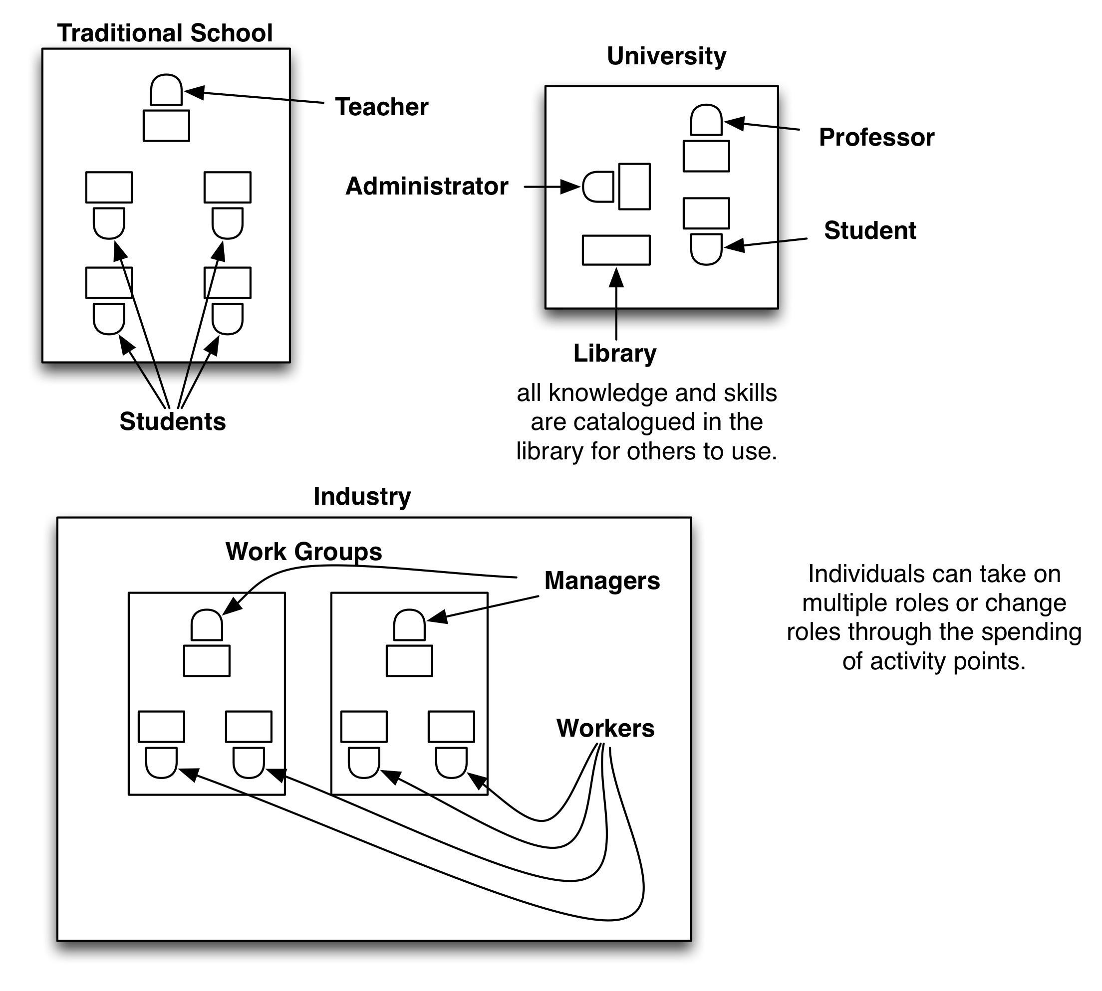

Left-Side of Room – Dewey’s Society

The left side of the room will be where we set up our desks to simulate Dewey’s ideal society, built around his concept of the school as central to urban life. All the desks will be arranged in a circle, exemplifying both the Dewey School and the public forum. Inside the public forum, there will be a desk or table set aside as the Library. Around the outside of the Dewey school will be break-out satellite work groups that are responsible for industry in the Dewey Society.
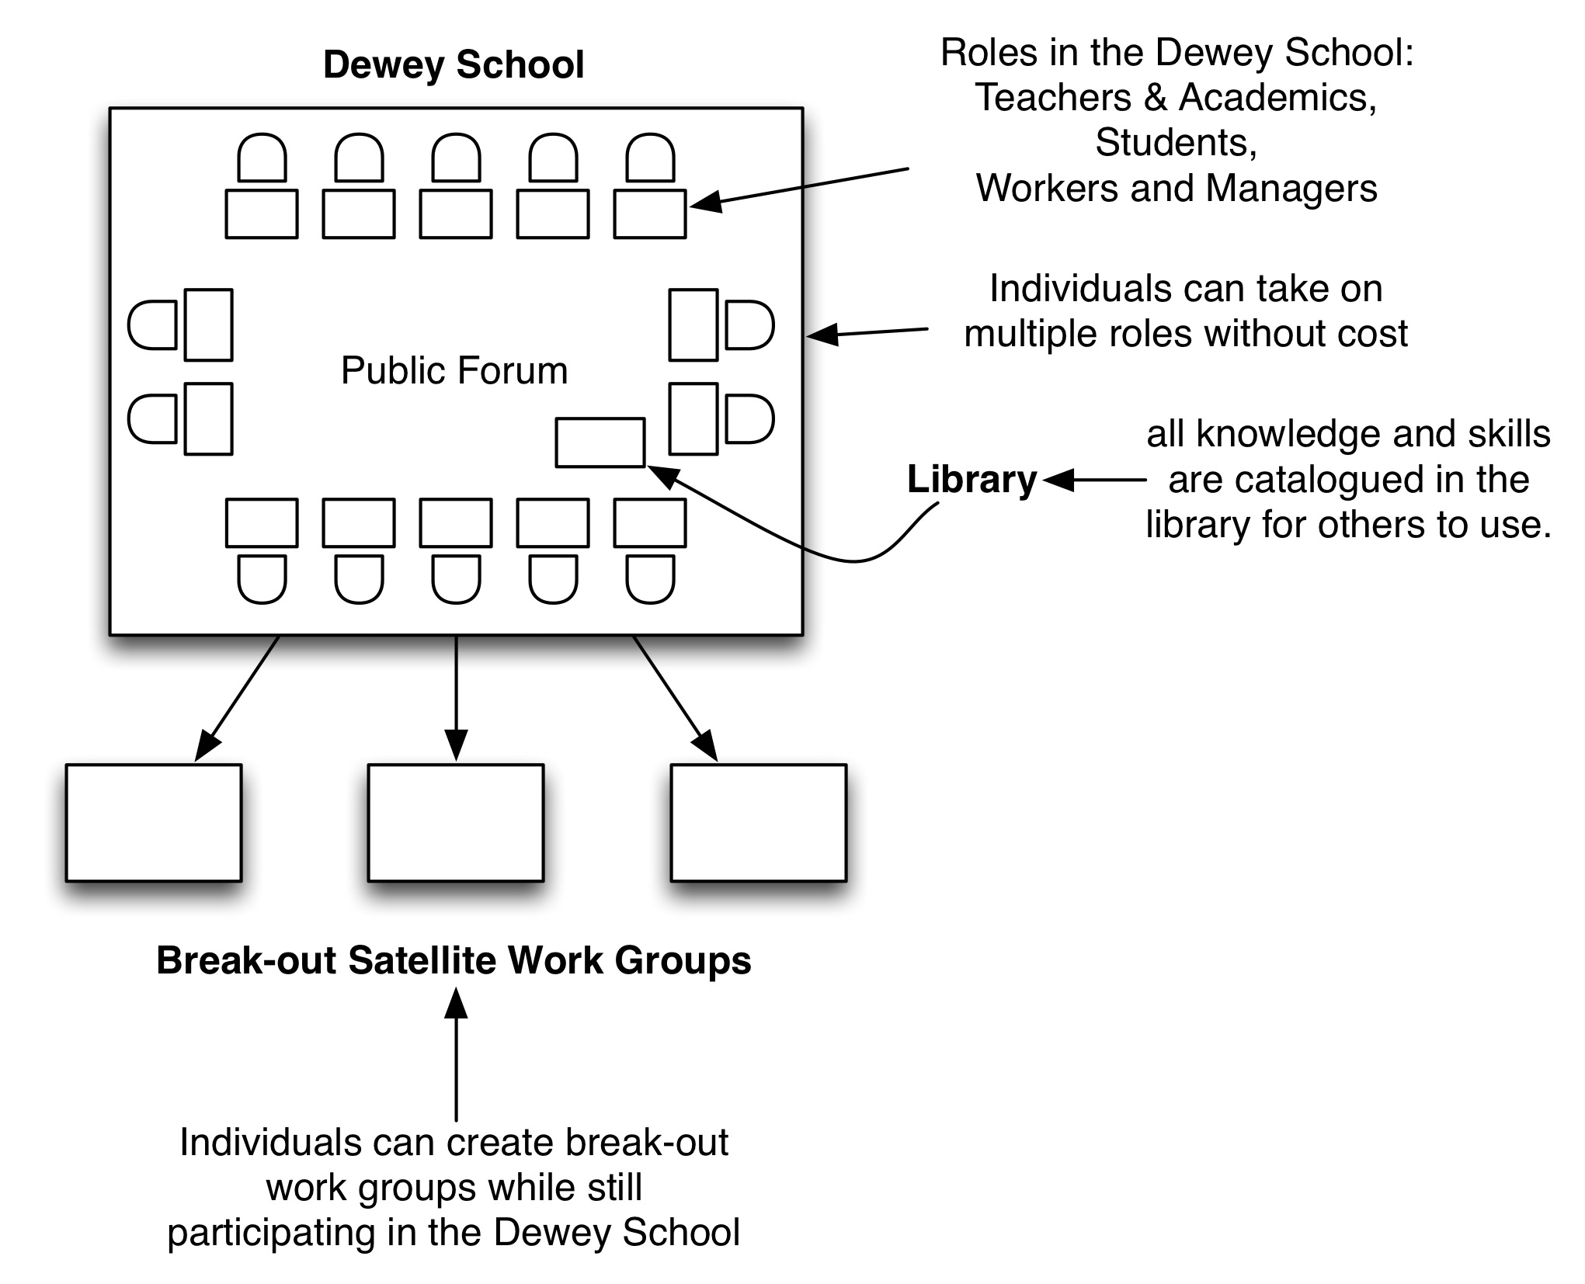

Once the desks have all been set up, stock the library with the knowledge and skills provided as part of your society set-up package (included separately).

2: Game Play

The game is divided into rounds, and in each round, there are particular phases that must be followed in order. Depending on the society to which your character belongs, you may have differing content associated with those phases.

In both the Traditional Society and the Dewey Society, the name and number of the phases are the same, though the content will differ significantly (described later).

The phases of each round proceed as follows:

- Education and Industry
The first phase of the round is when each member of each society spends his or her activity points, either in pursuing knowledge and skills through education, or pursuing goals through work in industry. Activity points may be held in reserve to contribute to Reorganization activities, to apply to Emergent Issues, or to augment one’s happiness score at the end of the round. At the end of each round, any unused activity points may be traded in for volunteer or leisure activities, which contribute to one’s happiness score, and any excess points are summarily lost without value.

- Reorganize
During the second phase of the round, each society will have a chance to move its members around, and make changes to its institutions, if applicable. This may include issues of setting policy, changing curriculum, or changing roles for individual characters.
- Emergent Issues
Throughout the game, the game referees (that’s us!) may throw each group a curve ball and introduce some unexpected situation that may threaten the well-being or happiness of their society, or a portion of their citizenry. During this phase, each group will get a chance to hear what happens to them, but must wait to react until their next round. Emergent Issues may affect individual and overall happiness scores.
- Score
At the end of each round, each player will tabulate the happiness points for their character, based on the realities left by the actions and events of the round concluding.
- Game Play – Traditional Society
In the Traditional Society, the phases of each round proceed as follows:

- Education and Industry
During the first phase of game play, ‘Education and Industry’, the traditional society may educate its citizenry and produce goods and achieve goals set by industry.

Education: In the Traditional Society, in order for anyone to learn a skill, they:
a) Must be in school, and have the role of a student, with a teacher present that either knows the skill/knowledge in question, or has access to the knowledge through the library, and the skill/knowledge is part of the current curriculum, or…
b) May not be in the role of a student, but must have access to the knowledge/skill through another individual –not- in the role of a teacher, or…
c) May not be in the role of a student, but must have access to the knowledge/ skill in question through the library.

In case a), a student with a teacher present that possesses the necessary skill or knowledge AND DESIRED RANK may learn up to 2 ranks in any given skill per round. The cost of increasing a skill or knowledge is 1 activity point per rank. The teacher must also spend 1 activity point per rank for teaching the student. Teachers may educate more than one student at a time, and will only pay the activity point cost once per round, based on the highest rank achieved by a student that round.
E.g. two students in the presence of a teacher with ‘Mathematics: 5’ may increase their knowledge of Mathematics up to a maximum of a rank of 5. Student 1 raises his ‘Mathematics: 1’ to a ‘Mathematics: 2’ in a single round. This will cost the character 1 activity point. Student 2 raises her ‘Mathematics: 2’ to a Mathematics: 4’ This will cost the second character 2 activity points. This activity will cost the Mathematics teacher 2 activity points.

If the student does not have a teacher present, but has access to the knowledge through the library of the DESIRED RANK, they may learn up to 1 rank in any given skill per round, with a cost of 2 activity points per rank.
E.g. If the library has ‘Astrophysics: 7’, any student may learn from the library one rank per round, up to the maximum of RANK 7, at a cost of 2 activity points per rank.
In

In case b), a character that is not currently a student may learn a new skill or knowledge, but only if they have access to the skill or knowledge AND DESIRED RANK through another character. This character may learn up to 1 rank in any given skill per round, at TWICE THE STANDARD COST. This will also cost the worker teaching the skill the same number of activity points.

E.g., if a worker wishes to raise their Farming skill from 2 to a 3, they must find another character with the skill of ‘Farming: 3’, and spend 2 activity points to raise the skill. The teaching character must also spend 2 activity points.

In case c), A non-student character with access to the knowledge or skill through the library AT THE DESIRED RANK, may teach themselves a skill or knowledge. This character may learn up to 1 rank in any given skill per round, at FOUR TIMES THE STANDARD COST.

E.g., If a worker wishes to increase their ‘Mechanical Engineering’ knowledge from a 2 to a 3, and they have access to ‘Mechanical Engineering: 3’ in the library, they may spend 4 activity points to do so.

Education Cost Matrix for Traditional Society:

Role of learner | Conditions met | Cost to learner | Cost to teacher
Student | Has teacher present with desired skill and rank. | 1 activity point per rank, up to two ranks per round. | 1 activity point per rank, for all students, using highest # of ranks achieved.
Student | No teacher, but has library access to skill and rank | 2 activity points per rank, up to one rank per round. | N/A
Non-Student | Has character to teach skill, in possession of skill at appropriate rank. | 2 activity points per rank, up to one rank per round. | 2 activity points per rank, up to one rank per round.
Non-Student | No character to teach skill but has access to skill through library at appropriate rank. | 4 activity points per rank, up to one rank per round. | N/A

Prerequisites: Any skill or knowledge that has a prerequisite must have that prerequisite met by the character attempting to learn the skill or knowledge.

Interests align with learning: If the learning character has an interest that aligns with the knowledge or skill being used, they get 1 free activity point that round to spend towards the acquisition of ranks in that skill or knowledge.

Industry: In the Traditional Society, individuals may endeavor towards industrious goals that are defined by an overall purpose or explanatory phrase, such as ‘make shoes’ or ‘build widgets’, and an accompanying set of skills of particular rank, and number of activity points defining the effort necessary to complete the goal. The goal also might have a level of capital expense related to its completion as well, which must be spent out of the work group funds, or the individual funds of the workers in the work group.

If a given goal is not completed in a single round, the activity points spent on the task are retained, and effort may be made to complete the task in subsequent rounds UNLESS OTHERWISE NOTED ON THE GOAL.

Each goal, when completed, offers up a certain number of wealth points to be distributed among the workers at the going rate (equal to the rank of the skill required to complete the task, times the activity points required, divided by two or twice as much for a contractor). Managers make twice the rate of the highest paid worker, and the rest of the profit is to be held by the work group for future expenses.

E.g. A work group may endeavor to ‘make 500 pairs of running shoes’. This might require completion of ‘leatherworking rank 2, 5 activity points’, ‘chemistry rank 4, 2 activity points’, ‘ergonomic engineering rank 2, 2 activity points’, ‘Sales rank 2, 2 activity points’, and ‘Fashion Design rank 3, 2 activity points’. The task might also carry with it a cost of 5 wealth points, and on completion will create 40 wealth points in return. On completion, the work group needs to pay one worker 5 wealth (rank 2 x 5 activity points / 2), one worker 4 wealth (rank 4 x 2 activity points / 2), two workers 2 wealth (rank 2 x 2 activity points / 2), one worker 3 wealth (rank 3 x 2 activity points / 2), and must spend 5 wealth points in materials. The manager will make 10 wealth points (x2 the highest paid worker of 5). This is a total cost of production of 31 wealth points, making a wealth profit of 9 points for the work group. If the Fashion Designer were a contractor, his cost would be 6 wealth instead of 3, and the manager would make 12 wealth instead of 10, cutting excess profits to 4 wealth instead of 9 for the work group.

A character may contribute to the completion of said goals:
a) As a worker or manager, in a work group, striving to achieve the goals set by the given work group manager, or…
b) As a worker endeavoring on a goal without a manager, or…
c) As an academic, endeavoring to extend knowledge or skills through work in the University, under the direction of an Administrator, or…
d) As an academic, endeavoring to extend knowledge or skills through work in the University, not under the direction of an Administrator, or…
e) As a volunteer on a pre-determined goal organized by another character or organization, or…
f) As an entrepreneur, striving to achieve a goal set by oneself.

In case a), a worker is employed by a work group, working alongside other workers and under the direction of a manager. If the worker is not hired into the work group, he may be brought in as a consultant at twice the payout cost of a normal worker. For said workers, the activity point cost to contribute to a goal or task is 1:1. The manager must also spend 1 activity point per worker on the project.

In case b), a worker endeavoring without a manager must spend an activity point cost to contribute to a goal or task of 2:1.

In case c), an academic endeavoring to extend knowledge or skill at a University, under the direction of an Administrator must have appropriate prerequisites for extending that skill of at least the same skill at one rank below the targeted level, or if a new skill or knowledge, a game referee must deem the Academic is capable of extending that knowledge given their current set of knowledge and skills. The cost of extending the knowledge is 2:1 and the administrator must spend 1 activity point per rank of knowledge extended. Any academic may only extend knowledge or skills up to 3 ranks total per round ACROSS ALL DISCIPLINES.

In case d), if an academic endeavors to extend knowledge through work at a university not under the direction of an administrator, the academic must have the appropriate prerequisites, and the cost of extending knowledge is 3:1. Further, the knowledge created cannot be added to any teaching curriculum until the Administrator and a quorum of 3 Academics deem it appropriate.

In case e) a character may volunteer activity points towards the completion of goals set by entities not in a work group or at the university in particular. These goals are considered ‘voluntary’, and do not earn any wealth points for the character. The completion of volunteer goals, however, does add to an individual’s happiness score, as well as the happiness score of the society at large. The cost for participation in volunteer activities is 1:1.

In case f), a worker is launching off his or her own goal without a work group or manager. A referee must approve any goal not currently defined in the set of goals available. The cost of contributing to the goal or task is 3:1, and the wealth cost for materials must come out of the entrepreneur’s pockets. The entrepreneur gets to keep all the profits, of course. An entrepreneur can also hire employees, or contractors, at the same rate as a work group. At that point, the entrepreneur becomes a manager, and follows the same rules as work groups follow.
Industry Cost Matrix for Traditional Society:

Role of Worker | Conditions met | Cost to Worker | Other Costs
Worker / Manager | Working in work group. Skills prerequisites met. Manager present | Worker cost is 1:1 per activity point.  Manager cost is 1 activity point per worker on project. | Workers are paid out of profits (rank of skill x activity points) / 2.  Contractors are paid x2 workers.  Managers are paid x2 highest paid worker. Work group retains excess profits.
Worker | Working in work group. Skills prerequisites met. Manager not present. | Worker cost is 2:1 per activity point. | Workers are paid out of profits (rank of skill x activity points) / 2.  Contractors are paid x2 workers.  Work group retains excess profits.
Academic | Working inside University to extend knowledge. Skills prerequisites met. Administrator directing work. | Academic cost is 2:1 activity point per rank of new skill. Administrator cost is 1 activity point per rank of new skill.  Academic may extend up to 3 ranks of all knowledge skills combined per round. | Knowledge is available through library at University, and is approved curriculum for any teacher.
Academic | Working inside University to extend knowledge. Skills prerequisites met. Administrator not directing work. | Academic cost is 3:1 activity points per rank of new skill. Academic can extend up to 3 ranks of all knowledge skills combined per round. | Knowledge is available through direct work with Academic or through library, but is not approved curriculum for teachers.
Any role | Working as a volunteer. Goal is defined and managed by someone. Skills prerequisites met. | Activity cost is 1:1. | No wealth is earned for the worker, but happiness for worker and society may be improved.
Any role | Working as an entrepreneur, on a goal that is managed by self. Skills prerequisites met. | Activity cost is 3:1. | All costs come out of individual’s pockets, but individual keeps all profits.

Prerequisites: Any goal or task that has a prerequisite must have that prerequisite and rank met by the character attempting to contribute to the project for that given skill. A character may not contribute to a goal or task for which they have no aligning skills to contribute.

Interests align with industry: If the working character has an interest that aligns with the task or goal, they get 1 free activity point that round to spend towards the accomplishment of that task or goal.

- Reorganize
Once the Traditional Society has completed the first phase of the round, they may now spend time and energy and resources in reorganizing their society to better fit their emerging needs. Change is more difficult for the Traditional Society, however, than it is for the Dewey Society. All change is subject to one form of restriction / approval, or another. The types of reorganization that can happen in the Traditional Society are:
a) An individual may change or modify his or her role(s).
b) New knowledge or skills may be added to the teaching curriculum by the teacher of a school.
c) Employees may be hired or fired from work groups, School, or University.
d) Rules of the society can be changed.
e) Change may be lobbied from interest groups to appropriate authorities.
In case a), an individual may change or modify their role for the cost of 1 activity point. A worker may quit their job and become a student, a student may be hired on as a worker, or become a freelance/contractor, a teacher may go back to University and become an Academic, or a student or worker may become a teacher. A worker that is promoted to manager does not need to spend an activity point. A worker can be promoted to a manager by another manager, or by the result of entrepreneurial activity.
Any character may choose to intern with a work group for one activity point. An intern does not share in wealth rewards for completed goals, but gains access to individuals with particular skills, whom may be convinced to pass on particular skills or knowledge while the intern is present and working; costs are defined in the education section of this rule set.
If an individual wishes to maintain two or more roles simultaneously, the cost is 2 activity points per additional role.
In case b), a teacher may set their curriculum to a different set of skills or knowledge – a teacher may ONLY set their curriculum at this point in the round, and not before. It costs 1 activity point per addition of new skill or knowledge into the curriculum. The Administrator of the University must approve any new curriculum before it can be official taught in a school. If the curriculum needs to be approved, it takes 1 activity point on the part of the teacher, 1 activity point on the part of the Administrator, and 1 full round must go by before the skill or knowledge may be added to the teaching curriculum.
In case c) Work groups, schools, or Universities may hire or fire employees. In each case, a hiring or a firing takes 1 action on the part of the hiring/firing manager or administrator (use the University administrator to hire into the school), and 1 additional action on the part of the individual being hire/fired. If an individual is fired before the completion of a goal, the employer must pay out a small severance equal to the rank of the highest relevant skill or knowledge possessed by the employee towards the project.
In case d), there might be rules of the society that impede success for that society, and they may be modified, but only under great effort. A rule change requires a qualified advocate to present the rule change during this phase of the round, and expend 2 activity points. Any rule change must be ratified by a majority of the society’s members, including all managers and administrators, and requires 2 activity points from each assenting member, plus 1 complete round must pass before the change is fully ratified and put into action. A qualified advocate is a manager of a work group, or an administrator.
In case e), change of the operations of any particular interest group, be it work group, school or university, may be lobbied for by individuals from within or external to said interest group. Lobbying for change requires the attention of a manager or administrator, and the cost is 1 activity point from both the lobbying party, and the authority in said interest group. Once change has been lobbied, the authority may decide to bring this change forth as policy, as defined in case d).
Reorganization Costs for Traditional Society

Role of Change Agent | Conditions Met | Cost to Change Agent | Other Costs / Notes
Any individual | Role is available | 1 Activity point to change current role; 2 Activity points to add role but not change current role. | Workers promoted to Managers do not spend activity point.
Teacher | Curriculum available to teacher and approved by Administrator. | 1 activity point per additional skill or knowledge. | If curriculum not approved by Administrator, it will take 1 activity point from the teacher, 1 activity point from the administrator, and 1 full round to add the skill or knowledge to available items that may be added to curriculum.
Manager or Administrator | Position available for hiring into, or no condition necessary if firing. | 1 activity point on part of manager/administrator and 1 activity point on part of employee. | Severance package for employees: wealth = rank of highest relevant skill or knowledge to project goal.
Manager or Administrator | Rule to change has advocate. Vote is had and change is ratified by majority of society members. | 2 action points from advocate and all assenting members in vote. | 1 full round must pass before new rule is put into action.
Any individual | Attention from manager or administrator. | 1 activity point from lobbyist, 1 activity point from authority. | After one round, authority may bring change up for vote.

- Emergent Issues
In phase three of the round, after all player actions have been accounted for, the referees will introduce into the game specific emergent issues that will provide unique challenges or opportunities to the individual societies, particular groups within the society, or across both societies. Details of those changes will be available at that time. Players will have to wait until the next round to enact changes or otherwise react to the introduced issue.
- Score
In the final phase of the round, each individual will tally his or her current wealth points and happiness points. At this point, a player may wish to spend wealth on maintaining a lifestyle. Every point spent on lifestyle equates to an increase in happiness points for the round. At the beginning of the score phase, however, the player must subtract the happiness equivalent to the lifestyle purchased the previous round. This models our tendency to grow accustomed to a specific way of living.
E.g. On the first round, Bill spends 3 wealth points on lifestyle, earning him 3 happiness points, giving him a total of 7 happiness points for the end of round one. On round two, Bill does not earn enough money to sustain his current lifestyle. On the score phase, Bill subtracts 3 from his happiness points, and then invests 2 wealth points in lifestyle, earning him 2 points back. After calculations, Bill has 9 points of happiness, but only 2 come from his lifestyle. He is down a net 1 from his lifestyle contribution to his happiness.

Individual wealth may also be spent along with leftover Activity points on Vacations or other Leisure activity, and the benefit is the total activity points plus wealth points converted to happiness points. An individual can spend no more than 3 Activity points on leisure/vacations a round. The next round, during the score phase, the individual must subtract ½ of the total happiness points gained by any leisure/vacations spent the round before. This models our ability to quickly forget the good times in the face of the current moment.
E.g. On the first round, Sally decides to go on a luxurious cruise in the Caribbean. This will take 2 action points, and 4 wealth points. The total happiness earned for the end of round one is 6 points from vacations. At the end of round two, at the beginning of the score phase, Sally must lose 3 happiness points (1/2 of 6) – because, well that cruise was a long time ago!

- Game Play – Dewey Society

In the Dewey Society, the phases of each round follow much as for the Traditional Society, with a few modifications to each phase along the way:

- Education and Industry
During the first phase of game play, ‘Education and Industry’, the Dewey society has a great deal of flexibility in the way it may educate its citizenry and produce goods and achieve goals set by industry. Education and Industry also are synergetic, as in the Dewey Society, education and work are often one in the same. Because of this, every member of the Dewey Society is automatically considered to be of the role ‘Student’, no matter what other roles they may possess.

Education: In the Dewey Society, in order for anyone to learn a skill, they:
a) Must be in collaboration with a mentor or teacher that either knows the skill/knowledge in question, or has access to the knowledge through the library, or…
b) Must have access to the knowledge/ skill in question through the library, or…
c) Must be in collaboration with a mentor or teacher or a set of other individuals who have/have access to the pre-requisites to the skill, but not the skill itself.

In case a), a learner with a mentor present that possesses the necessary skill or knowledge AND DESIRED RANK may learn up to 2 ranks in any given skill per round. The cost of increasing a skill or knowledge is 1 activity point per rank. The mentor must also spend 1 activity point per rank for teaching the learner. Mentors may educate more than one student at a time, and will only pay the activity point cost once per round, based on the highest rank achieved by a learner that round.
A mentor is defined as any character that has the appropriate skill and rank to educate another character. If the mentor is a teacher, a learner may learn up to 3 ranks in any given skill per round.
E.g. two learners (Jim and Linda) in the presence of a mentor with ‘Mathematics: 5’ may increase their knowledge of Mathematics up to a maximum of a rank of 5. Jim raises his ‘Mathematics: 1’ to a ‘Mathematics: 2’ in a single round. This will cost Jim 1 activity point. Linda raises her ‘Mathematics: 2’ to a Mathematics: 4’ This will cost Linda 2 activity points. This activity will cost the Mathematics mentor 2 activity points. The mentor is a teacher, so Linda may choose to raise her skill to ‘Mathematics: 5’ for 3 points, and costing the teacher 3 points.

In case b), if the learner does not have a Mentor present, but has access to the knowledge through the library of the DESIRED RANK, they may learn up to 1 rank in any given skill per round, with a cost of 2 activity points per rank.
E.g. If the library has ‘Astrophysics: 7’, any student may learn from the library one rank per round, up to the maximum of RANK 7, at a cost of 2 activity points per rank.

In case c), if the learner has a mentor or a cohort of other individuals present that have all the pre-requisites for a given skill or knowledge (or have access through the library to said pre-requisites), the group can work together to develop the skill or knowledge while they learn it. Each member can spend 2 activity points per rank, one rank maximum (or two ranks if any member is an Academic). If the skill is a new skill, the team must define what pre-requisites go into the skill, and the team should have a referee approve the skill. Once the skill is developed, it can be placed in the library for others to access and use. Any individual may only extend knowledge or skills up to 3 ranks total per round ACROSS ALL DISCIPLINES.
Education Cost Matrix for Dewey Society:

Role of learner | Conditions met | Cost to learner | Cost to mentor
Any | Has mentor present with desired skill and rank. | 1 activity point per rank, up to two ranks per round. If mentor is a teacher, up to three ranks per round. | 1 activity point per rank, for all students, using highest # of ranks achieved.
Any | No mentor, but has library access to skill and rank | 2 activity points per rank, up to one rank per round. | N/A
Any | Has mentor or cohort with desired skill’s prerequisites known or available through library. | 2 activity points per rank, one rank per round. If member of cohort is Academic, 2 ranks may be developed. | Each member of cohort must spend two activity points per rank, but each learns the skill at the end of the process.

Prerequisites: Any skill or knowledge that has a prerequisite must have that prerequisite met by the character attempting to learn the skill or knowledge.

Interests align with learning: If the learning character has an interest that aligns with the knowledge or skill being used, they get 1 free activity point that round to spend towards the acquisition of ranks in that skill or knowledge.
Synergy between learning and doing: Any learning that is done in concert with a stated goal or objective (learning skills necessary to complete the task while completing the task) allows for a +1 activity point to be applied to the completion of said task.

Industry: In the Dewey Society, individuals may endeavor towards industrious goals in the same fashion as the Traditional society, with the required skills and capital rules in place. Tasks may span multiple rounds, and wealth points are to be distributed among the workers at the going rate
(equal to the rank of the skill required to complete the task, times the activity points required, divided by two or twice as much for a contractor). Managers make twice the rate of the highest paid worker, and the rest of the profit is to be held by the work group for future expenses.
If an individual manager is not assigned to manage a goal, but the goal is being used for educational purposes, the school will appoint a manager to the task, and will retain the profits, as would a work group.

A character may contribute to the completion of said goals:
a) As a worker or manager, in a work group, striving to achieve the goals set by the given work group manager, or…
b) As a worker endeavoring on a goal without a manager, or…
c) As an individual, endeavoring to extend knowledge or skills, or…
d) As a volunteer, or…
e) As an entrepreneur, striving to achieve a goal set by oneself.

In case a), a worker is engaged by a work group, working alongside other workers and under the direction of a work group manager. If the worker is not hired into the work group, he may be brought in as a consultant at twice the payout cost of a normal worker. For said workers, the activity point cost to contribute to a goal or task is 1:1. The manager must also spend 1 activity point per worker on the project.
If the worker is also learning a skill or knowledge through the activity of the goal directed by the school, the worker achieves 1 less wealth point, but gains 1 more happiness point.

In case b), a worker endeavoring without a manager must spend an activity point cost to contribute to a goal or task of 2:1, and will be appointed manager of said activity if working solo, or if there are multiple workers on the project, the most skilled individual will be selected as manager for the task.

In case c), an individual endeavoring to extend knowledge or skill must follow the rules in the education section, but may apply ½ the points spent on learning the skill or knowledge to the task involved with the learning process.

In case d), a character may volunteer activity points towards the completion of goals set by any individual, including one’s self. The character must have the appropriate skills to help with the volunteer task. These goals are considered ‘voluntary’, and do not earn any wealth points for the character. The completion of volunteer goals, however, does add to an individual’s happiness score, as well as the happiness score of the society at large. The cost for participation in volunteer activities is 1:1.

In case e), a worker is launching off his or her own goal without a work group or manager. A referee must approve any goal not currently defined in the set of goals available. The cost of contributing to the goal or task is 3:1, and the wealth cost for materials must come out of the entrepreneur’s pockets. The entrepreneur gets to keep all the profits, of course. An entrepreneur can also hire employees, or contractors, at the same rate as a work group. At that point, the entrepreneur becomes a manager, and follows the relevant rules.
Industry Cost Matrix for Dewey Society:

Role of Worker | Conditions met | Cost to Worker | Other Costs
Worker / Manager | Working in work group. Skills prerequisites met. Manager present | Worker cost is 1:1 per activity point.  Manager cost is 1 activity point per worker on project. | Workers are paid out of profits (rank of skill x activity points) / 2.  Contractors are paid x2 workers.  Managers are paid x2 highest paid worker. Work group retains excess profits. Learners earn -1 wealth but +1 happiness.
Worker | Working in work group. Skills prerequisites met. Manager not present. | Worker cost is 2:1 per activity point. | Workers are paid out of profits (rank of skill x activity points) / 2.  Contractors are paid x2 workers.  Managers are paid x2 highest paid worker.  Work group retains excess profits.
Any role | Working to extend knowledge. Skills prerequisites met. Group cohort formed for skill development. | See rules for education –  ½ skill points spent on learning can be applied to tasks. | Knowledge is available through library at University, and is approved curriculum for any teacher.
Any role | Working as a volunteer. Goal is defined. Skills prerequisites met. | Activity cost is 1:1. | No wealth is earned, but happiness for worker & society improved.
Any role | Working as an entrepreneur, on a goal that is managed by self. Skills prerequisites met. | Activity cost is 3:1. | All costs come out of individual’s pockets, but individual keeps all profits.

Prerequisites: Any goal or task that has a prerequisite must have that prerequisite and rank met by the character attempting to contribute to the project for that given skill. A character may not contribute to a goal or task for which they have no aligning skills to contribute.

Interests align with industry: If the working character has an interest that aligns with the task or goal, they get 1 free activity point that round to spend towards the accomplishment of that task or goal.

- Reorganize
In the Dewey Society, change is simple and fluid. Any change in the rules of the society may be altered at this point with a simple majority vote. There is no cost for these changes. Individuals may also alter their own roles (adding or changing) for no cost.

- Emergent Issues
In phase three of the round, after all player actions have been accounted for, the referees will introduce into the game specific emergent issues that will provide unique challenges or opportunities to the individual societies, particular groups within the society, or across both societies. Details of those changes will be available at that time. Players will have to wait until the next round to enact changes or otherwise react to the introduced issue.
- Score
In the final phase of the round, each individual will tally his or her current wealth points and happiness points. At this point, a player may wish to spend wealth on maintaining a lifestyle. Every point spent on lifestyle equates to an increase in happiness points for the round. At the beginning of the score phase, however, the player must subtract the happiness equivalent to the lifestyle purchased the previous round. This models our tendency to grow accustomed to a specific way of living.
E.g. On the first round, Bill spends 3 wealth points on lifestyle, earning him 3 happiness points, giving him a total of 7 happiness points for the end of round one. On round two, Bill does not earn enough money to sustain his current lifestyle. On the score phase, Bill subtracts 3 from his happiness points, and then invests 2 wealth points in lifestyle, earning him 2 points back. After calculations, Bill has 9 points of happiness, but only 2 come from his lifestyle. He is down a net 1 from his lifestyle contribution to his happiness.

Individual wealth may also be spent along with leftover Activity points on Vacations or other Leisure activity, and the benefit is the total activity points plus wealth points converted to happiness points. An individual can spend no more than 3 Activity points on leisure/vacations a round. The next round, during the score phase, the individual must subtract ½ of the total happiness points gained by any leisure/vacations spent the round before. This models our ability to quickly forget the good times in the face of the current moment.
E.g. On the first round, Sally decides to go on a luxurious cruise in the Caribbean. This will take 2 action points, and 4 wealth points. The total happiness earned for the end of round one is 6 points from vacations. At the end of round two, at the beginning of the score phase, Sally must lose 3 happiness points (1/2 of 6) – because, well that cruise was a long time ago!

3: Final Scoring

At the end of the game, both societies will tally the individual wealth and happiness scores for every member, and then will create a total score by adding up all these points together. A highest member score and a lowest member score will be noted as well, denoting the individuals with the highest individual score and the lowest individual score, respectively. The team with the lowest span between highest and lowest will be granted an additional +20 happiness points. This is to reflect the lack of social unrest that is caused by great disparity between the upper and lower classes in a society.

