El Juego de la Vida:
Using “The Game of Life” to Teach Spanish in the Workplace
Joshua Archer
EDCT 585 – Fall 2015

Unit Review 4
Summary 4
Rationale 5
Transactional and peer-oriented learning 5
Games, Engagement and Motivation 6
Role-play and Simulation 7
Constructivism and Discovery-Based Learning 8
Divergent Thinking, Open-Ended Solutions and 21st-Century Skills 9
Education as Enacting Social Change 10
Multi-Faceted Assessment Methodology 11
Educational Goals 11
Unit Topics 12
Interdisciplinary and Multicultural Goals 12
District-Required Goals and Objectives 13
Grade Level 13
Scope and Sequence 13
Unit Themes 14
Personal Themes 15
Work-Related Themes 15
Education-Related Themes 17
Meta-Level Game and Learning Themes 17
Overview of Unit 18
Character Creation 18
Currencies of Success 20
Standard Game Phases 21
End-Game Goals and Moving Beyond 25
Evaluation 25
A: Self Perspective, Intent 26
B: Collaborative Others, Intent 27
C: Society, Intent 28
D: Self Perspective, Engagement 29
E: Collaborative Others, Engagement 30
F: Society, Engagement 31
G: Self Perspective, Artifact 31
H: Collaborative Others, Artifact 32
I: Society, Artifact 33
Unit Resources 34
Lesson Plan Example 35
Objectives 38
Materials list 38
Into 39
Through 39
Beyond 40
Evaluation 41
APPENDIX A: Unit Syllabus and List of Lessons 43
APPENDIX B: El Juego de la Vida – Player’s Handbook 57
APPENDIX C: Skills Mechanics Worksheet (Alpha Ver 0.3) 80
APPENDIX D: Student Opinion Survey Questions 82
APPENDIX E: Character Generation Worksheet 90
APPENDIX F: Role-Play Scenario Examples 94
APPENDIX G: Character Sheet 113
APPENDIX H: Chance Cards 122
ENDNOTES 136

Unit Review

Summary
“El Juego de la Vida”, or “The Game of Life”, is a year-long curriculum designed to use a game-based constructivist, transactional learning techniques and scaffolding for learning a foreign language (in this specific case, Spanish). Through engaging with this game-based curriculum, students learn about the situations and aspects of everyday work experience while learning Spanish contextualized around those work experiences with the goal of fostering situational Spanish fluency.

We begin the curriculum with students in the class creating written representations of personas or ‘characters’ through which they act in the simulation of life after high school. These characters are new high school graduates, each coming from a specific background and with their own personal story. Through the course of the game, the students or ‘players’ act through their characters to co-create a story with their peers detailing their endeavors to set and achieve goals to improve their characters’ socio-economic status and lifestyle.

“El Juego de la Vida” provides opportunities for students to improve their Spanish fluency in the context of their characters’ fictional life paths, including circumstances at work, home, school and private life. Simultaneously, students gain familiarity with situations common in working life, and have a chance to practice both communications and skill sets relevant to those settings.

The goal of “El Juego de la Vida” is for student players to advance their characters along their socio-economic trajectory. Students’ participation in game activities, such as role-play scenarios and creating specific game artifacts and projects, allow them to earn an abstract reward currency, called ‘Vida Points’. ‘Vida Points’ are used by student players to improve their character’s lives, by advancing their character’s skills and education, creating for them beneficial advantages or assets, and by allowing them to get out of sticky life situations that appear in Chance cards (a deck of random life occurrences, both positive and negative that interject into the narrative of the characters). Student players receive a regular paycheck from which they must pay their bills and debts, they must manage a budget for their characters, and keep a schedule of their time throughout the month.

Through playing “El Juego de la Vida”, students engage in scenarios with their characters that require them to create important work-related artifacts, such as resumes, cover letters, job applications, personal stories, job performance reviews, etc. that simultaneously require the use of Spanish and domain-specific knowledge to complete. These created artifacts become an important assessment criterion for educators to use to track students’ learning. Another important assessment criterion are role-play scenarios which occur between students and are peer-judged for Spanish fluency, realism, and relevance. Periodically, the curriculum calls for the entire class to reflect on the game play process, and allows student players to comment on the efficacy of the game, and provide constructive criticism and advice for game improvement. These group reflections not only help educators course-correct on the game narrative (and allow us as game designers to improve the game play), but give students practice in critical thinking and reporting on their reflections.

While this curriculum is designed originally for Spanish, the base game is translatable to any language, and can even stand alone as a course for native speakers to learn, practice and understand situational fluency of both communication skills and business vernacular.

“El Juego de la Vida” is currently in development and being administered as a prototype to two separate high school classrooms at Casa Grande High School, in Petaluma, CA. My business partner, Bert Holcomb, and I are currently administering and developing the content for this game, and as we go along, we are refining both the individual lessons, and the overall game mechanics, and we are making plans for future development, hopefully with the aid of a grant.

The curriculum which I am presenting here is a combination of what we have already delivered this semester, and our current plans for the coming semester. While this represents our current plan, I acknowledge that input from the students in the game, and from the instructor of the class will likely create modifications in the curriculum as delivered.

Rationale

My partner, Bert Holcomb, and I established The Game Academy as a 501(c)3 non-profit organization with the strong conviction, gained through personal experience and allegorical reports from many we have met, and reinforced by my own educational scholarship, that our standard transmission-based, top-down, sage-at-the-stage teaching methodology carried within itself flaws which served to disenfranchise many learners from the process of learning. It is through a desire to address these flaws that we have developed a game-based role-play approach to education of which this curriculum is a representative instance.

While leaving the deeper philosophical justifications for our methodology and technique to my second paper on this curriculum, I will outline the areas in which I believe traditional transmissive teaching methodology to fall short, and how I believe our game-based curriculum serves to bridge the gap between learners and learning.

Transactional and Peer-Oriented Learning

For the latter part of the 20th century and into the beginnings of the 21st century, top-down, transmissive educational practices and methodologies have dominated public education in the United States. Classes are organized in rows, or sometimes more progressively, in a circle, but typically the mode of education follows the model of the teacher at the head of the class (figuratively and/or literally) instructing the class on a subject, and the students passively absorbing the knowledge in preparation to return that knowledge in the form of written or oral tests. Even in the face of alternative approaches being both invented and put into practice, this model has continued, perhaps more for the reason of ease and expedience of preparation on the part of the educator than one of best practices for learning. This model of education, known and named as the ‘banking’ model by , has been criticized as inadequate by many on several counts. This approach devalues any knowledge or perspective of the student, discourages critical thinking, and emphasizes the memorization and regurgitation of discreet ‘facts’ without any allowance or focus on deeper understanding of the content with which the educational experience is engaged. The agency of the learner is challenge, and for Freire, this leads ultimately to a re-enforcement of oppression. indicates that the “Banking” concept of education leaves children feeling inadequate: “Regardless of the method, as long as the “banking” concept is operative, the teacher pretends knowledge and projects ignorance onto the students. All questions have more or less correct answers, according to this view.”

Bennet, in A Nation Still at Risk, suggests “We must be as open to alternatives in the delivery of education as we are firm about the knowledge and skills being delivered.” Bobbit, in Scientific Method in Curriculum-Making puts forth that “any inherited system, good for its time, when held after its day, hampers social progress.” While we are not yet poised to revolutionize all of our public schools, and certainly there are times when traditional transmissive techniques might have limited merit, we believe that the time has certainly come, at least for us, to reorient our methodologies towards a more inclusive, engaging and participatory ethos. We believe we have found that in the use of role-playing games.

With “El Juego de la Vida”, we have endeavored to use a modality of learning that depends on interaction with narrative situations and with other peer student players that gives the student a sense of agency in their inquiry and allows for student players to bring their own knowledge to forming solutions for their characters in their pursuit of socio-economic success. Problems are posed in the form of situations that must be resolved, either through direct role-play interactions, or through the manipulation of game mechanic which use as currency rewards from role-play interactions. There are no ‘right’ answers to the situations posed, but certain outcomes may carry with them different consequences, some more desirable and effective in promoting success than others.

Games, Engagement and Motivation

One of the main problems we’ve identified with traditionally-based educational methodologies, specifically transmissive-based top-down methodologies, is the potential for the learner to feel disconnected and disenfranchised from the learning process. If a learner does not feel connected to the learning process, and does not have an intrinsic desire to learn about the topics and questions about which are being inquired, this can lead to a subsequent decrease in engagement and motivation on the part of the learner.

One identified way to increase engagement for learners is to use games and gamification techniques to change the relationship between learners and the learning process from one of top-down lecture and instruction driven learning, to one that incorporates elements of play and that increases the sense of agency and efficacy on the part of the learner in the process of learning. Both James Paul Gee (2008) and Jane McGonigal (2011) have spoken extensively on the benefits of games as educational modalities, and I will go into their evidences in detail in my next paper. What is important now is to indicate there has been high profile scholarship on the effects of games on motivation, engagement, and educational efficacy, which is what we are attempting to address with our curriculum.

In “El Juego de la Vida”, we create a learning environment that places the individual agency of the player as their character in the center of the activity, allowing students as players to control the actions and destiny of their characters while pursuing their character’s career and life goals. Students are learning information and producing artifacts not merely as assignments but as means to the ends of promoting their character’s success in advancing their careers and lifestyles, and in a contextualized environment that emulates real-life situations. Activities in class, such as group role-plays, are performed in character and are rewarded with game-related currency (Vida Points) that may be used in the process of advancing a character's skills and abilities. As student players play the game, and as their characters become more successful, the student player becomes more proficient in the activities required for their character to succeed. The knowledge they create is connected in their minds to contextualized situations and will aid in recall in their everyday life.

Role-play and Simulation

Role-play and simulation are modalities that have been used in education for a long time, and much has been written to their support. Instead of running the learning in the classroom from a transmissive top-down model, role-play allows the learning to occupy a space of possibility, allowing the learners to direct the action and focus of the learning through their personal investigations and interactions with the narrative of the scenario presented.

Role-playing games are by their nature a social endeavor, simulating life as lived and posing situations and problems that are naturalized and contextualized within a social context. Short & Burke, in Creating Curriculum, pose a model of ‘the natural learner’, who is learning constantly through life experience, and through an experience that is ultimately social. The Natural Learner is driven by curiosity, intentionality, and sociability. Role-playing games allow a student, through the actions of their character, to follow their own curiosity within the context and framework of the presented narrative; there is no specific set ‘correct’ answer or way to interact in the narrative, only possible consequences of your actions. If a student wishes to pursue a divergent theme or course of action, there is a low-stakes environment in role-playing games for which they may pursue actions that might prove problematic in the ‘real world’. It is ultimately the student player’s choice as to which course of action he or she decides for their character in any given situation or scenario, and this agency allows the student to possess a sense of responsibility for their actions and their learning path. And, of course, role-playing games are by their very nature a social activity; no only do role-playing games allow us to interact in relationship to one another, both with other players and with the game master / education facilitator, but in our curriculum, student players have the advantage of witnessing others role-play their own distinct situations and learn from others in the process of active learning. To quote Short and Burke, they can “borrow others’ experiences and understanding” to lend greater “flexibility to their own personal worlds.”

Bobbit, in Scientific Method in Curriculum-Making and How to Make a Curriculum make the case that we should study the life of adults to build our curriculum. While he is driven by the idea that “education is primarily for adult life, not for child life” as a preparatory exercise, and with this I disagree, as education must be relevant to the learner as it is being learned or they again run the risk of being alienated and disenfranchised from the educational experience, there is a way in which role-playing games can get you both immediate relevance for a child in the playing of the game, and a practice of future life as an adult through the development of game curriculum that simulates the issues, problems and narratives of adult living.

Bobbit makes an argument, and I think correctly, that the complexity of life in its entirety precludes a comprehensive scientific survey of the life of adults for the means of education, I do think it is possible, through focused scenarios around specific adult roles, such as the roles of ‘employee’, ‘job seeker’, ‘college student’, and the like, which can give us a rich field of topics for imaginative inquiry. In exploring with student learners the possibilities of adult life through role-play, students have immediate access to imaginative interchange with the possibilities that might influence their present educational interests as well as their future educational path. In this way, the possible future is brought into the present relevance for the student learner. While playing a game with a character in scenarios based on the experiences of the possible future, and seeking success for their character in the game, players can investigate the complexities of adult life in a low-stakes environment. Divergent pathways allow for exploration into situations that might be considered ill-advised or even taboo; what is learned may be rejected or integrated into the student learner’s identity without risking personal success or integrity.

Constructivism and Discovery-Based Learning

I am a strong believer in the constructivist model of the creation of knowledge, and firmly believe we build our network of knowledge piece by piece, one interconnected with another, over time, and through our experiences. Facts memorized in isolation do not have longevity in the mind, and tend to drift into obscurity after the test is given and the grade received. While this is true in many fields of knowing, I imagine this to be even more the case with learning a foreign language. Grammar and vocabulary build upon one another, and fluency is an additive process. By providing a context of learning that links language fluency with contextual use not only allows the language to be assimilated in a more natural and easier to recall fashion, but also serves to connect the context itself more deeply in the minds knowledge network when the language is called upon to be used in those contexts.
“El Juego de la Vida”, in using a role-playing game model, exemplifies constructivist learning as well as discovery learning; the student players begin their adventure with their characters fresh out of high school - in a position not so very different from the students playing the game, and not given any more information than what they themselves bring to the game through their own lives’ contexts. The characters are created with qualities that might insight some inquiry on the part of the students to understand. “What is it like to be of a different gender than their own?”, “What is it like to be Muslim?” — such questions provoke a beginning of inquiry, in as much as the players must have a full understanding of their character’s motivations to properly act from their perspective. This exploration also promotes inquiry into issues of multiculturalism, discrimination, and other related issues.

As the characters develop along their path, from first jobs, to first resumes and cover letters, interviews, job performance reviews, etc., their character’s personal experience joins learned knowledge to previous experience. As the character encounters chance issues in their lives, they are faced with new problems to solve, and integrate the solutions of these problems into the narrative of their characters, as well as into the network of their knowledge.

Much of the activity in the game is between the characters that the students play, and the game facilitator stands mostly to the side. As Horton suggests, in Islands of Decency, “Education is what happens to other persons, not what comes out of the mouth of the educator.” By his suggestion, our curriculum posits trust in our learners, in allowing them to pursue their own narratives, no matter how divergent they might become, and by empowering them to act as peer assessors of one another’s work and progress. We act as “gardeners” of the game, adding fertilizer where we want to encourage growth (in the form of chance cards and circumstances, as well as in the determination of the themes of our role-play scenarios), and pulling weeds when they threaten to choke out the growth that we wish to encourage (such as by bringing divergent narratives back towards the goals of our game). I agree with Horton when he states “Popular education should give people experience in making decisions”, and that’s exactly what our role-playing game curriculum is designed to do.

Divergent Thinking, Open-Ended Solutions and 21st-Century Skills

One of the major benefits of using a role-playing-game-based curriculum is that the narrative may set up the directionality of the learning experiences we intend our student players to enact, but we as game facilitators do not control the reigns of the conversations had by the players as their characters, nor of the actions they perform. More often than might feel comfortable for an educator attempting to follow a pre-established curriculum richly packed with the designs for desired learning experiences, the interactions by players as their characters can take a scene or a situation off the rails and into unplanned territory, and the players may end up engaging in learning experiences outside of the parameters originally designed into the narrative.

Divergent thinking, a concept and term coined by J.P. Guilford (1956), is generative of creative ideas through exploring many possible solutions, and reinforces one of the “21st-century skills” cited by the Framework for 21st Century Learning, along with critical thinking, communication, and collaboration. In fact, tabletop role-playing games have been cited to contribute not only to divergent thinking, but they reinforce most of the “21st Century Skills”, such as: critical thinking (solving problems and puzzles, analyzing a situation and acting on discovered information), communication (role-play is intrinsically about communication), collaboration (problems are solved in a group context), and depending on the themes of the role-playing games and the design of the content, they can teach key subjects and life and career skills. “El Juego de la Vida” by design provides opportunities for learning and practicing many life and career skills, as well as world languages, and basic mathematics and economics.

Education as Enacting Social Change

We believe in the project of Henry Giroux, put forth in Critical Pedagogy and the Postmodern Divide, when he states that “it seems imperative that educators revitalize the struggles to create conditions in which learning would be linked to social change in a wide variety of social sites, and pedagogy would take on the task of regenerating both a renewed sense of social and political agency and a critical subversion of dominant power itself. Under such circumstances, agency becomes the site through which power is not transcended but reworked, replayed, and restaged in productive ways.” While a single piece of curriculum can only do limited work in the arena of social change, we believe that “El Juego de la Vida” has the potential to uncover inequality in the power relations around work and school, and through its role-play methodology and game-based goals of personal success, questions regarding these inequalities have a high potential of being reflected upon by the students, and explored through their role-play. As the students work towards their own personal success, they will begin to question issues of discrimination in the workplace that they either witness or suffer. Perhaps through their role-play, they may even find plausible alternative solutions that help them envision a world with a different power relation, or one that is modified towards greater equality.

“El Juego de la Vida”, as most role-playing games, provides an opportunity for its players to step into the shoes of another person’s perspective, and to make decisions based on that perspective which may differ greatly from one’s own. In other words, merely through participation, we are fostering the capacity for empathy in our student players. Short and Burke, in Learning as a Social Process, suggest that “our ability to empathize with others provides our only opportunity to stand outside ourselves and observe who we are and what we are doing. These socially provided observation points lend flexibility to our personal worlds. They create choices that would not be available to us if we were isolated from others. We have potentials for learning that would never be realized without these social relationships.” Both through group role-play, and through witnessing others in their own role-plays, student players have excellent opportunities to practice and witness decisions made from perspectives and histories alternate to their own, and in doing so gain skills in empathy that not only have the potential for promoting social change through a broadened understanding, but also create a greater set of possibilities in understanding of their own perspectives.

Multi-Faceted Assessment Methodology

Tyler, in Basic Principles of Curriculum and Instruction, puts forth “if an educational program is to be planned and if efforts for continued improvement are to be made, it is very necessary to have some conception of the goals that are being aimed at. These educational objectives become the criteria by which materials are selected, content is outlined, instructional procedures are developed and tests and examinations are prepared.”

While I agree with this in sentiment, I also believe that the objectives can also be broad and can be expanded upon as the educational program is delivered, and the curriculum expands to include that which is experienced, as well as that which is planned. Insights can be made along the way that subsequently get integrated into the intentional learning objectives and content of the curriculum. What is important, when defining your educational goals, and judging the efficacy of your curriculum, is robust and broad-based assessment.

Short and Burke provide a useful matrix for curriculum evaluation and assessment in Learning-Centered Curriculum that crosses process and perspective in a nine-way grid, comparing the processes of intent, engagement, and artifact with the perspectives of self, collaborative others, and society that we feel quite useful, and one of which we do our best to make the most use in our own assessment program. Because we believe philosophically that traditional assessment tools are not enough to judge progress of a student learner, and because our teaching modality involves a good deal of peer interaction and peer assessment, we felt alignment with their matrix, and represent many of the elements in the grid, which I will detail in the assessment section of the curriculum below.

Educational Goals

Unit Topics
The educational goals of this unit are built upon the framework lain down by the original course description of Spanish 3 In the Workplace at Casa Grande High School, and the three greatest topics of this unit are as follows:

The primary topic of the unit is teaching Spanish fluency within the contextual scope of workplace situations, interactions and communications necessary for success in workplace environments.

The secondary, but equally as important, topic of the unit is teaching a familiarity with the concepts and situational interactions of the workplace, and more generally life after high school, including subjects such as pursuing a formal education through colleges and universities, participation in informal education through mentorship relationships or self-training, as well as issues of time management, economics, keeping a budget, managing debt and planning for the future through investments.

The tertiary goal is to allow for students, through the proxy of their characters, to explore the details of specific careers of their choosing and of their own personal interest. Through independent research, role-play and through the character-advancement mechanics of the game, students build a contextualized understanding of these explored professions, and build practical experience using Spanish vocabulary and grammatical concepts related to those professions.

Interdisciplinary and Multicultural Goals

Above and beyond the stated unit topics, there are several secondary educational goals that the unit is designed to address, that while are not necessarily part of the explicit standards required by the class, are part of the hidden curriculum and are in my judgement just as important for creating a well-rounded person in our society.

Because the curriculum takes form of the students inhabiting through role-play characters/personas in the game, through which the students are practicing understanding another person’s perspective and making decisions based on that perspective, the students are gaining practical training in empathy. While each student is responsible for creating the character which he or she will be playing in the game throughout the unit, each character also possesses elements of background and personality that are randomly determined. These random elements are designed to create diversity in the population of characters included in the game, and challenge the students as players to understand perspectives that may be very different form their own. These elements include differences in gender, religion, cultural background, socioeconomic status, sexual orientation, etc. and are designed to introduce aspects that might illuminate issues of discrimination in the workplace, and cultural differences that may lead to communication issues in the role-plays.

Furthermore, situations that the players must navigate through the course of the game may include difficult issues such as theft, drug abuse, sexual harassment, or other themes that place the player in relationship with subject matters with which they in life may have very limited access or experience. By playing through role-play scenarios, from a perspective possibly quite divergent from their own in life, the students gain valuable practice in empathetic thinking for others and a broader understanding of situations outside of their own perspective.

District-Required Goals and Objectives

This unit serves to meet or exceeds the High School Graduation and Minimum 4-Year College Eligibility Requirements for not only Petaluma City Schools (10 credits required in Foreign Language / Visual Performing Art/CTE), but also for California State University Minimum Eligibility Requirements (2 years Language Other Than English) and for the University of California Minimum Eligibility Requirements (2 years Language Other Than English, 3 years recommended).

Grade Level

The grade level for the class is targeted at second or third-year high school, within a third-year level of Spanish instruction. The role-plays and game can be adjusted to differing levels of language proficiency, but this coursework was created with a third-year language class in mind.

Scope and Sequence
“El Juego de la Vida” takes a constructivist and discovery-based approach to learning, allowing students to take their own pathway through the narrative of their characters’ lives, and using those pathways, along with guidance from the instructor, to guide and inform the direction of the instruction. Due to the variability that the choices student players make in the game, it is difficult to say with certainty which exact topics may be covered and which may be skipped in any given instance of the game being played in the classroom. The pathway that the students take through the game depends on their individual goals and actions, along with the guidance provided by the instructor along the way and the influence of the students’ individual actions upon one another.

There are specific learning objectives, however, that we have identified through collaboration with the instructor in our pilot classrooms as being key to cover during the unit. We have therefore designed our curriculum schedule to promote those topics and objectives for the entire class. The actual pathway through the material will depend largely on the interaction between the players, the instructor(s), and the planned materials. In the spirit of Eisner (2002), I hold that the curriculum is necessarily different for each learner due to their differing “backgrounds, aptitudes, interests, and the like”, but also because we are allowing each learner to progress through the game on their own path, to some extent, in collaboration with the teacher, with each other, and the elements of the game.

In the game’s current prototype version, we are using paper-based solutions for character sheets, role-play scenarios, activities such as budgeting and scheduling, etc. and thus we are, out of mechanical necessity, more tightly pacing the class with the same role-play scenarios and circumstances on a given game day. but even in the game’s current state, we offer a variety of experience from student to student, due to the inclusion of random elements such as our Chance cards (explained later), and each small group that performs a role-play together will necessarily vary in content and situation, regardless of their common theme.

In future versions of the game, we intend to develop portions of the game mechanics as online individualized components in a web context, which can make use of asynchronous play and individualized interactive content to further tailor the individual experience of each player to their character’s personality, background, goals and life path. This will allow for far more divergence and personalization in game play, and aids to address the materials more directly to the path and interest of each student as they play the game.

Unit Themes

For our current prototype run of “El Juego de la Vida”, we have created a specific syllabus and weekly schedule (see Appendix A), allowing us to mark a progressive building of skills and experiences that support the learning goals of the class. Due to the game-like and student-driven nature of the curriculum, however, the schedule is subject to modification as we move through the course. Our intention for the future is to have a larger set of Role-Play Scenarios, Circumstances, Chance Cards, and the like, with a more individualized pathway through the materials as each student follows their own narrative, and a larger subset of materials that an educator can draw upon while administering the game for their classroom. Not all the themes can be explored in any single iteration of the game, but they are provided as seeds for supporting the exploration that students may wish to take with their characters during the narrative.

The general themes that “El Juego de la Vida” is created to explore include topics such as occur in the following list. This list is not exhaustive; it is our intention that this list will grow and increase in complexity as the game develops, and as more players interact with the game over multiple iterations.

Personal Themes
Personal themes include issues and learning objectives that affect the student players’ character on a personal level. Examples of such situations and issues include:

- Students having the experience of developing their character personas, including having students write personal background and personality descriptions, draw or collect pictures, and otherwise assemble artifacts supporting the overall idea of their character as a whole person.
- Projecting into the future of their characters, after they have achieved their goals, to create a target image for their character to set goals and mark progress towards those goals.
- Personal financial budgeting and paying bills.
- Time management and scheduling (this covers personal, work, and education).
- Managing debt, applying for and paying off loans. This theme also applies to education.
- Balancing work, school and personal activities, and staying happy, healthy and effective.
- How events and issues in one’s personal life impact work and school life, and vice-versa.
- The effects of assets and possessions on opportunities of personal fulfillment and achieving goals.
- Investing and planning for the character’s economic future.
- Dealing with the unexpected situations in life that impact work, school and home life, and managing resources in relation to these unexpected situations.
- Dealing with unexpected personal setbacks and managing their effect on all aspects of the character’s life.
- Ethical issues (theft, betrayal, romance, heart-break, etc.)
- Personal tragedy and its effects on the other aspects of the player’s character’s life.
- Dealing with stress and conflict at home and their effects on work and education.
- Issues around transportation between work, home and school.
- Learning to share one’s cultural identity with others.
- Divergent pathways and dealing with non-standard narrative elements (such as laws and consequences, prison, etc.)
- Personal relationships, dating, romance, conflict, etc. and how these affect other aspects of your life.

Work-Related Themes
Work-related themes include issues and learning objectives that affect the student player’s character on a professional level, regarding their employment and financial life. Examples of such situations and issues include:

- Reading, understanding and negotiating employment contracts and agreements.
- Social interaction with co-workers and supervisors.
- Group dynamics and personality testing.
- Workplace friendships, romance and enmities.
- Attending, participating in, and facilitating work group meetings.
- Exploration of concepts of privilege, discrimination and inequality in the workplace and society, as they apply to the player’s character or their co-workers.
- Creating career goals for professional development at work.
- Exploration of different employment opportunities and careers, starting with basic entry level employment and building towards and through the ultimate career goals of the player’s character.
- Issues around work performance and performance reviews, including complex issues of personality, bias, discrimination, and effective self-representation and self-advocacy.
- Practice in writing targeted resumes, individualized cover letters, and filling out job applications.
- Interviewing for jobs, and conducting effective interviews for job applicants.
- Issues of internship, job shadowing, and mentoring through internships.
- Practice with and exploration of issues around workplace social and professional interactions, workplace etiquette, effective communication skills and conflict resolution.
- Exploration of and practice performing different hierarchical roles in the workplace, including new hire, seasoned employee, supervisor, and manager.
- Exploration of and practice with managing toxic work interactions and tackling issues of workplace discrimination and harassment.
- Exploration of ergonomics, workplace safety, workplace injuries and issues around workers’ compensation.
- Exploration of and practice with proper workplace communication; verbal (in-person, phone) and written (email, documents, etc.)
- Entrepreneurial endeavors, owning one’s own business, and managing a company as an owner.
- Non-standard employment opportunities such as contracting, freelancing, and working in the military.
- Losing a job, filing for unemployment, dealing with finances and bills while unemployed.
- Giving notice at a job, and comporting oneself with integrity in your final days.
- Participating in and facilitating exit interviews.
- Multicultural understandings and misunderstandings in the workplace.
- Dealing with workplace gossip, rumors and drama.
- Dealing with issues such as downsizing and lay-offs.
- Planning, asking for and taking vacation time.
- Maternity/Paternity and sick leave.
- Dealing with personality conflicts at work, with co-workers and supervisors.
- Workplace dress code and hygiene.
- Drug testing and drug use/abuse in the workplace.
- Hazards in the workplace.
- Workplace injury, ergonomics, worker’s compensation and occupational therapy.
- Dealing with displeased customers.
- Theft in the workplace and appropriate use of work property.
- Workplace training of interns and new hires.
- Volunteerism.
- Workplace benefits, such as health insurance and matching investments in 401(k)’s.

Education-Related Themes

Education-related themes include issues of skill and career advancement, through self-education, mentorship and/or enrollment in classes through schools. Examples of such situations and issues include:

- Self-improvement and learning as an activity.
- The pursuit of skill and career development.
- Researching, selecting and applying for college.
- Reading college course catalogs and making educational plans based on class availability.
- Applying for and managing financial aid.
- Working with a mentor.
- Learning skills through online resources.

Meta-Level Game and Learning Themes

Meta-level game and learning themes include issues related to the student players and their interaction with one another and with the game. Examples of such situations and issues include:
- Learning game mechanics and how they relate to game success and modeling of real-world situations.
- Reflecting on the game from a player’s perspective, discussing issues including educational efficacy, player motivation and player fun/enjoyment. Use online surveys and group discussions.
- Reviewing, critiquing and contributing to modifications and adjustments to the game.
- Maintaining a character sheet with mechanics that relate metaphorically to their character’s skills, capabilities, and resources.
- Creating artifacts to help track game progress, such as charts and posters.
- Maintaining, organizing and presenting a character career portfolio. Sharing and reflecting on portfolios with class.
- Peer review and assessment of, and reflection on game-related artifacts and activities.

Overview of Unit
“El Juego de la Vida” is designed to engage students through a game-play environment, using situational contexts to inform character development activities and creating opportunities for building foreign language fluency through focused role-play and project work.

Character Creation

The game begins with character creation, where students are tasked to generate models representing people in a similar context to themselves, or to a version of themselves in the near future. By creating personas that are of individuals just leaving high school, working in what is most likely their first job (or one of the first), the context is set and grounded in a place that is familiar to the students. In framing these characters, we make some implied assumptions about their personalities and goals that inform the goals of the game, and become the structure of the game in play. First and foremost, we state that the characters have a goal to improve their socio-economic status, and that they have a target career that they would like to work towards achieving. By creating these motivations in the psyche of the characters, we are implying that the students will work in the role of their character to improve their status and standing, and that they have clear goals they are trying to pursue. While I acknowledge this is a big leap to imply for just any person, as some do not have clear goals or even a motivation to move beyond their current station, creating this motivation drives the activities in the game such as self-improvement, searching and applying for jobs, investigating training, etc. In creating these character motivations, not only do we present the goals of the game (improve your character’s skills and economic standing), but we present a hidden curriculum that normalizes the ideas of having life goals of self-improvement and creates a place for students to practice and play with having such motivations, even if they themselves do not have a clear sense of their own goals and plans. This becomes the basis for a form of identity work that students will have a choice to integrate into their own lives if they so choose.

Another part of the hidden curriculum comes into character creation through random assignment of character background traits that are designed to present student players with the challenge of playing a character that may differ from themselves in either subtle or in more significant ways, giving them opportunities to practice empathy through their efforts in the game to make decisions from the perspective of their characters. Our desire is to create a distribution of different perspectives that more closely models the general population and creates opportunities for exploring issues of power, such as pay disparity, prejudice, discrimination, harassment, and the like.

Characters begin with a randomly assigned characteristics, such as:
- Socio-economic background, such as lower, middle or upper class; this will be expanded in a future version of the game to better represent how we understand class and status,
- Community type of residence reflecting homogenous or heterogeneous mixes of ethnicities and socio-economic status,
- Ethnicity and/or nationality; we attempt to create a distribution in the class population that covers a white majority, with differing percentages of minority groups that have traditionally been subject to issues of discrimination,
- Religious background, including Islam, Judaism, Christianity, Buddhism, Hinduism, Atheism, etc.,
- Disabilities, ranging from cognitive to physical (learning, speech, hearing, vision, etc.),
- Sexual orientation and gender identification (this is kept light and optional)
- Background advantages, assets and disadvantages that can have serious consequence in issues of employment, financial prosperity, social interactions, etc., including criminal records, poor credit scores, coming from parents of means, having a car, etc.

Many of these can be found in Appendix E, under Background Information, which is not meant to be an exhaustive list, but gives a fair representation of the different factors we try to include.
To further connect the players to their characters, we have exercises throughout the curriculum designed to bring the character to life, such as having students create detailed background narratives about their character’s history and personality, creating role-plays such as having the characters present aspects of their culture or background through a work-related cultural fair, and the like.

It is our design that players will gain cultural perspective by playing characters different than themselves in significant ways, and/or through interactions with other characters in the game that differ from themselves. Through role-plays and the creation of artifacts, there are opportunities for players to reflect on unconsciously held stereotypes about these minority groups, and to uncover issues around inequalities that might have not been part of the student player’s world framework or experience outside of the game.

Characters are created and recorded on a multi-page ‘character sheet’, which is a sort of portfolio that covers all aspects of the character that are important to the game. This character sheet includes not only personal information, but also includes assets and possessions, skills possessed by the character and level of those skills, educational relationships and resources such as mentors and schools attended, monthly schedules, employment records, monthly budgets, records of investments, loan records, etc. Appendix G is an example of our current character sheet concept, but our intent is to move much of this information into a distributed online interface, making the maintenance of these game aspects easier to manage and maintain, allowing the language fluency practice to take precedent over the mechanics of the character accounting.

Currencies of Success

“El Juego de la Vida” is played with the goal of every student player to improve the socio-economic status of their character throughout the course of the unit, and the mechanics of this activity revolve around multiple currencies.

The first currency represented by the game is simply money - every character has a lifestyle that they must find a way to maintain, and the primary way this is achieved is through acquiring and maintaining employment. Money can also be acquired through chance - lottery tickets, an inheritance, an unexpected bonus at work, and the like. Money is used to pay rent, food, utilities, and the like, but is also used to pay for education, invest, purchase assets and advantages that aid the character towards their goals. The game mechanics around the acquisition of money is relatively straightforward, through mechanisms such as regular paychecks, and through events detailed on chance cards or through circumstances. Players are not precluded from having their characters share resources (such as through being roommates, or through having a romantic or familial relationship with other characters), and divergent thinking is encouraged.

Sometimes, the players invent non-standard, and sometimes even non-legitimate means of acquiring money (such as one player wishing to have their character become a thief), and these situations require extra care on the part of the instructor / game facilitator to handle with respect for the creativity of the player but simultaneously preserving the purpose and goals of the game. Sometimes this requires the narrative of the character to disconnect from the main narrative presented to the class, and depending on classroom resources, can either be sidelined through writing interchanges, or can be highlighted through classroom role-play (such as a mock courtroom).

The second currency used in the game is more abstract, and is called ‘Vida Points’, or ‘VP’. VP are rewarded to characters through completing projects and participating in role-play scenarios, and are meant to represent an abstract measure of effort applied towards tasks and situations either planned (such as skills improvement), or unplanned (such as dealing with the random events that complicate one’s life). Some VP are awarded as a direct result of completing a project or artifact related to the player’s character, but most of the time, VP are awarded through participation in group role-play scenarios, and are awarded by classroom peers involved in the role-play. We provide a simple 3-part rubric in our role-play scenarios that guide evaluation on categories of language proficiency, role-play characterization, and realism.

While it is the case that many of the tasks that require VP also require other forms of currency or require a time commitment, character improvement cannot occur without acquiring and spending VP. This is intended by design, as our primary goal in this game is to provide motivation for the use of Spanish in specialized contexts; without participation in these group role-plays, characters cannot advance in their goals.

Standard Game Phases

The model of instruction that we have been following with the game in its prototype phase is to come into the classroom once a week, and run the game session with the class with the instructor, and the instructor uses the rest of the week in reinforcing the themes and lessons of the game week, through individual and group activities, and through the creation of artifacts which become a part of the character portfolio.

Because we have the class for one session a week, we have followed a general pattern of play that is detailed in a weekly agenda, and that includes a collection of game phases. We imagine a more integrated play experience for this curriculum if we were to use it exclusively for instruction, that would involve many more opportunities for inter-character role-play and more interaction through an online medium, such as an adapted learning management system. We have plans for development of a more integrated curriculum in future versions of the game.

Our standard weekly agenda breaks down into the following game phases:

- Initial Presentation of Material / Class Topic:
We begin each class day with a brief introduction of the concepts we plan on covering for the class, and we give any short instruction necessary to get the day moving. During this time, we field any questions the players might have concerning the topic of the day, mechanics of the game, or other unresolved issues. We try to keep this time under ten minutes, if possible.

- Character Improvement
The players begin their day with resources left over from the previous session; they have money left over from their previous sessions’ expenses, and they have VP left over from the last game session. Players may use this money and VP to improve their character, either by acquiring assets and advantages, or through skill improvement. The mechanics detailing these allocation of points is somewhat in flux, but previous versions of our skills management and VP spending rules can be found in Appendix B and Appendix C. While it is important that there are a consistent set of rules and mechanics that players can follow in the task of improving their character, the primary goal of these mechanisms is to create a context for language fluency practice through role-plays, and to create a context through which to learn the aspects of the situations related to adult life and the workplace.
We have found through our observations, and through results of some of our early student surveys, that we wish to find the right balance between realistically representing the process of self-improvement, and providing a mechanic that is easy to use and that does not get in the way of the primary learning goals. Currently, our design is not quite there, as the mechanics err on the side of more realistically representing the time and energy costs of self-improvement, but which unfortunately requires more complicated accounting than students feel comfortable with. Ideally, we will reach a better balance through using an online interface that works most of the mechanics behind the scenes, and represents a simpler interface to the player that focuses on role-play and end-results of self-improvement, with a more easily understood representation of a character’s capabilities and employment opportunities.
- Resource Management:
After character improvement, players move on to the nuts and bolts of their resource management. In brief, they receive their paychecks from their jobs, pay their bills, manage their debts and investments, and do any accounting of money and time required by their current situation. This is another area where the manual tasks required by our prototype are too cumbersome for easy and fun play of the game, and we need better balance, primarily using online tools, such as spread sheets and online calendaring software. This would be far easier to manage than paper handouts, and would more closely emulate what is actually done in the real world, giving a closer match between game play and real-world practice.
- Chance:
Life is by its nature, somewhat unpredictable, and many things can happen that are unexpected, and that might impinge on our freedoms and resources. We have invented a mechanism in the game to capture this reality, using Chance cards. Each player rolls a normal six-sided die, and on a result of a 1, 2 or 3, they receive a Chance card. These are brief situations that the player must encounter and resolve, with differing consequences, either positive, negative, or mixed, on the character. Appendix H is a list of some of the chance cards we have created for the game, in English. There are also cards in Spanish that are used in the game, scaled to the class level and capabilities of the students. Sometimes the Chance cards require certain character traits to be valid, and often they require the expenditure of some resources (money, or VP, or both) to resolve. Sometimes these Chance cards are resolved through simple accounting of resources, and sometimes they require a scene to be role-played between students. Some cards affect only the player pulling the card (having car trouble), and some might affect the whole class (a raise in interest rates).
- Circumstance:
Much like Chance, Circumstance is a phase in the game that allows the instructor or game facilitator to present a set of conditions that affect a large group or the entire class at the same time. For example, Circumstance might invoke a mass lay-off across industries, pushing the players into a phase of the game where they are required to create resumes and apply for new positions. Sometimes Circumstance is associated with the creation of an artifact (filling out an Unemployment form in Spanish), and sometimes it is involved with performing a brief role-play between paired student players.
- Job Performance Rolls:
Job performance is a function of multiple factors, such as personal skill level, attitude, motivation, inter-personal relationships, communications, and no small portion is just the circumstances of the day. Sometimes there are good days, and sometimes there are bad days, and many things can tip it from one side of the spectrum to the other. We wanted to create a mechanism that both honors the work and preparation a player has made through their character, and that also includes a certain amount of variability. It is important also that this mechanism is simple to use and understand.
In our case, we made a very simple equation that involves a character’s skill rank (S), a target number for a particular job (T), any complicating factors (F₁, F₂, F₃, etc.) and the roll of a single six-sided die:
Performance Score (P) = ((results of a die roll) + (S) + (F₁, F₂, F₃, etc.)) - (T).
This equation ends up with a result, either positive or negative, represented by (P), which indicates a good period at work with a positive number, and a challenged period represented by a negative number. Each session the player makes this roll and records the results on their employment page of their character, and these results can be used as the inputs to specific role-plays, such as end-of-year performance reviews.
Early versions of this mechanic can be found in Appendix B under Job Performance Rolls, but we have made some changes since then, focusing on a sense of a career ranking, versus individual skills. What is important from this mechanic, however, is that there is some set target difficulty for the character’s current job, there is some skill level in that job that the character possesses, and there are many possible mitigating factors that might affect that roll. These factors become an area in the game that makes allowance for divergent thinking. Players may suggest any number of mitigating factors (either possession of advantages, or creative problem-solving in the moment) that can affect their results.
Ultimately, we would like to move this mechanic to an online system, and perhaps link the raw score results with more qualitative responses (and perhaps posing circumstances) to the players about what happens on a ‘good’ or ‘bad’ day.
- Role-Play Scenario:
The main portion of the game day has the players engage in role-play with one or more other players through specific Scenarios. The role-play Scenarios last anywhere from 5-20 minutes long, and involve two or more participants interacting in character around a given situation or theme as described in the Scenario briefing. These Scenarios are aligned with the class theme of the week, and require players to act out scenes through which they demonstrate their Spanish fluency and proficiency, as well as their grasp on the issues and relationships of the work-place situation represented by the Scenario. Often, there is preparatory work to be done the week previous, and we give out Scenario handouts to prime the students for the activity. Appendix F has a list of example role-play Scenarios that we have used in the game this semester so far.
The most salient aspects of the role-play Scenarios are a) the students are practicing their Spanish fluency (verbal, listening, and sometimes written) in a contextualized setting, and b) the students are evaluating one another on their performance. Sometimes the evaluator is also recording responses to questions or the content of interactions in which they are participating, or of which they are witnessing. As will all artifacts, the results of these written evaluations become part of the character portfolio to be assessed at various periods during the unit.
- Review and Reflection:
After we are finished with the character advancement and resource management, and after our role-play scenarios, we take a moment to reflect as a class on the activities of the day. We discuss our experiences in the class of playing the game, and students keep an ongoing journal of their experiences playing the game, both from the perspective of their character, and from their perspective as a player. This gives the students a sense of their path through the game, both from the character perspective, and through their own perspective, allowing them to track their own learning progress. Furthermore, students may use these journals as material for fleshing out their character, giving them history and context for role-plays and written assignments.
- Preparation for Next Game Session:
In the last few minutes of class time, we as game administrators orient the student players to the theme and role-play scenario for the following game session, and present any preparatory assignments the students must complete before we meet back together. Sometimes the work takes more than one week to complete, so we help students track their progress on the projects, and answer any last-minute questions before our next period together.
- Communications:
In-between sessions, we have open communications with the players of the game — we provide a class-wide email list for wide distribution that the students may use for questions or concerns, and we have made our email addresses and other contact information available for student players to use if they have questions, comments or concerns in the game.

End-Game Goals and Moving Beyond

By the end of the game unit, we expect students to have had ample opportunities for practice and improvement on their Spanish proficiency and fluency in work-related contexts. They have created many artifacts that relate to working life, and have been exposed to many processes and situations that are common in adult working life, all in a low-risk environment. Through the exploration of their character’s career and life goals, the students have explored the specific requirements, responsibilities, and details of several professions and careers. Students have learned the basics around applying for and attending college (or entering other educational relationships, such as mentorships), and have dealt with both time management and financial budgeting. Students, through their characters have explored issues of managing debt and investments. Depending on the pathway taken by the player through their character, divergent and non-standard situations may have been explored with low stakes, through which results may be incorporated into the identity of the player, or discarded.

Because most of the game occurs in contexts that model real-life work and adult life issues, the skills practiced are transferrable to and more easily recalled for those same real-life situations. As these student players graduate from high school and move into the same developmental period that is emulated by their characters, they will already have had real practice performing work-related activities, and will have already had practice creating goals for their personal development, and working incrementally towards those goals. Through their role-play and character development, students will have hopefully developed at least a limited sense of empathy for those in different contextual frames than themselves, and will have practiced Spanish fluency in those same situational frames and circumstances.

Evaluation

In establishing different evaluation modes for both student progress and instructor success, we have looked to implementing a multi-modal evaluation scheme that takes differing perspectives and processes into account. I have used as my model the evaluation and curriculum matrix presented by Short and Burke, in Learning-Centered Curriculum, which creates a 9-way grid of evaluation that considers multiple perspectives and multiple modalities of interaction. I’ve done this for multiple reasons, but foremost I agree with several assertions from Short and Burke grounded in their work with The Authoring Cycle. First, their statement that “in order for evaluation to support inquiry, learners need a systemic way to gather, record, and analyze what is occurring during learning” agrees with our belief that our student players need to understand and have a record of their pathway through their own narrative in the game, including the tasks and results of the tasks they’ve performed, to better inform their role-play and completion of their own personal narrative. Getting a final percentage grade at the end of the unit does not help them in their process of learning, and does nothing to enrich their experience. Second, I am also in strong agreement with the assertion that “learning involves being engaged in active doing and in changing our perspective through reflection and interaction with others” — in fact, this is a primary reason behind our use of the modality of role-paying games for this educational unit.
Re-creation of the curriculum evaluation grid presented by Burke, 1985
Perspective->  Process | Self | Collaborative Others | Society
Intent | A | B | C
Engagement | D | E | F
Artifact | G | H | I

While we have not made use of every one of these evaluations in our pilot of this curriculum, I am including them into our evaluation matrix, and will promote them as possible points of evaluation for educators that might use this unit.

A: Self Perspective, Intent
Evaluating one’s own intent behind inquiry and learning is particularly useful and interesting to students playing “El Juego de la Vida.” By understanding and reflecting upon their own intent and motivation, student will not only understand their own interests, but will be better equipped to pursue them through game play.

The following are a few examples of this type of evaluation the game already includes, or might include in future revisions:

- Character Creation - Exploration of Themes, Goals and Identity
Students have a great deal of lee-way in the creation of their characters, and the process itself serves to illuminate their interests. They make decisions on what careers to pursue, what personality traits their characters possess, what relationships they maintain, their family structure, and many other features that allow them to move forward in inquiry. In order to be able to assign traits and characteristics to their characters, students must first investigate and learn about them.
- Player/Character Journals
Students playing the game are encouraged/required to keep an ongoing journal detailing the experience of playing the game, both from the perspective of their character (like a diary), and from the perspective of a player (like a play tester). These journals become artifacts that can be shared with collaborative others (other students in the game, or the game facilitators), and becomes a part of the player’s character portfolio.
- Brainstorming in preparation for completing assignments
There are moments in the curriculum where the game facilitators call for players to sit and think about aspects of their character, in order to complete a written assignment or a group role-play scenario. This brainstorming helps expose to the student their own intent around their inquiry and how that inquiry serves to manifest in game behavior.
One recent example in our play test, we had the students spend some time (a few minutes) quietly reflecting on what aspects of their character they might wish to represent through a cultural fair, and what artifacts they might create or find and bring in to support their presentation at the cultural fair. We then had the students volunteer their answers to the entire class, helping one another see others’ choices and perhaps create inspiration for themselves.

B: Collaborative Others, Intent

Learning about each other’s intent in the game not only allows players to understand their own perspective more completely when compared against that of other players, but it helps inform the engagement activities that happen between players, their characters, and between players and the game facilitators. It is in these moment that divergent thinking can give birth to creative, expansive narratives that might otherwise go unrealized in the game. Both of the following activities are already a part of the game by design, and help guide students toward more completely expressing their interests and pursuing inquiry in directions they might not have otherwise thought allowed or possible.

- Group discussions around preparation for role-play scenarios and other assignments.
Some role-plays require coordinated planning between players, so that their characters have the right context for the role-play. In those cases, we have the class break into the relevant groups and work out details around where their characters interface.
One recent example was with a role-play scenario about job shadowing; each player’s character works at a job with other player’s characters, and the day-to-day of the job, the interfaces between one person’s job and another, even the name of the company, the name of the supervisors, etc. all needed to be worked out. We allowed the groups to brainstorm and discuss these details so that they would be in accord with one another, and so that the scene would play properly. This also allowed each player to work out their intent for the scene with one another, and come to some sort of consensus. This also calls for collaboration and communication on the part of the players, which are examples of what are referred to as ‘21st-Century skills’.

- Discussion between players and game facilitators around goals and objectives for their characters.
Occasionally, players may wish to create a divergent narrative from what is normally accommodated by the game, and there is a need to discuss this narrative direction with the game facilitators, in order to find out a) is it permitted (most things we try to permit, as long as it doesn’t cross a line of propriety that goes against school or classroom policy), and b) how does the player go about enacting that narrative, and how does it impact the greater narrative of the game?
We have seen several examples of this in or prototype already; one student wished to enter the military, so we worked out special case rules for his work and educational goals and activities. Another student wanted to gamble, so we had to create an ad hoc gambling system to support his choices. Yet another student wished to become a professional thief, and so we supported him in his acquisition of skills and when he finally wanted to pull a heist, we had him write out a narrative description of his plans of execution, and walked through that with him, adding in some adjudication rules to determine his success (he was not successful, ultimately, and we are now in the middle of a police investigation with his character).

C: Society, Intent
To receive full support from the interested outsiders in the lives of the students (and instructors), it’s important to have mechanisms to explain the intent of the inquiry in the game, and to get buy-in that this is a model of education that is effective and desirable. This is even more so the case when the methodology of the curriculum is as non-standard as our game. In our individual case with our pilot play test, we have the buy-in of the school principal as well as the teacher of the class. We do not have explicit buy-in from the parents of the students in the class, but the default class description integrates well with our game, and we are not in violation of the objectives set forth in the description of the class. It is important, however, to create ways to share the intent of the game, and the means in which the game promotes the deep contextualized learning that we know that it does.
Some avenues we could explore to educate the interested others of society are:
- Parents’ night
Allowing the parents to come in and listen to the educators and game facilitators present the curriculum, and field questions is an excellent way to inform and educate on the game’s learning potentials.
- Parent conferences
Speaking individually with parents would allow for a more intimate way to share the details of the game, and discuss in detail any concerns or questions that parents may have, but may feel less inclined to share in the context of a parent’s night meeting.
- Student Goal Statements
Having the students create and present a statement of their learning objectives as seen through the prism of “El Juego de la Vida” is a strong way to share the mechanisms of the game and the students’ commitment to learning in that environment to parents.

D: Self Perspective, Engagement
While the students are playing the game, it is important that they have a way to reflect upon their progress and their decisions along the way. Fortunately, the game requires specific mechanics of record-keeping, such as the maintenance of a ‘character sheet’, that allows a player to reflect on their choices directly. With the introduction of player/character journals, a student player has access to a rich record of their game play experience. These written records of play serve as artifacts that both the player and collaborative others can examine and reflect upon to understand the experience of playing the game from the player’s perspective.

- Character Sheets
As a player progresses through the game, they are making changes to the skills and socio-economic status of their character, as well as managing bills, debts, investments, and work-related issues. These actions are tracked and recorded on the player’s character sheet. In this sense, the player has a record of all the decisions he or she has made for his or her character that he or she may examine and reflect upon at any time.
- Player/Character Journals
Player/Character journals are a weekly written record of the experiences and reflections on those experiences the player has both from the perspective of their character, and from the perspective as a player. The narrative format allows for a more qualitative record of the experience of playing, as opposed to the more quantitative data stored on the character sheet.

E: Collaborative Others, Engagement
Playing “El Juego de la Vida” is first and foremost about learning and practicing Spanish fluency, and that means necessarily speaking with others. Reflection and assessment between collaborative others offers a special sort of feedback to learners that is hard to get in any solitary work that might be done. Papers can be written and graded, sentences can be parsed and translated, but real-time communication between players is the essence of using and speaking a language.

Playing “El Juego de la Vida” is also about telling a narrative about a character, and advancing that character along a career and socio-economic trajectory, and through this activity, learning about what it is to operate in a work-oriented world. Whether it be language or work-related skills and situations, learning is the main goal of the game. For a player to effectively learn in this environment, they must be engaged, motivated, and driving the inquiry around the path of their character. To aid in this, we have created both game mechanisms and reflective evaluation methods that serve to inform the student of their own path, how well they are doing as reflected to them by their fellow players, and additionally to inform us, the game designers and educators, how the game is serving the learning of the students.
- Role-play Scenarios
Role-play scenarios are the main interaction between players, and make use of peer evaluation as their scoring mechanism. In this way, students are helping one another achieve success in the game, and can reflect each other’s learning to one another. Each scenario preparation sheet is accompanied by a 3-part rubric for scoring a player’s performance, focusing on Spanish fluency, convincingly portraying their character, and keeping the conversation realistic to the scene. Appendix F gives a collection of examples of the scenarios the players act out with their fellow classmates.
- Student Surveys / Evaluation of the Unit and Instructor Performance
Periodically, we break from the game play and spend a session at a higher level, reflecting on the efficacy of the game as an educational tool. We both provide students with surveys to evaluate the game from their perspective, and we break the class into discussion groups to dig deeper into elements of the game, and to share the results of those discussions with the greater class. Appendix D is one example of an extended student survey we had students complete individually after having group discussion breakouts on individual issues found in the survey.

F: Society, Engagement

While most of the game occurs in the context of the class, there are some opportunities to expand the circle of collaborative others to include other concerned members of the students’ community. These opportunities help to bring the community into the game play and allow for reflection from the greater community on the progress and efficacy of the curriculum.

- Public Role-plays (Example: Cultural Fair)
Some of the role-play scenarios designed for the game can be expanded to include a larger audience. Instead of focusing on specific work-place or school interactions, we have created some scenarios to allow for a more personal representation of the character that students are playing, and contain interactions with the potential for reflection on identity and the development of empathy.
One such scenario we have created, to take place during the normal ‘finals’ period of the classroom, is a show-and-tell “cultural fair”, where players as their characters, come in and present something about themselves that comes from their cultural background, and in doing so, they tell about themselves in the process. The preparation for this presentation requires the player to dig deep into their character, find some aspect they wish to illuminate, and to create an artifact or performance that details that aspect. This reflection on their character hopefully creates a deeper connection for the player with the game, and with each other’s characters in the game.

- Bringing in community members to play the game with students
Some role-play scenarios can be designed to involve what are called in role-playing games “non-player characters”, or NPCs. These are personalities that are important to the storyline, but do not represent an actual character played by a student. In many scenarios, we have other players take the role of these NPCs for one another (employee and boss, parent and child, etc.), but there is ample opportunity to bring in community members for the engagement, and involve them in the role-play.

G: Self Perspective, Artifact
In playing “El Juego de la Vida”, students create a great deal of artifacts, such as resumes, cover letters, written communications, posters, charts, etc. that serve to add realism to the narratives being created, and to provide practical experience in performing regular tasks in the working world. These created artifacts become part of the player’s Character Portfolio, and stand as a physical record of the activities played through in the game.

- Character Portfolios
Simply put, Character Portfolios are the compiled works created through the process of the game, and become one evaluative measure for the student and for the instructor of the progress in learning made by the student.
- Research results for game content
Sometimes, we ask students to do some research to support their game activities, such as researching a career or a school, and using their findings in written artifacts and in role-play scenarios. The record of that research becomes itself an artifact that can be used for self-assessment by the student on their learning progress, and if shared, can provide equal benefit for other players.

H: Collaborative Others, Artifact

Artifacts created by the individual player not only serve as a guidepost in that student’s learning goals and progress, but can also help collaborative others understand their own progress, as well as aid them in reflecting the progress of the student who created them. Some artifacts are created in group settings, and those also serve as tools of evaluation and reflection.

- Written evaluations and records from role-play scenarios
Role-play scenarios necessarily occur between two or more individual players, and in those scenarios, it is the role of each student player to evaluate one another’s performance. This evaluation can be a simple rubric score set, but may also involve a written record of what is said, and how it is performed. These recorded evaluations become part of the player’s Character Portfolio.
- Character Portfolios
Everything created by the player in the game is part of their Character Portfolio; this Character Portfolio is a rich source of evaluation for the player, but also serves as a reflection to other players on their own progress. Sharing and reflecting on one another’s portfolios is an excellent way to evaluate progress between players and for the entire class.
- Classroom Artifacts
Some items are created jointly for use by the whole class, such as an advancement chart that tracks individual players’ progress in the game in meeting their educational, vocational, and economic goals. These serve to reflect to the class the progress of individuals within the class, and help instructors and game administrators judge the overall distribution of success. These types of artifacts can also serve to reveal hidden power inequalities that may be due in part to character background information, such as sex, ethnicity, religion, economic background, etc., and through which help teach empathy and motivate the development of critical pedagogy.

I: Society, Artifact
It is in this quadrant of Short and Burke’s matrix that we find our most recognizable and used forms of evaluation; those which allow society to make a declaration of what it thinks an individual has learned. These are measures that can be standardized and compared against others to report metrics of success. While important measures, we obviously believe they alone are insufficient to guide a learner in their inquiry.
- Instructor Evaluation of Student Performance
During the game play, the instructors have ample opportunity to create an evaluation of the progress of each of their students, either in a narrative style, or in one that is measured against a rubric. These evaluations help the greater community understand the educational progress of individual players in the game.
- Oral Exams
Instructors can assess both Spanish fluency and situational understanding through individual oral examinations, where a single student presents some information orally to the instructor.
- Written Exams
Instructors also have the option to create a written exam for students to demonstrate Spanish fluency and situational understanding. These might take the form of short essays on prompts, short written answers, or multiple choice.
- Character Portfolio
Character Portfolios serve as excellent records of the progress made by students in the curriculum, and can be graded against standards to demonstrate learning progress as well as serve as a summative evaluation of the student’s language and work-related skills.
- Classroom Artifacts
Shared classroom artifacts as mentioned above also serve to demonstrate measurable progress to members of the greater concerned community.
- Student Surveys / Evaluation of the Unit and Instructor Performance
The artifacts generated by student surveys and classroom group evaluations may serve to inform members of the greater concerned community as to the efficacy of the curriculum, and the general perceptions of the curriculum from the perspective of the students.

Unit Resources
Because “El Juego de la Vida” is relatively open-ended in its content and promotes divergent thinking, it is very difficult to give a full resource list that would support game play, especially when part of the objective in many of the circumstances and scenarios presented is to give a concrete reason for student players to execute research into their topics of interest. Nevertheless, there are several resources that will prove to be useful to anyone playing the game.

I have included many appendices that are themselves resources for both instructors/game administrators, as well as student players. Many of the scenarios contain links to outside sources that help students and instructors to play and administer the game. Some of them I will list here:
Resources for Budgeting Based on Income:
- https://www.quicken.com/home-budget-cost-living-reality-check
- https://www.valuepenguin.com/average-household-budget
Resources for Resume Writing:
- https://www.monster.com/career-advice/article/how-to-write-a-resume
- https://resumegenius.com/how-to-write-a-resume
- http://www.resumebuilder.org/

Resources for Writing Cover Letters:
- https://hbr.org/2014/02/how-to-write-a-cover-letter
- http://theinterviewguys.com/how-to-write-a-cover-letter-examples-included/
- https://www.monster.com/career-advice/article/sample-cover-letter
- https://resumegenius.com/cover-letters-the-how-to-guide

Information used to develop skills and learning mechanics:
- http://www.lasc.edu/students/Credit%20Hour%20Definition%20for%20LASC.pdf

Information used to model learning durations and educational requirements:
- https://www.insidehighered.com/news/2013/06/17/associate-degree-program-requirements-typically-top-60-credits
- https://www.insidehighered.com/sites/default/server_files/files/Program%20Requirements%20-%20A%20National%20Survey(1).pdf
- https://www.dccc.edu/college-q-and-a/credit-hours/how-many-credit-hours-do-i-need-receive-associate-degree

Information on Socioeconomic status:
- http://www.nytimes.com/packages/html/national/20050515_CLASS_GRAPHIC/index_01.html

Lesson Plan Example
In Appendix A, I present our intended set of lessons throughout the year as created for our pilot play test, which describes the basic content of each game week’s themes, materials and assignments. Most game session days follow the same pattern as I have described in the Unit Overview above, with slight variations when more time is needed for extended role-play engagements, or when all the mechanics have not yet been fully introduced in the beginning of the game. Presenting any single lesson in this unit in full detail is a challenge, due to the constructivist methodology and divergent nature of the responses that can be generated by the interaction between students and game administrators. There is some utility, however, in looking at an individual lesson plan in as much detail as we can to understand the interactive processes, and to reveal some of the underworking of the mechanics of playing the game.

I have chosen to detail a recent lesson plan that we have run with our pilot play test group that features several important topics and is well connected with the lessons scheduled before and after. This is “Week 13” of the game, and I’ve pulled the basic description from the course syllabus (Appendix A).

______________________________________________________________________________

Week 13 “YEAR 1: APRIL” Dec 8 & 9
CLASS TOPIC: Are you prepared for unemployment? / Writing a cover letter.
CIRCUMSTANCE: Filing for Unemployment (if you qualify)
ROLE-PLAY SCENARIO: #10 Exit Interviews
HOMEWORK: Write first stab at cover letter / Prepare for job interviews and fair.

DESCRIPTION:
We continue this week discussing the importance of a resume cover letter to the students as part of a job application, and prepare our students to write a cover letter for homework, along with preparing themselves for holding job interviews at a mock job fair. This week’s role-play scenario asks the students to conduct job exit interviews for one another.
______________________________________________________________________________

We began the game clock in June, to align the characters with the concept of just graduating from high school and entering the workforce. This also allowed us to teach a scaled-down mechanics and provide sufficient scaffolding to get the students up to speed on the idea of playing a role-playing game, making characters, advancing, etc. We could postpone the introduction of college concepts for a few sessions, as well as debt (as many would be carrying school loans to pay for college). We would generally advance the clock one month every game week, allowing us to handle month-level granularity issues, such as paying bills, monthly budgeting and scheduling, etc. This lesson occurs in ‘April’ of the same school year, the 11th month including June — we spent a few weeks off the clock when discussing the game at a meta-level, and participating in group discussions, surveys, etc.

I have included a copy of the agenda we used internally to structure our presentation and time spent on different elements of the game (fig. 1).

Objectives
The lesson for week 13 continued with the narrative thread we had introduced in the previous weeks around job insecurity (in week 7, we introduced a circumstance where characters began to hear rumors of their companies needing to downsize), and finally in week 12, we had all the characters lose their jobs, either by being laid off, fired, or having them quit. We allowed the players to choose for their characters whether they quit, were laid off or fired, and had them write a short narrative (1-2 paragraphs) in Spanish describing what happened, how they found out, how they felt about it, and describing their future plans. The students were also supposed to have created a first draft of a reverse-chronological resume for their characters, using the information they had on their character sheets and filling in any missing information with their own imagination.
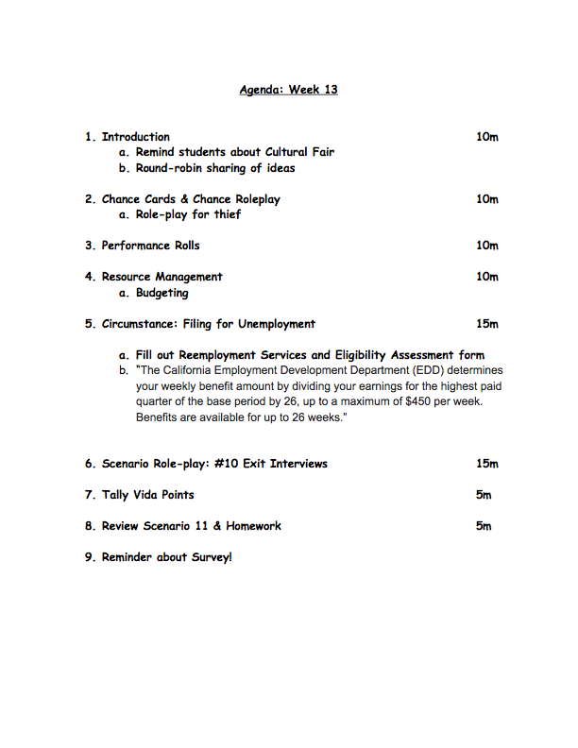
Figure 1 – Agenda for Week 13
More formally, we wanted to engage the students in the following ideas and concepts, and have them practice their Spanish fluency in regards to these concepts:

- Leaving a job and conducing an exit interview with their supervisor detailing their experiences of and reasons for leaving.
- Filing for unemployment benefits, and understanding how the amount of benefits is calculated.
- Reviewing their written resumes with one another, and preparing for writing cover letters for new job opportunities.
- Continuing with the tasks of managing their budgets and schedules, with the new circumstance of their pending unemployment making an impact on those tasks.
- Following up with any divergent narrative story lines created by players (such as one player deciding to conduct a robbery on someone they know).
- Continuing to plan for the Cultural Fair that is to occur during their finals week, where they present artifacts and information about their character’s cultural background to one another.

Materials list
Students were required to have their character sheets on hand, the narrative they wrote the week previous, and they should have also a draft of their resumes that they worked on from the week previous. We provided a set of questions the previous week for conducting an exit interview as a supervisor, and each student was required to bring those questions translated into Spanish.
As game administrators, we had several six-sided dice for the random elements in the game, and we brought with us copies of unemployment applications in Spanish for the students to fill out as their characters. We also brought with us our weekly agenda and as was our normal practice, we emailed links to the scenario descriptions for the week previous, the current week, and the week to follow.

Into
We started our day with a quick focus on the upcoming Cultural Fair, as we knew this was a stressful time with finals and term papers, and we wanted to grab the students’ attention for the class with something that they might be looking forward towards as a potential fun activity. There were only a few weeks before finals, so we wanted to have the kids think about their characters and come up with some solid ideas which they could use in their presentations. We had the kids take a few minutes of quiet contemplation, looking over their character sheets, and finding at least one element of their character that they would like to illuminate, and to think up a single idea of an artifact they could create or find and bring, or some performance (some wanted to do a cultural dance) that they could present. We then went around the room and had each student report on their ideas to the class. This provided a few teachable moments around cultural sensitivity and unconscious stereotypes, as some kids wanted to bring in fried chicken for their African-American characters, or tacos for their Mexican characters. While we did not reject these ideas out of hand, we did make sure to emphasize that we wanted these presentations to be authentic to their characters, and not just a shallow stereotype. For example, we said if your character comes from the south and has a family recipe for fried chicken that is important to them, this would be an authentic expression of that idea. We also had some students wondering what they should do as a cultural expression if they were ‘white’ — one suggested bringing in Starbucks. We challenged these students to think beyond the ‘white’ label (which we identified not as an ethnicity, but rather as a power relationship) and consider where their people came from, be it parts of Europe, Western Asia, etc.

After the brainstorming and reporting, we had the students bring out their character sheets in preparation for the next phases of the game, along with copies of their resumes that they had worked on in the previous week, and their translated questions for the exit interviews they were to conduct later in the class.

Through

After this brainstorm and reporting, we moved into resolving Chance cards (a collection of potential random occurrences detailed in Appendix H), and during this phase, I pulled aside the one student with an unresolved divergent story line around a burglary they were conducting, and ran them through a mini-encounter scenario. I had required this student to write for me, in Spanish, a detailed plan of the theft they were to conduct, and I checked over with him that there were no missing details that he might want to include. I then had this player roll against their skills relevant to the burglary, and we told a story together about what happened. Because I had my own hidden agenda around showing that ‘crime does not pay’, I was very realistic around what types of evidence might have been left at the scene, and despite a relatively careful plan, the encounter ended with a police officer knocking on his door several days later and bringing him in for questioning.

We continued with our normal phases, including job performance rolls (the last they would conduct at this current employer — it was important to illuminate that often job termination comes with notice time of a few weeks on average), and resource management (budgeting would become tougher next week after their monthly salary was replaced with unemployment benefits). I used the dice to determine new stock prices for those who were involved with investments, and one person turned up a Chance card that affected the whole class by raising federal interest rates by 1%, affecting anyone with an outstanding loan.

As the class circumstance, we had all students fill out forms in Spanish for unemployment benefits, both to introduce them to the concept of unemployment benefits and to have them understand the amount and duration given, and to have them practice their Spanish in reading the form and filling it out with their information.

After filling out forms for unemployment, we performed our exit interviews (see Appendix F, Scenario 10) with the students pairing up and spending 7-8 minutes each interviewing one another, with one student playing their character, and the other standing in as their supervisor. They were to use their character sheets and newly-completed resumes as reference, as well as the translated exit interview questions, and the interviewer was to record the responses of the employee on paper and give them to the player after the interview is conducted to add to their character portfolio. The interviewer was also to give a score on the rubric given that also equates to their earned Vida Points. The player then would record those VP on their character sheets to spend on character advancement next game session.

Beyond
In filling out their unemployment forms, students encountered vocabulary with which they were not always completely familiar, and those items we instructed them to write down and investigate over the coming week. The completed forms became part of their character portfolio, along with their first draft of their resumes, and the results from their exit interviews.

The assignment for the following week is for students to write a cover letter for their resumes to a job of their choosing for their character. This requires them to do a little research online and either select a job they find, or to invent one with a description of job responsibilities and qualifications. We will present to them an assortment of job listings, and we will have students interview each other for several different jobs in class next week. There will be continued work on the Cultural Exchange Fair, as it is to occur in two sessions time.

All artifacts that are created will become part of the students’ Character Portfolios, and the narrative for each character of course continues. Any divergent narratives will continue to resolve as well, such as our burglary case.

Evaluation

Many evaluation measures are built into the game play, but we can call out a few in this lesson:
- Reviewing character sheets throughout the game gives an indication of student progress in achieving the goals of the game, and will give further indication on how well the students understand the concepts needed to work through the phases of the game. If many or most of the students show consistent problems in their character sheets, this may be a strong indication that the curriculum or the teaching of the curriculum needs improvement.
- All students are encouraged to record their reflections and thoughts in a weekly Player / Character Journal, and those journals give a strong qualitative measure of a student’s learning. If many students show indication in their journals of difficulty with either the curriculum or the way it is being taught, this would be a strong resource to help with improving shortcomings.
- This session starts with an individual brainstorm on their characters and their participation in the Cultural Exchange Fair. Students’ ideas and responses from this brainstorm shows how well the students are connecting with the project, and helps evaluate the learning happening in the game.
- Discussions between student players and game administrators / instructors happen periodically throughout the class, and these interactions help instructors evaluate the students’ learning, as well as the success of their curriculum and their teaching.
- Role-Play Scenarios help students gauge one another’s proficiency and learning, and as instructors listen in, they are also able to evaluate the students’ learning, and the effect of their curriculum.
- Periodically, we administer student surveys to help us measure the effectiveness of the curriculum and our teaching, and any issues from this lesson hopefully will surface in that survey process.
- All artifacts created in the game become part of the students’ Character Portfolios. This lesson contributes several artifacts, such as a completed unemployment application form, notes and scores from the role-play scenario, plus any change made to the student’s character sheet. The Character Portfolio gives a great deal of information to instructors as to the effectiveness of their teaching the curriculum, and the students’ learning from that curriculum.
- This session we ask students to research potential jobs for which to complete a cover letter from their resume. The results of that research help evaluate student learning.
- Throughout the class session, the instructors have ample opportunity to listen and observe the game play of the students, especially during role-play scenarios. This helps in assessing the curriculum, and student learning.
- Any material covered in this lesson may be used in periodic oral or written exams; in our pilot play test, the instructor intends on using situations from the game and details from characters in essay questions and oral examinations for grading the term.

APPENDIX A: Unit Syllabus and List of Lessons

OVERVIEW
This syllabus and list of lessons is a basic plan for our pilot program, and is subject to change given the input from students, the instructor, and the consequences of our game play. Our curriculum is designed to work in concert with objectives set forth by the instructor, allowing the instructor to create his or her own assignments and activities in concert with our weekly topics.

Each week is described by several sections:

CLASS TOPIC
This is the general topic for the day or week of game play, and describes what material or subject our conversation in class will entail. This may take the form of explanation from the game administrator or instructor to students, through group reading, group discussion, or a combination of activities thereof. A CLASS TOPIC might also be reinforced by work given to the students throughout the week before the game class session, held once a week with the game administrators.

CIRCUMSTANCE
The CIRCUMSTANCE of the game day is a shared situation to which each player must react as their character in the game. It might involve some complication of their life for which they must make affordance, or create a reality that changes the game in some significant way. The CIRCUMSTANCE is presented to the class together as a whole, though the individual interaction with that CIRCUMSTANCE may vary from player to player and character to character. Future versions of the game might have this be more contextually tailored to each student and player, and the same CIRCUMSTANCE may not necessarily be presented to the entire class.

ROLE-PLAY SCENARIO
The ROLE-PLAY SCENARIO describes the topic or situation to which the students are expected to act out verbally (and sometimes physically) with groups of their peers. These ROLE-PLAY SCENARIOS are the primary way during the game that students are meant to practice Spanish grammar and vocabulary within the context of their characters within the game. Each ROLE-PLAY SCENARIO is performed with at least one partner, and each participant is given an assessment from their peers for their fluent use of Spanish, their realism in the situation, and their ability to stay in the perspective of their character. The assessments are turned into Vida Points, which each player may spend on advancing their character in their goals.

HOMEWORK
The HOMEWORK given each week is designed to prepare the student for the next week’s game participation, and may take the place of research (such as discovering the classes offered by a chosen college), a written assignment (such as a background for the player’s character), or the creation of an artifact of the game (such as creating a resume for the player’s character). The artifacts created by the HOMEWORK assignment also become part of the player’s portfolio.

DESCRIPTION
While I endeavor for brevity, this section gives some small amount of information as to what is to be expected in the content of each weekly lesson. This DESCRIPTION, like the rest of this syllabus, is intended for the instructor and/or game administrators to understand in brief what is to be presented. Each lesson will have its own detailed write-up and accompanying student handouts.

SEMESTER 1

The first semester is meant for the class to learn the ins and outs of the game, and to play the game at a close time scale (one week of real time equals one month of game time). We provide scaffolding for the students to understand the game and its mechanics, and slowly remove that scaffolding as we proceed. Several times through the first semester, we take a step back and discuss the game play as a class; how is it working, does it make sense, how can we improve the experience, etc.

Week 1 “YEAR 1: JUNE” Sep 1 & 2
CLASS TOPIC: Character Creation / Learn Game Mechanics
CIRCUMSTANCE: None
ROLE-PLAY SCENARIO: None
HOMEWORK: Think on your character’s background and personality.

DESCRIPTION:
On the first day of our game, our goal is to create some scaffolding for the students to understand what the game is about, how to play, and primarily how to create their characters. We work with the students in creating their characters and filling out the provided character sheets. The homework is for each student to consider their character, with all their traits as randomly or personally selected, and think about who they are as people. What makes them tick, what do they like, dislike, hope for, fear, etc. This thought experiment will prepare the students for the role-play scenario next week.

Week 2 “YEAR 1: JULY” Sep 8 & 9
CLASS TOPIC: Finish Character Creation / Learn Game Mechanics
CIRCUMSTANCE: None
ROLE-PLAY SCENARIO: #1 Character Connections
HOMEWORK: Create a version of your character that has completed his/her
goals.

DESCRIPTION:
During this session, we continue our game mechanics explanations, and scaffold the players through finishing their characters, and understanding more of the game play. The homework is for each student to envision their character in the future, after they have achieved their goals and using the game mechanics, craft a version of their character sheet that matches this future self. This exercise will both give each student a tangible target for their character in the game, and will prepare them for the role-play scenario next week. The role-play scenario this week is designed to get the players to create and express connections between their characters in the game.

Week 3 “YEAR 1: AUGUST” Sep 15 & 16
CLASS TOPIC: Budgeting
CIRCUMSTANCE: Communications and conflict at home
ROLE-PLAY SCENARIO: #2 Future Planning
HOMEWORK: Prepare for a break room conversation about your character’s life.

DESCRIPTION:
During this session, we introduce the concept of budgeting into the game, and set the students up with budget sheets. We go over standard budget percentages for different life expenses, and encourage the kids to make decisions on how they’d like to spend their paychecks. Money can be a point of conflict in a family, so we created a circumstance that emulated that sort of internal family conflict. Many of the students in character creation chose to live at home to reduce their monthly costs, and not all of them chose to contribute to the family expenses from their work. Depending on each character’s choices of whether to contribute to family finances, and depending on the character’s communication skills, different results could result from family harmony to being asked to leave and get their own place. The homework is to prepare topics of discussion for a workplace conversation in next week’s role-play scenario. This week’s role-play scenario is designed to have each student in the perspective of their character introduce themselves and speak about themselves from the future when they have achieved their goals.

Week 4 “YEAR 1: SEPTEMBER” Sep 22 & 23
CLASS TOPIC: Introducing College Admissions
CIRCUMSTANCE: Public Transportation Failure
ROLE-PLAY SCENARIO: #3 Break Room Conversation
HOMEWORK: Prepare for workplace issues meeting at work.

DESCRIPTION:
This session we broaden the scope of the game through the introduction of skill and career advancement through formal education. We introduce mechanics around learning through a school or university vs. through a mentor or on one’s own, including topics such as college admission and grades. Our circumstance covers public transportation as a concept, and effects those that rely on public transit for getting to work and school. This week’s role-play scenario has every student sit in a work group and discuss elements of their daily lives together. This week’s homework has each student do some online research around specific workplace issues (Job Safety, Discrimination, Sexual Harassment, etc.) and be prepared to present this information in character at a workplace meeting.

Week 5 “YEAR 1: OCTOBER” Sep 29 & 30
CLASS TOPIC: Investments and Managing Debt
CIRCUMSTANCE: Acquiring Debt
ROLE-PLAY SCENARIO: #4 Rules of comportment in the workplace meeting.
HOMEWORK: Create a weekly schedule for your character.

DESCRIPTION:
This week we introduce the concept of investments and debt, and the associated game mechanics. As a circumstance, we require everyone to take on some debt in the form of an adjustable-rate loan. Our role-play scenario has the students use the information they researched over the week on workplace issues, and discuss in a mock group work meeting, organized by one student who serves as the supervisor and facilitator. This week’s homework asks students to create a schedule for work, school, and personal time for their character.

Week 6 “YEAR 1: NOVEMBER” Oct 6 & 7
CLASS TOPIC: Discussing the game as a class #1
CIRCUMSTANCE: None
ROLE-PLAY SCENARIO: #5 Discuss your weekly schedule with co-workers.
HOMEWORK: Prepare for your performance reviews.

DESCRIPTION:
This week we participate in our first student feedback session, at which we ask our student players about the efficacy of our game, in terms of enjoyment, engagement, and efficacy in learning. During our role-play scenario, we take the schedules the students have created over the last week and use them in conversation with other students in character about their work weeks and scheduling issues. Homework this week is to prepare for our first mock performance reviews, both as employees being reviewed and as supervisors reviewing others.

Week 7 “YEAR 1: DECEMBER” Sep 13 & 14
CLASS TOPIC: Modifications to game and new character sheets
CIRCUMSTANCE: Rumors of company downsizing
ROLE-PLAY SCENARIO: #6 Performance reviews.
HOMEWORK: Prepare for a phone interview as your character’s future self.

DESCRIPTION:
This week we introduce modifications to the game system and character sheets created in response to student feedback last week, and our own analysis of the efficacy of the game. The circumstance for this week introduces the idea of job insecurity through rumors, and demonstrates the effect such news can have on morale. The role-play scenario this week ask our students to conduct performance reviews for their characters, and the homework prepares students to conduct and participate in phone interviews from the perspective of their characters in the future.

Week 8 OUT OF GAME SESSION Sep 21 & 22
CLASS TOPIC: Update characters into new character sheets
CIRCUMSTANCE: None
ROLE-PLAY SCENARIO: #7 Telephone interviews in target profession.
HOMEWORK: Prepare for being shadowed on your character’s job (#8-1).

DESCRIPTION:
This week we continue updating our new character sheets, and explain further the changes in the game system. Our role-play scenario has our students interview each other in a mock phone informational interview where the interviewer asks the character-as-future-self about their career. Our homework this week asks our students to prepare, together with their company groups, a narrative about their typical day at work to be used in our future role-play.

Week 9 “YEAR 1: JANUARY” Sep 28 & 29
CLASS TOPIC: Job Shadows
CIRCUMSTANCE: Performance Review Results
ROLE-PLAY SCENARIO: #8-1 Write about your character’s job and discuss with work group.
HOMEWORK: Prepare for being shadowed on your character’s job (#8-2).

DESCRIPTION:
This week we go into more depth about the concept of job shadowing, and instead of a role-play scenarios, we have the students spend time in class finishing their narratives about a typical day at work. Our circumstance is discussing the results of the performance reviews conducted by the students and adjusting information on the player’s character sheets based on those results (raises, promotions, demotions, fires, etc.) This week’s homework is to continue preparing for our job shadow role-plays.

Week 10 “YEAR 1: FEBRUARY” Nov 3 & 4
CLASS TOPIC: Going deeper with your character’s background and personality.
CIRCUMSTANCE: None
ROLE-PLAY SCENARIO: #8-2: Job shadow role-play.
HOMEWORK: Write a 2-page detailed background of your character.

DESCRIPTION:
This week we spend time discussing with the students about creating a deeper connection with their characters, and assign homework to create a 2-page written background for their characters, including personality and background details. This week’s role-play scenario is enacting job shadows for one another in groups of three: one person is the shadowing interviewer, one is the employee, and one takes notes on questions and answers taken.

Week 11 OUT OF GAME DISCUSSION Nov 17 & 18
CLASS TOPIC: Class feedback on game 2
CIRCUMSTANCE: None
ROLE-PLAY SCENARIO: None
HOMEWORK: Finish online survey about game.

DESCRIPTION:
This week, we have another class reflection on the game, breaking into groups and discussing key elements of the game, then sharing results with the entire class. We assign as homework a survey that mirrors the questions asked in each group.

Week 12 “YEAR 1: MARCH” Dec 1 & 2
CLASS TOPIC: Getting or Giving Notice / Resumes
CIRCUMSTANCE: Leaving your job (Quit / Fire / Lay-off)
ROLE-PLAY SCENARIO: #9 Discuss written detailed background
HOMEWORK: Write first stab at resume

DESCRIPTION:
This week we prepare the students to write resumes for their characters, and create a circumstance where the students must leave their jobs. For our role-play scenarios, we have the students discuss in Spanish their character backgrounds, and for homework each student creates a first attempt at a resume for their characters.

Week 13 “YEAR 1: APRIL” Dec 8 & 9
CLASS TOPIC: Are you prepared for unemployment? / Writing a cover letter.
CIRCUMSTANCE: Filing for Unemployment (if you qualify)
ROLE-PLAY SCENARIO: #10 Exit Interviews
HOMEWORK: Write first stab at cover letter / Prepare for job interviews and fair.

DESCRIPTION:
We continue this week discussing the importance of a resume cover letter to the students as part of a job application, and prepare our students to write a cover letter for homework, along with preparing themselves for holding job interviews at a mock job fair. This week’s role-play scenario asks the students to conduct job exit interviews for one another.

Week 14 “YEAR 1: MAY” Dec 15 & 16
CLASS TOPIC: Briefly discuss plans for rest of class; Reviewing resumes and cover letters together; Discuss Job Application forms.
CIRCUMSTANCE: Pick three jobs for which to interview from job listings at fair
ROLE-PLAY SCENARIO: #11 Job interviews at a job fair
HOMEWORK: Plan for Cultural Exchange Fair

DESCRIPTION:
This week we disclose to the class our plans for how the game is to change in the next semester, and have the class review their resumes and cover letters with one another. We also discuss job application forms and how they play a role in finding employment. Our circumstance is to have each student pick three jobs for which to interview, and we run those interviews during our role-play scenario. The class homework is to prepare for a cultural exchange fair, allowing each student to bring food and/or other cultural artifacts related to their character in the game.

Week 15 “YEAR 1: JUNE” FINALS
CLASS TOPIC: None
CIRCUMSTANCE: None
ROLE-PLAY SCENARIO: #12 Cultural Exchange Fair (all of class)
HOMEWORK: N/A

DESCRIPTION:
This week is finals week, and we have our students use the entire class period to hold mini presentations on their cultural items. This may take more than one day, and could extend to multiple days during this week.

SEMESTER 2

In semester 2, we speed up the pace of the game so that each week covers a quarter of the year, allowing a faster progress for characters to achieve their final career goals. We will spend less time on the minutiae of game mechanics and more time on highlighting individual topics and issues related to work and career.

Week 16 “YEAR 2: SUMMER” Jan 12 & 13
CLASS TOPIC: New Jobs, New Responsibilities, New Game Speed
CIRCUMSTANCE: Reading, negotiating and signing your Employment Contract
ROLE-PLAY SCENARIO: #13 Meeting the new team and new boss
HOMEWORK: Research your school / college of choice and use their course catalog to plan your character advancement. Create a career advancement chart and poster.

DESCRIPTION:
This week we introduce the details of our altered game pace and mechanics, and attempt to move the game from abstractions to more practical representations. In the new semester, every character has a new job, and we spend our circumstance time reading, negotiating, and signing mock employment contracts. During our role-play scenarios, we have the students meet and interact with their new teams and bosses, and for homework we have students research a real school or college of their choosing, and they must find and use that school’s course catalog in their plans for their character’s skill and career advancement. During the week, we will also have students create an individual career advancement chart and collaborate on a group advancement poster to track their progress.

Week 17 “YEAR 2: FALL” Jan 19 & 20
CLASS TOPIC: Workplace bonding - making new friends.
CIRCUMSTANCE: Group Dynamics - Personality Testing at Work
ROLE-PLAY SCENARIO: #14 Discussing results of personality test.
HOMEWORK: Prepare for Performance Reviews 2

DESCRIPTION:
Continuing with the theme of new jobs and new environments, we discuss issues surrounding workplace friendships and working relationships. We use our circumstance time to conduct a brief personality test, and for our role-play scenario we discuss the results of that personality test in character. This week’s homework is for the students to prepare for a performance review in their character’s new job.

Week 18 “YEAR 2: WINTER” Jan 26 & 27
CLASS TOPIC: Workplace Discrimination
CIRCUMSTANCE: You are a victim of / witness of workplace discrimination.
ROLE-PLAY SCENARIO: #15 Performance Reviews 2 (discuss new responsibilities)
HOMEWORK: Write a love letter to a co-worker or write a report of sexual harassment you have witnessed at work.

DESCRIPTION:
This week we discuss issues of workplace discrimination, and we bring in elements of the character’s background into the circumstance, having the students play characters that are either witness to or victims of workplace discrimination. During the role-play scenario, we have the students conduct their second performance reviews for one another, focusing on issues of their new responsibilities, as well as bringing in the details of their experience with discrimination. Homework this week prepares the students to discuss issues of dating, romance and sexual harassment in the workplace by having them either write a love letter to a co-worker, or have them write a report of sexual harassment they witness at work.

Week 19 “YEAR 2: SPRING” Feb 2 & 3
CLASS TOPIC: Dating and Romance / Sexual harassment in the workplace.
CIRCUMSTANCE: You are being gossiped about at work, or you are a victim of /
witness of sexual harassment at work.
ROLE-PLAY SCENARIO: #16 Proclaim your affections to your beloved -or- Let someone down easy.
HOMEWORK: Plan a summer vacation and prepare to ask for time off -or- Request Maternity / Paternity leave.

DESCRIPTION:
This week we discuss dating, romance and sexual harassment in the workplace. For our circumstance, each student either finds themselves the subject of workplace gossip (in the case of romance) or are witness to or victims of sexual harassment. During our role-play scenario, the students will role-play a romantic encounter with another student that is either received with reciprocation, or with rejection. This week’s homework will be for students to plan a summer vacation, time off, or leave and to prepare to ask their supervisor for time off.

Week 20 “YEAR 3: SUMMER” Feb 9 & 10
CLASS TOPIC: Requesting Vacation Time or Sick/Maternity/Paternity leave.
CIRCUMSTANCE: You get a new manager / supervisor who isn’t so nice.
ROLE-PLAY SCENARIO: #17 Request vacation time or maternity/paternity leave from your new supervisor / manager.
HOMEWORK: Research issues around dress code and hygiene in your workplace.

DESCRIPTION:
This week we discuss how to request time off, either as vacation, sick leave, or maternity/paternity leave. The circumstance for each student is for their characters to have a manager switch that is fraught with a personality conflict. The role-play scenario this week is to request time off or leave from their new, less-than-cooperative supervisor or manager. This week’s homework will be to research issues around workplace dress codes and workplace hygiene.

Week 21 “YEAR 3: FALL” Feb 16 & 17
CLASS TOPIC: Dress Codes and Hygiene in the Workplace
CIRCUMSTANCE: You catch an illness due to improper hygiene at work.
ROLE-PLAY SCENARIO: #18 You are witness to / guilty of a dress code or hygiene violation at your workplace.
HOMEWORK: Prepare for Performance Review 3

DESCRIPTION:
This week we discuss issues of workplace dress codes and hygiene. Our circumstance this week is that each student’s character catches an illness that is linked to improper hygiene at work. This week’s role-play scenario has our students’ characters be witness to or guilty of a dress code or hygiene violation at work. This week’s homework is to have the students prepare for a third performance review.

Week 22 “YEAR 3: WINTER” Mar 2 & 3
CLASS TOPIC: Drug testing and abuse in the workplace
CIRCUMSTANCE: Mandatory drug testing; do you pass/fail?
ROLE-PLAY SCENARIO: #19 Performance Review 3 (include discussion of drug testing) Gift Exchange at work - reveal cultural differences.
HOMEWORK: Prepare for a class discussion on game

DESCRIPTION:
This week’s class discussion is about drug use, drug testing, and drug abuse in the workplace. The circumstance for this week has the students’ characters be subject to a mandatory drug test, with varying results. This week’s role-play scenario is the student’s third round with performance reviews, including a discussion of their drug test results, and we will conduct a mini gift exchange between characters to reveal and discuss cultural differences. Our homework this week is to have the students prepare for another all-class discussion of the game.

Week 23 “YEAR 3: SPRING” Mar 9 & 10
CLASS TOPIC: Class discussion on game #3
CIRCUMSTANCE: N/A
ROLE-PLAY SCENARIO: Group and class discussion on game.
HOMEWORK: Complete online survey; Research worker’s compensation and job safety; how would your character be affected? Write up a worker’s compensation claim and be ready for a role-play.

DESCRIPTION:
This week we spend our class time in a full-class discussion on our game so far, how the mechanics and the narrative are advancing, and how the class feels about the effectiveness of the current game version. For homework, we will have the class finish another survey relating to the game, and we will have them research issues of workers’ compensation and job safety, and write up a worker’s comp claim for their character.

Week 24 “YEAR 4: SUMMER” Mar 30 & 31
CLASS TOPIC: Hazards in the Workplace, Job Safety, Ergonomics
CIRCUMSTANCE: You suffer an injury out of work and you are forced to take time off.
ROLE-PLAY SCENARIO: #20 You suffer a workplace injury and must file a workers’ comp claim
HOMEWORK: You have displeased a customer at your workplace. Prepare for a role-play concerning this incident.

DESCRIPTION:
This week we discuss issues of workplace hazards, job safety and ergonomics. The circumstance this week is that each player’s character suffers an injury out of work and must take time off for recovery. Our role-play scenario is for each player’s character to suffer a workplace injury and file a worker’s compensation claim. This week’s homework is to have each student prepare for a role-play around the student’s character having displease a customer at work.

Week 25 “YEAR 4: FALL” Apr 6 & 7
CLASS TOPIC: Theft at the workplace; appropriate use of work property
CIRCUMSTANCE: An important piece of equipment you use at work goes missing.
ROLE-PLAY SCENARIO: #21 You have displeased a customer at your workplace; role-play issue with supervisor.
HOMEWORK: Prepare for performance reviews / revise resumes / future plans.

DESCRIPTION:
This week we discuss issues of theft at the workplace, including appropriate vs. inappropriate use of work property. This week’s circumstance is that an important piece of workplace equipment goes missing that the student’s character interfaces with on a regular basis. This week’s role-play scenario is for each student to role-play as their character a meeting with their supervisor to discuss an issue where the character has displeased a customer. The homework this week is to prepare for another round of performance reviews, as well as having the students revise their character’s resume, and to have them make plans for their character’s future regarding their position at their work and their overall career goals.

Week 26 “YEAR 4: WINTER” Apr 13 & 14
CLASS TOPIC: Workplace communications
CIRCUMSTANCE: You are responsible for answering the phone and must record several messages for your supervisor.
ROLE-PLAY SCENARIO: #22 Performance Reviews 4 (discuss pathways for promotion) Gift Exchange mishap.
HOMEWORK: Write a cover letter for 3 new job opportunities.

DESCRIPTION:
This week we will discuss issues around appropriate and effective workplace communications. Our circumstance will be a practice in recording phone messages. Our role-play scenario will be the fourth round of performance reviews, but focusing on career development and pathways to promotion. We will also role-play a gift exchange mishap, where some cultural or social norm is violated and the students will work out the misunderstanding. Our homework will be writing separate cover letters for three new job opportunities.

Week 27 “YEAR 4: SPRING” Apr 20 & 21
CLASS TOPIC: Exploring new employment opportunities.
CIRCUMSTANCE: You must cancel a work meeting on short notice.
ROLE-PLAY SCENARIO: #23 Interviewing for a new position / job.
HOMEWORK: Write a professional email to your supervisor requesting time off (3 days) for personal reasons.

DESCRIPTION:
This week’s topic will be about exploring new employment opportunities, such as going on job interviews while still employed, and how to handle the difficult communications in that environment. Our circumstance will be a practice in canceling a work meeting on short notice, via phone call, email, and in-person conversation. Our role-play scenario will have the students interview one another for new job positions at the same company or new jobs at new companies. Homework this week will have students as their characters write a professional email to their supervisor requesting 3 days off for personal reasons.

Week 28 “YEAR 5: SUMMER” Apr 27 & 28
CLASS TOPIC: Training interns and new hires
CIRCUMSTANCE: You are assigned an intern or new hire under your supervision.
ROLE-PLAY SCENARIO: #24 Written work email exchange in class.
HOMEWORK: Prepare for a job skills training exercise.

DESCRIPTION:
This week’s class topic will be about training interns and new hires, and the related issues and responsibilities. The circumstance this week has our students as their characters receive an assignment of a trainee (intern or new hire) – they must make introductions with this individual and schedule a time at work to conduct a skills training session. Our role-play scenario this week has the students as their characters conduct a back-and-forth work email exchange on a given subject, following proper business email and communications etiquette. Our homework this week has the students preparing for the job skills training exercise as their character with their assigned trainee.

Week 29 “YEAR 5: FALL” May 4 & 5
CLASS TOPIC: Volunteerism
CIRCUMSTANCE: Your work asks you to give volunteer hours to a local charity.
ROLE-PLAY SCENARIO: #25 Job skills training for new hire / intern
HOMEWORK: Prepare for Performance Review 5 (discuss volunteer activity)

DESCRIPTION:
This week’s topic is on volunteerism, how it relates to work life, and how it differs from normal employment. Our circumstance this week is that each student’s character is asked by their employer to donate some time to a local charity in volunteer hours. Each student must decide on the charity, what they would be doing, when it will happen, and what the outcome of the volunteering might be. The role-play scenario this week has students as their characters train an intern or a new hire in some task they must perform under your supervision, and have that intern/new hire successfully ‘perform’ the task (verbal or pantomime). This week’s homework is to prepare for their fifth performance review, focusing on their volunteer activity.

Week 30 “YEAR 5: WINTER” May 11 & 12
CLASS TOPIC: Health Insurance and Other Work Benefits
CIRCUMSTANCE: You must use an out-of-network health provider which your insurance may or may not cover.
ROLE-PLAY SCENARIO: #26 Performance Review 5
HOMEWORK: Revise resume, Work on portfolios

DESCRIPTION:
This week’s topic will discuss the issue of work benefits, such as health insurance, matching 401(k) contributions, and other possible employer-provided benefits. This week’s circumstance has each student as their character deal with the communications necessary to try and get their health insurance company to pay for an out-of-network medical provider through phone calls and/or filling out forms. Our role-play scenario is the fifth and final performance review for each student’s character, focusing on issues of volunteerism. The homework this week has the students spend time revising their character’s resume and working to complete elements of their class portfolio.

Week 31 “YEAR 5: SPRING” May 18 & 19
CLASS TOPIC: Investment and retirement
CIRCUMSTANCE: Stock market takes a nosedive.
ROLE-PLAY SCENARIO: #27 Discuss plans for investment and retirement
HOMEWORK: Complete Portfolios for class review and presentation.

DESCRIPTION:
This week’s topic will be discussing issues of investment and retirement, and our class circumstance is dealing with a stock market that takes a nose dive, and how it affects the character’s retirement and investment portfolios. Our role-play scenario will be group discussions in character about investment and retirement plans, and the homework this week is for the students to continue to complete their portfolios in preparation for a class review and presentation.

Week 32 “YEAR 6: SUMMER” Jun 1 & 2
CLASS TOPIC: Determining Success and Aiming for the Future.
CIRCUMSTANCE: None
ROLE-PLAY SCENARIO: Portfolio Review with Class (full class period)
HOMEWORK: None

DESCRIPTION:
This is our last session, and we will be focusing on issues of what we have learned from the game. We will discuss whether each student’s character has been successful in their career and life pursuits, and how they might continue to aim for their future success. The class role-play will be presenting their character portfolios to one another.

APPENDIX B: El Juego de la Vida – Player’s Handbook
Note: This document is incomplete, has gaps and holes, and needs revision. I’ve included this in the Appendix to show the kinds of details that go into playing the game, but we are still crafting and working through the mechanics as we play. After our play test, we will revise this document to more fully reflect the mechanics of the game. The intent of this document is to serve as a resource for students playing the game and instructors administering the game to understand the game mechanics.

Table of Contents

- Introduction to The Game of Life
  - Understanding the Goal of The Game of Life

- Creating and Understanding Your Character
  - Skills
  - Advantages and Disadvantages
  - Assets
  - Schedule and Time Management
  - Background (Demographics and Socio-Economics)
- Playing the Game
  - Typical Game Session Agenda
    - Character Improvement
    - Resource Management
    - Chance
    - Circumstance
    - Performance Rolls
    - Scenario Role-Play
    - Awarding Life Points
    - Review and Preparation
- Bibliography and References

Introduction to The Game of Life
Creating and Understanding Your Character

Skills
I have *learned* this.
Skills should be specific and teachable.

Advantages
I can *do* this, or this is true about me

Assets
I *have* this.

Schedules and Time Management
- Full-Time Work is 40 hours a week or more.
  - Hourly positions are eligible for overtime pay; salaried positions are not.
- Part-Time work is generally between 1 and 20 hours a week, but can be more (up to 40).
- Part-Time school is enrollment in 1-3 classes
- Full-Time school is enrollment in 4-6 classes.
- Each class requires 3 hours of time investment a week in classes (3-1 hr classes, 2-90 min classes, or 1-3 hr. class is typical), plus 1-2 hours of homework a week (with bursts of work for finals, term papers, etc.

Schedule overload: If anyone is working for more than 70 hours a week (including employment and school), they are experiencing overload, and all performance rolls (school and work) are reduced by -1. If anyone is working for more than 100 hours a week, include an ADDITIONAL -2 to their performance rolls)

Background (Demographics and Socio-Economics)
Your character will have two values for your socioeconomic status (or SES): one that covers their family of origin, and one that covers their current SES. SES is important to your character in the way that you are treated, what schools you can go to, what jobs you can get, interest rates on loans, and other factors.

This reflects where your character has come from, specifically: what was/is your family’s background. This is designated as Low, Mid or High and is used to determine some basic facts about your character, as well as initial interest rates on loans.

Playing the Game

Typical Game Session Agenda
- Character Improvement
  - Increasing skills, buying assets and advantages, buying off disadvantages
  - Use vida points earned last session
- Resource Management
  - Paying Bills (use money from last session)
- Chance cards (and associated roleplay)
  - VP earned can be spent immediately or held
- Circumstance
  - VP earned can be spent immediately or held
- Performance Rolls
  - Payday (hold money until next session)
- Roleplay of weekly scenario
  - VP earned must be held to tally phase.
- Tally up vida points earned this session
  - Include points earned during chase, circumstance, and roleplay.
  - Keep running total of all points spent, all points earned, and current pool.
- Review of next week’s scenario and associated preparation.

Character Improvement
General advice:
- Plan for the future
- Think broadly about your character
- Consider the whole person

See “Using Vida Points” section below
Resource Management
Each week players must track and manage their monetary resources. They do this by
- Paying themselves their monthly salary (adding their monthly income to their current balance minus any deductions resulting from “Chance!” or Performance Evaluations),
- Deducting their monthly expenses
- you must pay ALL your bills. If you go negative in your bank balance, you have not paid all your bills, and you must decide what gets paid, and what you do not pay. Late and unpaid bills can have consequences.
- Adding the remaining balance (income minus expenses) to their “Current Balance.”

Players may also purchase new Assets during this phase, subtracting the cost from their current balance and keeping a record of costs and date of purchase.

Chance!
During the “Chance!” phase, each player rolls a 6-sided die. On a result of 1, 2 or 3 the player must randomly choose a “Chance!” card from the deck. Some “Chance!” cards are beneficial, some present challenges and some do both. Players must read their chance cards carefully and follow instructions to resolve that card. Instructions may include a die roll, a VP or monetary expenditure and/or a scene that must be roleplayed. If there is a scene for roleplay, players self-evaluate (as per rules for Scenario Roleplay, see below) and can earn VP. Players may also be given an opportunity to roleplay their “Chance!” cards in front of the whole class for bonus VP.

Circumstance
Circumstances are provided by the Game masters and usually affect the entire class. Such circumstances might be an increase in loan interest rates, or some other event that affects many or all characters in the game.

Performance Rolls

Job Performance Rolls:

Each performance roll is made on a base single six-sided die roll, to which the player adds their character’s top skill in the job they are performing (or a multiple set of rolls, depending on the job - we need to think about skills, and skill trees, etc.), and adding in bonuses from related advantages and assets, and finally deducting penalties from disadvantages.

The roll is made, and the player subtracts the target for their profession from the total of the roll (plus the related skill and any modifiers). Once players have this “weekly performance roll score,” they then add it to their “Overall performance score.”

Example 1:

What is your target?
“Player A” has a job that requires a performance roll at target 3 each week.

What is your highest rated skill related to your job?
“Player A’s” highest rated skill related to their job is “Critical Thinking” at rank 2.

Do you have Chance! or Circumstance that adds or subtracts from your performance roll this week?
“Player A” has no Chance! card or Circumstance that adds or subtracts from their performance roll.

Roll a d6.
“Player A” rolls a six-sided die and gets a result of 2.

Add your die result to your highest skill then add/subtract any performance modifiers for your final result.
“Player A” adds their die result (2), to their highest rated skill (2) and gets a 4 (2+2 =4).

Subtract your target from your final result to calculate your Weekly Performance Roll Score for the week.
“Player A” then subtracts their target of 3 from their final result of 4, getting a Weekly Performance Roll Score of 1 for the week (4-3 =1).

Add your Weekly Performance Roll Score to your Overall Performance Score.
“Player A” then adds their Weekly Performance Roll Score to their Overall Performance Score, keeping a cumulative total that increases or decreases from week to week.

Example 2:

What is your target?
“Player B” has a job that requires a performance roll at target 3 each week.

What is your highest rated skill related to your job?
“Player B’s” highest rated skill related to their job is “Communication” at rank 3.

Do you have Chance! or Circumstance that adds or subtracts from your performance roll this week?
“Player B” drew a Chance! card that reduces their performance roll by -2 for the week.

Roll a d6.
“Player B” rolls a six-sided die and gets a result of 2.

Add your die result to your highest skill, then add/subtract any performance modifiers for your final result.
“Player B” adds their die result (2) to their highest rated skill (3), then subtracts their Chance! reduction (-2), resulting in a 3 (2+3-2 =3).

Subtract your target from your final result to calculate your Weekly Performance Roll Score for the week.
“Player B” then subtracts their target of 3 from their result of 3, getting a Weekly Performance Roll Score of 0 for the week (3-3 =0).

Add your Weekly Performance Roll Score to your Overall Performance Score.
“Player B” then does not change their Overall Performance Score as they would be adding a 0.

Example 3:

What is your target?
“Player C” has a job that requires a performance roll at target 3 each week.

What is your highest rated skill related to your job?
“Player C’s” highest rated skill related to their job is “Car repair” at rank 3.

Do you have Chance! or Circumstance that adds or subtracts from your performance roll this week?
“Player C” draws a Chance! card that reduces their performance roll by -2 for the week.

Roll a d6.
“Player C” rolls a six-sided die and gets a result of 1.

Add your die result to your highest skill, then add/subtract any performance modifiers for your final result.
“Player C” adds their die result (1) to their highest rated skill (3), then subtracts their Chance! reduction (-2), resulting in a 2 (1+3-2=2).

Subtract your target from your final result to calculate your Weekly Performance Roll Score for the week.
“Player C” then subtracts their target of 3 from their result of 2, getting a Weekly Performance Roll Score of -1 for the week (2-3 = -1)

Add your Weekly Performance Roll Score to your Overall Performance Score.
“Player C” then adds their score of -1 to their Overall Performance Score, reducing that score by 1.

School Performance Rolls:

Each performance roll is made on a base single six-sided die roll, to which the player adds their Career Rank and any bonuses from related advantages (i.e. good/excellent grades) and/or assets (i.e. computer).

The roll is made, and the player subtracts the target for their education from the total of the roll (plus the related skill and any modifiers). Once players have this Weekly Performance Roll Score, they then add it to their Overall Performance score.

Example 1:

Roleplay of Scenario
Each player is required to participate in the role-play of each week’s scenario. Players evaluate each other’s performances based on a rubric that includes 3 areas for evaluation:
1. “Use of Spanish”
2. “Quality of Roleplay”
3. “Realism or Detail of Information.”
Each player can receive a maximum of 3 VP per area, up to 9 points maximum for participation. Scores are determined by taking the average score awarded for each area (rounding as per the usual mathematical standard, i.e. round up if .5 or above, round down if .4 or below) and adding the three averaged scores for a total score earned.

Using Vida Points

Spending Vida Points:

- Character Improvement (Skills, Advantages, Assets)

- Resolving Issues (Chance, Circumstance)
- Assets
  - Have monetary value/cost
  - May have VP cost (1, 3 or 6 points)
  - May add bonus (+1 or +2) to a related roll
  - Examples: car, computer, tools, bicycle, clothes

- Advantages
  - 3-point or 6-point VP cost
  - Adds bonus (+1 or +2) to a related roll
  - Examples: good/excellent grades, photographic memory, problem solving, friendliness, empathy, confidence, open-mindedness,

- All VP must be spent before awarding new VP - all unspent VP at this point are lost, as the time has come and gone (see below). Special types of VP might carry over, but will be denoted specifically in each case.

Tallying Vida Points:
First, players must erase or lose all previous VP earned and not spent, EXCEPT those that do not expire but instead carry over (see above). Players then total all Vida Points earned for the session (from Roleplay of Chance! and Scenarios) and record that as their current total. Players should also add this current total to their ongoing total, thus tracking the total VP earned since the beginning of the game.

- Skills

[JOSH: I’m starting to feel like we need to account for time in learning, both with mentors and school, or self-taught. The schedule needs to be more important, as time management is a big deal. Maybe also there is a time spent = number of VP that can be spent type metric. Also, maybe a learning performance roll that will allow for more or less points to be spent. Not wanting to overcomplicate this, but it may need to feel more real, with more consequences.]

  - Skills are measured in ‘Ranks’, with 0 being untrained, 1 being ‘novice’, and 10 being the expert in the field.
  - The cost to increase a skill is always 2 times the next skill rank. [JOSHUA: This may need to be more graduated than this. Early skills should be easy, later skills should take years in some case to increase. Maybe there’s a cut-off around 4 and then 6 and then 8? At 4, the skills cost x3, at 6 they cost x4, at 8 they cost x6?

  - Spending limits and maximum ranks on skills:
    - Self-taught
      - Without training, the maximum number of Vida points that can be spent on an individual skill is 2 points per session, and the maximum rank a skill can be with no training is 3.
    - Mentors
      - A mentor is someone who either casually (work friend) or professionally (tutor) works with you on skills to improve your craft. The mentor must possess the skill that you wish to increase, and each mentor has by default 2 skills that they can teach.
      - With a mentor, the maximum number of Vida points that can be spent on an individual skill is 3 points per session, and the maximum rank a skill can be depends on the level of the mentor.
        - If the mentor is a 3-point mentor, the maximum rank you can raise your skill to under this mentor is the mentor’s skill in that rank. At a 3-point mentor, this is generally rank 4.
        - If the mentor is a 6-point mentor, the maximum rank you can raise your skill to under this mentor is the mentor’s skill in that rank. At a 6-point mentor, this is generally rank 6.
We need Mentor records/sheets:
- Mentor Name
- Point cost of mentor
- Relationship to Mentor
- Number of hours/day you can work with mentor.
- Skills known by mentor and their relative rank.

    - School

Hard Skill List: (skills in bold are Group Skills)

- Appraise
- Communication (written? Verbal? listening?)
- Repair, Assembly, Construction (be specific w/in each category, i.e. Car Repair)
- Customer Service
- Cooking
- Driving
- Analysis (data,
- Study
- Writing
- Research
- Mathematics
- Business (investments? other?)
- Athletics (specific sport or activity?)
- Administrative Support (typing, organization, scheduling, filing, data management)
- Job Skill (specific to job)
- Computer Literacy
- Computer Programming
- Nursing
- Accounting
- Teaching
- Performance (type- or instrument- specific)

Soft Skills List:
- Problem Solving
- Adaptability
- Collaboration
- Strong Work Ethic
- Time Management
- Critical Thinking
- Self-Confidence
- Handling Pressure
- Conflict Resolution

Career Skill Packages
- Nurse (Advantage: multi-tasker, patience, friendly)
  - Nursing (base knowledge)
  - Medical Practice (base skill)
  - Communication: Listening, Speaking
  - Problem Solving
  - Organization
  - Computer Literacy
  - Critical Thinking

- Civil Engineer (Advantage: multi-tasker)
  - Communication: Speaking/Presenting, Writing
  - Design Creation & Development
  - Analytical Thinking
  - Critical Thinking
  - Computer Literacy: CAD, Microstation, Civil 3D
  - Engineering (base knowledge)

- Teacher (Advantage: patience, passionate, multi-tasker, flexible, leadership)
  - Communication: Speaking, Listening
  - Organization & Planning
  - Critical Thinking
  - Teaching: Curriculum Knowledge & Design, Classroom Organization & Management, Design Lesson Plans, Time Management, Instruction
  - Computer Literacy: Microsoft Office

- Musical therapist (Advantage: empathic, creative)
  - Music (base knowledge)
  - Communication: Listening, Speaking & Writing
  - Research
  - Psychology (base knowledge)
  - Therapy
  - Critical Thinking

- Sales engineer (Advantage: multi-tasker)
  - Engineering (base knowledge)
  - Computer Literacy
  - Communication: Speaking, Listening, Negotiation, Persuasion
  - Marketing
  - Research
  - Customer Service

- Physician: Anesthesiologist (Advantage: good judgement)
  - Organization
  - Communication: Speaking, Listening
  - Computer Literacy
  - Medicine (base knowledge)
  - Medical Practice (base skill)
  - Analytical Thinking / Diagnosis
  - Research

- Financial Analyst (Advantage: )
  - Analytical Thinking
  - Communication (Speaking, Writing, Listening)
  - Computer Literacy: MS Excel, MS Office
  - Data Management & Analysis
  - Accounting/Finance/Tax Code (base knowledge)
  - Problem Solving

- Intelligence Analyst (Advantage: )
  - Analytical Thinking
  - Critical Thinking
  - Communication (Speaking, Listening, Writing)
  - Computer Literacy
  - Problem Solving

- Athletic Trainer (Advantage: passionate, motivational, friendly)
  - Industry Knowledge (base knowledge)
  - Communication: Listening, Speaking (Motivational)
  - Organization
  - Teaching (base knowledge)
  - Time Management
  - Customer Service

- Barber (Advantage: steady hands,
  - Communication (Listening, Speaking)
  - Organization
  - Hair Cutting & Styling (base knowledge)
  - Customer Service
  - Time Management
  - Scheduling

- Ship Captain (Advantage: multi-tasker, good judgement,
  - Ship Operation & Control (base skill)
  - Communication (Speaking, Listening)
  - Critical Thinking
  - Systems Analysis & Evaluation (ship’s systems)
  - Troubleshooting & Problem Solving (ship’s systems)
  - Management (personnel)
  - Mathematics (base knowledge)
  - Nautical Navigation

- Paramedic (Advantage: good judgement, works well under pressure)
  - Analytic Thinking
  - Communication (Listening, Speaking)
  - EMT (base skill)
  - Driving and Ambulance Operation
  - Problem Solving
  - Decision Making

- Physician: Surgeon (Advantage: good judgement, works well under pressure, steady
hands)
  - Judgement & Decision Making
  - Communication: Speaking, Listening
  - Science & Medicine (base knowledge)
  - Medical Practice (base skill)
  - Critical Thinking
  - Complex Problem Solving

- Biochemical Engineer (Advantage: )
  - Analyzation/Problem Solving
  - Communication (Writing, Speaking, Listening)
  - Research
  - Leadership/Management
  - Science / Human Anatomy / Physiology (base knowledge)
  - Computer Proficiency

- Physical Therapist (Advantage: empathic)
  - Physical Therapy (base skill)
  - Data Collection / Assessment
  - Treatment
  - Critical Thinking
  - Communication (Active Listening, Speaking)
  - Problem Solving

- Psychiatrist (Advantage: empathic)
  - Psychiatry (base knowledge)
  - Therapy Techniques
  - Research
  - Critical/Analytical Thinking
  - Communication (Listening, Speaking)
  - Problem Solving
  - Organization / Time Management

- Art Therapist (Advantage: empathic)
  - Psychology (base knowledge)
  - Art (base skill/knowledge)
  - Therapy Techniques
  - Communication (Listening, Speaking
  - Analytical/Critical Thinking
  - Organization / Time Management

- Advertising Manager (Advantage: collaborative)
  - Advertising (base knowledge)
  - Communication (Listening, Writing, Speaking, Business Storytelling)
  - Computer Proficiency
  - Management / Leadership
  - Problem Solving
  - Creative Thinking

- Psychologist (Advantage: empathic)
  - Psychology (base knowledge)
  - Therapy Techniques
  - Research
  - Critical/Analytical Thinking
  - Communication (Listening, Speaking)
  - Problem Solving
  - Organization / Time Management

- Physician: Sports Medicine (Advantage: )
  - Organization
  - Communication: Speaking, Listening
  - Sports Medicine (base knowledge)
  - Medical Practice (base skill)
  - Analytical Thinking / Diagnosis
  - Research
  - Critical Thinking
  - Complex Problem Solving

- Wildlife Veterinarian (Advantage: )
  - Animal Medicine (base knowledge)
  - Medical Practice (base skill)
  - Problem Solving
  - Communication (Listening, Speaking, Writing)
  - Organization
  - Time Management

- Wildlife Biologist (Advantage: )
  - Wildlife Biology (base knowledge)
  - Outdoorsmanship (base skill)
  - Communication (Speaking, Writing, Listening)
  - Observation
  - Critical Thinking
  - Systems Analysis

- Nanny (Advantage: patient, empathic)
  - Child Development (base knowledge)
  - Caregiving for Children (base skill)
  - Communication (Listening, Speaking)
  - Organization / Time Management
  - Cooking
  - Housekeeping
  - Time Management

- Marketing Manager (Advantage: multi-tasker)
  - Marketing (base knowledge)
  - Communication (Speaking, Listening, Writing)
  - Problem Solving
  - Computer Proficiency
  - Management (personnel)
  - Creative Thinking

- Patrol Officer (Advantage: good judgement, empathy)
  - Communication (Speaking, Listening, Writing)
  - Policing (base knowledge)
  - Negotiation
  - Problem Solving
  - Critical Thinking
  - Computer Literacy

- Administrator (Advantage: multi-tasker)
  - Computer Proficiency
  - Organization
  - Communication (Speaking, Listening, Writing)
  - Critical Thinking
  - Problem Solving
  - Clerical Skills
  - Multi-tasking

- Airline pilot (Adv:
- Doctor
- Surgeon
- Agent (real estate)
- Attorney
- Architect
- Physicist
- Software engineer
- Mechanical engineer
- Special agent
- Firefighter
- Psychologist
- Therapist
- Sonographer
- Artist
- Photo Journalist

CHECK THESE LINKS for possibly useful skill lists:
http://www.careerplanner.com/ListOfSkills.cfm
https://www.thebalance.com/list-of-the-best-skills-for-resumes-2062422
... they might be good starting-off points for Skill Groups.

HERE ARE MORE JOB-SKILL RELATED LINKS:
https://www.thebalance.com/employment-skills-listed-by-job-2062389
https://www.thebalance.com/list-of-general-skills-2063753
http://examples.yourdictionary.com/examples-of-skills.html

Ongoing Education
Choices in ongoing education
- Self-taught
- Online courses
- Mentorship
- Junior Colleges and Community Colleges
- State-supported Colleges (e.g. CSU system)
- State-supported Universities (e.g. University of California System)
- Private Universities
[need a break-out sheet for particular implementations for *this* game (and other future games): E.g., what schools are available, and what they cost, in general]
Notes on our game:

- Characters live in Petaluma and work locally.
- The greatest distance that can be commuted reasonably is 60 miles each direction
- Available Schools:
  - JC/CC (part time costs $300/semester, Full-time costs $600/semester) (confirm prices). Santa Rosa JC, College of Marin, Berkeley CC, etc. The maximum skill Rank that can be learned at a Junior College or Community College is 4.
  - State / CSU (part-time costs $1500/semester, Full-time costs $4000/semester; confirm prices). SSU, SFU, etc. The maximum skill Rank that can be learned at a State School (CSU) is 6.
  - State University (UC system) (part-time costs $6000/semester, full-time costs $10,000/semester (confirm prices). UC Berkeley, UCSF, UC Davis, USF, etc. The maximum skill Rank that can be learned at a UC system school is 9.
  - Private schools (Cost is variable, we have set it to the same cost as UC, but that’s not accurate). Stanford, etc. The maximum skill Rank that can be learned at a private school is 9.
- Admission Rolls and bonuses to rolls
  - Admission rolls work like performance rolls; 1d6 + any advantages/assets that might apply, minus disadvantages.
  - Good Grades in High School (3pt advantage) gives a +1 to admission rolls
  - Excellent Grades in High School (6 pt. advantage) gives a +2 to admission rolls
  - Each type of school has an admissions target.
    - JC/CC: Target is 2
    - State: Target is 4
    - UC: Target is 5
    - Private: Target is adjustable, based on prestige and exclusivity. Stanford would be a 6, for example.
  - Take your roll and subtract your target; bonuses over the top of target mean better treatment at that school or college:
    - +1: Small scholarship offered through school (only at State or above). $500 - one-time.
    - +2: Medium grant (only at State or above) = $1500 - one time.
    - +3: Significant ongoing grant (state or above) = all tuition is ½ costs, while grades stay at Good or above.
    - Can think of other scholarship opportunities.

Classes
Classes run on semester basis (every three months). Every 3 sessions, grades

Debt and Loans
- Concepts
  - Interest and compound interest
- Applying for Loans
- Different kinds of loans
  - Adjustable rate
  - Fixed rate
  - Deferred interest
- Credit Cards

- Principal (starting amount of loan)
- Interest rates (can increase principal each month)
  - Minimum allowed interest rate for this game is 1%, no matter what adjustments.
    - If Low SES, interest rate starts at 4%
    - If Med SES, interest rate starts at 2%
    - If Upper SES, interest rate starts at 1%
  - If the character has specific advantages or disadvantages, they can increase or decrease the interest rate by 1 or 2%
  - If the character has assets whose total value is equal to or exceeds the principal of the loan, the interest rate is decreased by 1%
  - [we should consider student loan structures, and deferred interest]
  - Every session we apply the interest rate to the current value of the loan (compound interest).
  - [we can also consider other sorts of loans: personal loans, etc.]
- Effects of Credit (good/bad) on Interest for loans (and the ability to get a loan).

- Debt Record Sheet (may need to do some research - look at real loan docs)

- A proper Debt Record Sheet has:
- Original principal of loan
- Current interest rate %
- Amount paid into loan by player
- Current value of loan (principal + accumulated interest)
- Payment schedule, including date by which loan to be paid back in full
- Default agreement

Investments
- Bonds
  - Rewards are paid out after maturity of term
  - (we should research actual returns on bonds to get better numbers)

TERM | REWARD
6 months | 2% on initial investment
12 months | 3% on initial investment
24 months | 4% on initial investment

- Stocks
  - You can buy and sell stocks each session
  - There is a capital gains tax of 15% (double check this) on sold stock profits
  - Values for the stocks are adjusted each session up or down
(we should research actual trends on stocks to get better numbers)

Risk | Reward | Initial Cost | Upward trend factor
Low | 1D6 + x | $3 | X = # of sessions played / 6
Med | 2D6 + y | $6 | Y = # of sessions played / 4
High | 3D6 + z | $9 | Z = # of sessions played / 2

Initial Investment
Interest Rates

- Investment Record Sheet (need to make one and make available in ARTIFACTS)

- A proper investment record has:
- The type of investment (Stock, Bond)
- The date of the purchase of the investment
- The value of the investment at purchase
- The amount of ‘shares’ purchased at this purchase price
- If it’s a bond, give the term and interest rate.
- If it’s a stock, give the risk value (Low, Med, High)

Advantages of parents/others to help
Trust Funds [I don’t like how we’ve handled this, need to rethink]
3pt trust fund -- $20k in fund, can draw only $125 every month
6pt trust fund -- $40k in fund, can draw only $250 every month.

Employment Options
Part-Time
Full-Time
Entrepreneurship/Self-Employment
Military
Military is a special case: represents (or can represent) School and Job.
Part-Time = Reserves
Full-Time = Active Service

Gambling and Lottery

Bibliography and References

Information used to develop skills and learning mechanics:
http://www.lasc.edu/students/Credit%20Hour%20Definition%20for%20LASC.pdf

Information used to model learning durations and educational requirements:
https://www.insidehighered.com/news/2013/06/17/associate-degree-program-requirements-typically-top-60-credits
https://www.insidehighered.com/sites/default/server_files/files/Program%20Requirements%20-%20A%20National%20Survey(1).pdf
https://www.dccc.edu/college-q-and-a/credit-hours/how-many-credit-hours-do-i-need-receive-associate-degree

Information on Socioeconomic status:
http://www.nytimes.com/packages/html/national/20050515_CLASS_GRAPHIC/index_01.html

APPENDIX C: Skills Mechanics Worksheet (Alpha Ver 0.3)

Skills Mechanics:
To advance a skill’s rank, you must spend between 8 and 16 VP in that skill (or 2 to 4 VP for 4 game sessions) and at least 4 months (the equivalent of a semester of study). Ideally, you must also spend at least 36 hours total a month on learning activities (class time, homework, lab, etc.) to learn without risking a poor grade. The special case is earning the first rank in a skill; that only takes one month to pick up the basics (2-4 character points and 36 hours.)
8 VP spent in a skill means that you put enough effort into learning the skill to achieve an average grade (or a C equivalent). 12 VP spent is a B-equivalent, and 16 VP spent is an A-equivalent effort. Your GPA for the class (or equivalent proficiency in the skill rank) will be equal to the total number of VP spent towards the rank divided by 3. So, 16 VP spent means a 4.0, or A in the class (or an excellent performance if mentored or learning on your own).

Vida Points Spent | Grade or Equivalent Performance
2 per week / 8 total | C or Average Performance
3 per week / 12 total | B or Above-Average Performance
4 per week / 16 total | A or Excellent Performance

If for any reason, you cannot meet the minimum 36 hours a month (or 144 hours total of time learning) on a skill rank, you did not get enough study time to guarantee your grades, and you must roll the dice to see what grades you received. Roll a single six-sided die with a target number based on the number of hours you have spent in the class that semester.

If you miss the mark, you get a lower grade than expected. If you meet or exceed the mark, you get the grade equivalent to your VP points spent. If you get a D or lower grade, you do not advance the rank of the skill, and you must make another attempt, responding your VP and your time. This also pertains if you are learning on your own or being mentored, as you need a minimum proficiency for the skill rank to progress.

Hours Spent | Target on Die Roll to Get Expected Grade
24 to 44 Hours | 6
45-68 Hours | 5
69-92 Hours | 4
92-116 Hours | 3
117-144 Hours | 2
144+ Hours | 1

Career Package Ranks and related requirements
Career Rank | Equivalent /  Title | Admission  Requirements | Units | Life Points | Hours | Min. Skill Ranks | Skill Package Combos  (All ranks at least 2)
1 | Novice  (1 month) | None | 1 | 6-12 | 36 | 1 | 1 Skill at Rank 1
2 | Practiced  (6 months) | None | 12 | 24-48 | 252-468 | 4 | 2 Skills at Rank 2
3 | Competent  (1-2 years) | None | 27 | 54-108 | 756-972 | 9 | At least 2 Skills at Rank 3
4 | Associate Degree  (2+ years) | 2.0 GPA or min. 2 Life Points per skill rank | 60 | 120-240 |  | 20 | At least 2 skills at Rank 4.
5 | Skilled  (3+ years) | 2.0 GPA or min. 2 Life Points per skill rank | 90 | 180-360 |  | 30 | At least 3 Skills at Rank 5
6 | Bachelors  Degree  (4+ years) | 2.0 GPA and min. 2 Life Points per skill rank | 120 | 240-480 |  | 40 | At least 3 Skills at Rank 6
7 | Masters  Degree  (7+ years) | 3.0 GPA and min 3 Life Points per skill rank | 168 | 504-672 |  | 56 | At least 4 Skills at Rank 7
8 | Doctorate  (10+ years) | 3.5 GPA and min 3 Life Points per Skill Rank | 216 | 756-864 |  | 72 | At least 4 Skills at Rank 8
9 | Post-Doc  (12+ years) | 3.5 GPA and min 3 Life Points per Skill Rank | 264 | 924-1056 |  | 88 | At least 5 Skills at Rank 9

APPENDIX D: Student Opinion Survey Questions

- General Questions
  - Enjoyment
    - What is your favorite part of playing this game, and why?
    - What is your least favorite part of playing this game, and why?
  - Motivation
    - Why do you play this game? Other than it is are required, do you have any other reasons for participating in this game?
    - What, if anything, would give you a greater motivation to play the game?
  - Connection with characters
    - Do you feel connected with your character in this game? If so, describe what connections you have, and how strongly you feel those connections. If not, what keeps you from feeling a connection with your character?
    - Do you feel invested in the fate of your character? Do you care how things turn out for your hero? In what ways? What do you care the most about in regards to your character’s fate, and what do you care about the least?
  - Understanding of and connection with overall purpose and narrative
    - Do you understand the purpose of playing this game? If so, please describe. If not, please tell us what confuses you about why we are playing this game.
    - Do you feel connected to the narrative in this game? Do you have a sense of what is happening in your character’s life, in other characters’ lives, and in your character’s workplace?
  - Technology Integration
    - How might the use of technology improve the game? What sorts of suggestions might you have to improve the experience of playing the game using technology?
- Character Creation
  - Character Traits
    - How well do you understand everything that describes your character on your character sheet (look at the first page of your character sheet: socio-economic background, ethnicity, nationality, gender, disability, etc.)?
    - How do any of these traits help you connect with your character and understand what it might be like to be your character?
    - Are there any traits of your character to which you do not feel a connection? If so, why?
    - Are there any traits that you feel should be included that aren’t? If so, what are they and why should they be included?
  - Personality and Background
    - Have you fully developed the background of your character? Do you have a good sense of your character’s family? Do you know where your character was born, currently lives, where they have traveled, etc.? Please describe.
    - Have you fully developed the personality of your character? Do you have a strong sense of who they are as a person? Do you know what they like, dislike, hope for, or fear? Please describe.
    - Do you think that having a fully-defined personality and background for your character makes the game easier or more enjoyable to play? Why or why not?
  - Advantages, Assets, Disadvantages
    - How do your character’s Advantages, Disadvantages and Assets help you understand your character?
    - Do you understand how Advantages/Disadvantages affect the rules of the game?
    - Do you understand the differences between advantages and assets? What is the major difference between these two items?
    - Do you think that advantages, disadvantages and assets matter to the game play? If so, why? If not, how might we make these aspects of the game more meaningful?

- Character Advancement
    - How well do you understand character advancement as part of the game? Is there anything confusing, or unclear? If so, what?
    - What do you think is the purpose of this part of the game? Why do you think we’ve included this part in the game?
    - What do you think works about this part of the game? Please give details.
    - What do you think needs improvement in this part of the game? Please give details.
    - Do you have any ideas about what might be missing from this part of the game?
    - How do you think this part of the game helps you learn Spanish?
    - How do you think this part of the game helps you learn about issues in the workplace?
  - Learning and Advancing Skills
    - How do you feel about the mechanics for learning and advancing skills? Do you feel that the rules as given create a sense of getting better at skills, or do they get in the way of the experience of learning?
    - How do Vida Points play into the advancement of skills?
    - Do you have a sense of what skills are useful for in the game, or do skills seem too abstract to hold meaning for you? Please give details.
    - Do you anticipate and enjoy advancing skills? If so, why? If not, why not?
  - Advantages, Assets
    - Do you understand what advantages and assets are in the game? Please give details.
    - How do Vida Points play into the purchase of advantages and assets?
    - Do you understand the differences between advantages and assets? What is the major difference between these two items?
    - Do you think that advantages and assets matter to the game play? If so, why? If not, how might we make these aspects of the game more meaningful?
  - Careers
    - Do you understand Careers in the game, and how they work? What function do Careers play in the game?
    - How do Careers and skills rely upon one another?
    - Do you feel like your character is effectively pursuing their career goals? Why or why not?

- Resource Management
    - How well do you understand resource management as part of the game? Is there anything confusing, or unclear? If so, what?
    - What do you think is the purpose of this part of the game? Why do you think we’ve included this part in the game?
    - What do you think works about this part of the game? Please provide details.
    - What do you think needs improvement in this part of the game? Please provide details.
    - Do you have any ideas about what might be missing from this part of the game? Please provide details.
    - How do you think this part of the game helps you learn Spanish? Please provide details.
    - How do you think this part of the game helps you learn about issues in the workplace? Please provide details.
  - Economics
    - How well do you think the economic model in the game reflects real-life economics? Please provide details.
    - What, if anything, is confusing about the economic model in the game?
    - Do you have any suggestions for improving this part of the game?
  - Bills and Budget
    - Has managing bills and budgeting for your character taught you anything valuable? Please provide details.
    - Do you think managing bills and budgeting in the game helps you understand these aspects of life? If so, please describe how. If not, please tell us what you feel doesn’t work about this part of the game and offer any suggestions you have for making improvements.
  - Loans and Debt
    - Has managing loans and debt in the game taught you anything valuable? Please describe.
    - Do you understand the concept of compound interest? Did playing this game help you with that understanding? Please provide details.
    - Do you think managing loans and debt in the game helps you understand these aspects of life? If so, please describe how. If not, please tell us what you feel doesn’t work about this part of the game and offer any suggestions you have for making improvements.
    - How do you think that Spanish might play into issues of loans and debt?
  - Investments
    - Has managing investments in the game taught you anything valuable? Please describe.
    - Do you think managing investments in the game helps you understand this aspect of life? If so, please describe how. If not, please tell us what you feel doesn’t work about this part of the game and offer any suggestions you have for making improvements.

- Scheduling
    - How well do you understand scheduling as part of the game? Is there anything confusing, or unclear? If so, what?
    - What do you think is the purpose of this part of the game? Why do you think we’ve included this part in the game?
    - What do you think works about this part of the game?
    - What do you think needs improvement in this part of the game?
    - Do you have any ideas about what might be missing from this part of the game?
    - How do you think this part of the game helps you learn Spanish?
    - How do you think this part of the game helps you learn about issues in the workplace?
  - Calendar
    - Do you understand why you are being asked to manage your character’s calendar? Does this part of the game make sense to you? If not, please describe your issues with this part of the game.
    - Has managing a calendar in the game taught you anything valuable? Please describe.
    - Do you think managing a calendar in the game helps you understand this aspect of life? If so, please describe how. If not, please tell us what you feel doesn’t work about this part of the game and offer any suggestions you have for making improvements.
  - Disruptions in schedule
    - Have you experienced disruptions in your character’s schedule? Please describe an example.
    - If yes, has managing these disruptions taught you anything valuable? Please describe.

- Chance and Circumstance
    - How well do you understand Chance and Circumstance as parts of the game? Are there any aspects of these that are confusing, or unclear? If so, what?
    - What do you think is the purpose of this part of the game? Why do you think we’ve included this part in the game?
    - What do you think works about this part of the game?
    - What do you think needs improvement in this part of the game?
    - Do you have any ideas about what might be missing from this part of the game?
    - How do you think this part of the game helps you learn Spanish?
    - How do you think this part of the game helps you learn about issues in the workplace?
  - Chance Cards
    - What is your understanding of why Chance cards are included in the game? Is there anything confusing or unclear about Chance in the game? If so, please describe.
    - What, if anything, have you learned from working with Chance cards in the game? Please describe.
    - Are there particular Chance cards that seem realistic to you? Please describe.
    - Are the Chance cards that seem unrealistic to you? Please describe.
    - Do you have any suggestions for Chance cards to include in future iterations of the game? Please describe.
    - Do you understand the relationship between Chance cards and Vida points in the game? If not, please describe your confusion.
    - Please describe what you feel works or doesn’t work about Chance cards in the game.
  - Circumstances
    - What is your understanding of Circumstances in the game? Is there anything confusing or unclear about Circumstances in the game? If so, please describe.
    - Why are circumstances a part of the game, and how do they differ from Chance?
    - What, if anything, have you learned from working with Circumstances in the game? Please describe.
    - Are there particular Circumstances that seem realistic to you? Please describe.
    - Are the Circumstances that seem unrealistic to you? Please describe.
    - Do you have any suggestions for Circumstances to include in future iterations of the game? Please describe.
    - Please describe what you feel works or doesn’t work about this part of the game.

- Performance
    - How well do you understand this part of the game? Is there anything confusing, or unclear? If so, please describe.
    - What do you think is the purpose of this part of the game? Why do you think we’ve included this part in the game?
    - What do you think works about this part of the game?
    - What do you think needs improvement in this part of the game?
    - Do you have any ideas about what might be missing from this part of the game?
    - How do you think this part of the game helps you learn Spanish?
    - How do you think this part of the game helps you learn about issues in the workplace?
  - Performance Rolls
    - Do you understand the function of Performance Rolls in the game? If not, please describe your confusion.
    - Do you understand the relationship between Performance Rolls and Skill or Career ranks in the game? If not, please describe your confusion.
    - Do you understand why you are being asked to make Performance Rolls in the game? If yes, please describe your understanding. If not, please describe your confusion.
    - Do you think making Performance Rolls is an accurate way to represent a person’s actual attempts to perform in their job? If yes or no, please describe why.
  - Performance Score
    - Do you understand the function of your Performance Score in the game? If not, please describe your confusion.
    - Do you understand the relationship between your Performance Score (overall, running total) and you weekly Performance Rolls in the game? If not, please describe your confusion.
    - Do you think your Performance Score in the game is an accurate representation of your character’s Job Performance? If not, please describe why.

- Role-Play Scenarios
    - How well do you understand this part of the game? Is there anything confusing, or unclear? If so, what?
    - What do you think is the purpose of this part of the game? Why do you think we’ve included this part in the game?
    - What do you think works about this part of the game?
    - What do you think needs improvement in this part of the game?
    - Do you have any ideas about what might be missing from this part of the game?
    - How do you think this part of the game helps you learn Spanish?
    - How do you think this part of the game helps you learn about issues in the workplace?
    - Do you understand the relationship between Role-Play Scenarios and Vida Points in the game? If yes, please describe that relationship. If not, please describe your confusion.
    - Do you have an example of a Role-Play Scenario that seemed particularly useful or realistic to you? Please describe it and tell why it was useful or realistic.
    - Do you have an example of a Role-Play Scenario that didn’t seem useful or seemed unrealistic to you? Please describe it and tell why it was not useful or realistic.
    - Do you have any suggestions of Role-Play Scenarios that you would like to see included in the game?

APPENDIX E: Character Generation Worksheet

CURRENT EMPLOYMENT

  - Winery/Vineyard (Agriculture & Natural Resources)
    - Harvest Supervisor $16/hr. (40hrs/wk.; $2770/mo.)
    - Harvesters $12/hr. (40hrs/wk.; $2080/mo.)
    - Mechanic/Operator $15/hr. (40hrs/wk.; $2600/mo.)
    - Administrative Assistant $13/hr. (40hrs/wk.; $2250/mo.)
    - Sales/Tasting Room Server $11/hr. +tips (avg.$40/shift)

  - Hotel/Restaurant (Hospitality, Tourism & Recreation)
    - Supervisor $16/hr. (40hrs/wk.; $2770/mo.)
    - Prep Cook $12/hr. (40hrs/wk.; $2080/mo.)
    - Housekeeper $11/hr. (40hrs/wk.; $1906/mo.)
    - Front Desk/Customer Service $11/hr. (40hrs/wk.; $1906/mo.)
    - Server $11/hr. + tips (30hrs/wk.; $2200/mo.)
    - Busser/Host $10/hr. + tips (30hrs/wk.; $1900/mo.)

  - School (Education, Child Development & Family Services)
    - Teachers’ Aides $12/hr. (40hrs/wk.; $2080/mo.)
    - Aftercare Aides $11/hr. (40hrs/wk.; $1906/mo.)
    - Maintenance/Custodial Worker $13/hr. (40hrs/wk.; $2250/mo.)

  - Solar Panel Manufacturing & Installation Company (Manufacturing & Product Development and Building & Construction Trades)
    - Installation Supervisor $18/hr. (40hrs/wk.; $3120/mo.)
    - Installation Technician $14/hr. (40hrs/wk.; $2425/mo.)
    - Sales Representative $17/hr. (40hrs/wk.; $2945/mo.)
    - Administrative Assistant $13/hr. (40hrs/wk.; $2250/mo.)
    - Assembly/Manufacturing Worker $16/hr. (40hrs/wk.; $2770/mo.)

  - Hospital (Health Science & Medical Technology)
    - Administrative Supervisor $18/hr. (40hrs/wk.; $3120/mo.)
    - Nursing Assistant $14/hr. (40hrs/wk.; $2425/mo.)
    - Medical Secretary $16/hr. (40hrs/wk.; $2770/mo.)
    - Home-care Aide $11/hr. (40hrs/wk.; $1906/mo.)
    - Psychiatric Aide $14/hr. (40hrs/wk.; $2425/mo.)
    - Occupational Therapist Aide $13/hr. (40hrs/wk.; $2250/mo.)

BACKGROUND INFORMATION

  - Socio-Economic Background
    - 51% Middle Class (32:17, 25:13); +2 ASSET, $3k max; $2k bal.
    - 29% Lower Class (32:10, 25:8); +1 ASSET, $1k max; $1.2k bal.
    - 20% Upper class (32:5, 25:4); +3 ASSET, $10k max; $5k bal.

  - Community Type
    - Mostly white, middle class suburb or urban neighborhood
      - $1600/mo. Alone; $750/mo. Shared
    - Mixed ethnicity, middle class suburb or urban neighborhood
      - $1300/mo. Alone; $700/mo. Shared
    - Mostly white, lower or middle class rural area
      - $1000/mo. Alone; $600/mo. Shared
    - Mixed ethnicity, upper or middle class urban neighborhood
      - $2000/mo. Alone; $850/mo. Shared
    - Mostly white, upper class urban neighborhood or gated community
      - $2400/mo. Alone; $1100/mo. Shared
    - Mixed ethnicity, lower class suburb or urban area
      - $900/mo. Alone; $450/mo. Shared

  - Ethnicity/Nationality
    - 63% “White” (32:20, 25:15)
    - 17% Hispanic (32:5, 25:4)
    - 12.3% African-American (32:4, 25:3)
    - 5% Asian-American (32:1, 25:1)
    - 2.4% Multi-Racial (32:1, 25:1)
    - 2.2% Jewish (32:1, 25:1)

  - Disability 19% (32:6, 24:4)
    - Learning
    - Speech
    - Hearing
    - Vision
    - Physical
    - Autism

BACKGROUND INFORMATION (continued)

- DISADVANTAGES (1 per player):
  - Criminal Record
  - Poor Reputation (i.e. fired from last job, poor rental history, etc.)
  - Poor Credit Score
  - Outstanding Medical Bills
  - At Fault in Recent Vehicle Accident (Self-Injury and/or Debt)
  - Personal Debt
  - Victim of Crime (i.e. robbery, identity theft, scam, stolen vehicle, etc.)
  - Family Illness
  - Personal Illness
  - No Disadvantage

- ADVANTAGES (2 per player, only 1 of each type per player):
  - Connection in Industry of Choice
  - Good Reputation (i.e. letter of recommendation)
  - Good Credit Score
  - 1 Extra Skill
  - 1 Extra Asset
  - Live at Home
  - Family Who Can Help with $$
  - Trust Fund / Inheritance (LC: $1k, MC: $5k, UC: $20k)

- ASSETS (assigned $$ value)
  - Vehicle
  - Home
  - Degree or Certification
  - Investments
  - Heirloom (or some item of value)
  - Other

- SKILLS (3 per player to begin, add/increase with VP)

APPENDIX F: Role-Play Scenario Examples

SCENARIO 1: CHARACTER CONNECTIONS

Instructions:

- Spend 5-10 minutes discussing with someone in your group a way in which your characters are connected. This could be a family, professional, personal or other connection.

- Once everyone in your group has created one connection with one other player from the group, take turns spending 5 minutes ROLEPLAYING a scene between you and your connection. While you ROLEPLAY, the other players should use the following RUBRIC (making notes!) to evaluate each pair’s participation.

Critique Rubric:

- Use of Spanish
  - 0 pts. For using more English than Spanish.
  - 1 pt. For using Spanish some or most of the time, with some errors.
  - 2pts. For using Spanish most or all the time, with few errors
  - 3pts. For using Spanish, the ENTIRE time, with NO errors

- Quality of Roleplay
  - 0 pts. For little or no effort toward staying “in character.”
  - 1 pt. For staying in character some of the time.
  - 2 pts. For staying in character most of the time.
  - 3 pts. For staying in character the ENTIRE time.

- Realism of Interaction
  - 0 pts. For lack of realistic interaction.
  - 1 pt. For effort toward realistic interaction.
  - 2 pts. For mostly realistic interaction.
  - 3 pts. For CONSISTENTLY realistic interaction.
SCENARIO 2: Future Planning
Homework Instructions:

- Create a character sheet for your ‘future self.’ Use the template provided, and include assets and skills (with rankings) you think are necessary for your character to reach their target profession. Also, include your character’s lifestyle goals, including projected degrees or certifications held, annual salary (income) and savings.

- You will be required to give a brief, 2-minute introduction to your character, telling about them from a 1ST PERSON perspective. Use AS MUCH SPANISH AS YOU CAN to earn the maximum Life Points. You will be evaluated based on the rubric below. The following is a list of questions you should answer in your introduction:
  - Who you are
  - What is your profession?
  - How did you prepare to enter this profession? (i.e. professional training, or school, or?)
  - Where do you live?
  - What is your lifestyle? (i.e. family? assets/possessions? hobbies?)
- You should also be prepared to answer three (3) probing questions asked by your “interviewers.

- ALSO, be prepared to ask, IN SPANISH, three (3) probing questions that go beyond the information presented in each other player’s introduction. The purpose of this activity is to:
  - Help the player deepen their understanding of their character.
  - Help to determine the level of understanding the player has in what is required to enter their future career, as well as their capability to maintain their described lifestyle.

Evaluation Rubric:

Use this rubric to evaluate the player presenting their ‘future character’.

- Use of Spanish
  - 0 pts. For using more English than Spanish.
  - 1 pt. For using Spanish some or most of the time, with some errors.
  - 2pts. For using Spanish most or all the time, with few errors
  - 3pts. For using Spanish, the ENTIRE time, with NO errors

- Quality of Roleplay
  - 0 pts. For little or no effort toward staying “in character.”
  - 1 pt. For staying in character some of the time.
  - 2 pts. For staying in character most of the time.
  - 3 pts. For staying in character the ENTIRE time.

- Realism of Story
  - 0 pts. For an unrealistic story. Player describes only the “end goals,” does not connect skills and assets in a realistic narrative that tells how they achieved those end goals.
  - 1 pt. For a somewhat realistic story. Player realistically connects skills and assets to their end goals through providing some details about how those skills and/or assets were acquired (i.e. attended college or special training, found mentor, etcetera).
  - 2 pts. For a mostly realistic story. Player connects skills and assets to their end goals in a coherent narrative with greater detail (i.e. what school they attended, what car they drive, names of immediate family members, etcetera).
  - 3 pts. For a very detailed, realistic story. Player connects skills and assets to end goals, provides greater details (see above) AND can describe personal motivations (i.e. why they chose their profession, what their personal passions are, etcetera).

SCENARIO 3:
Breakroom Conversation

Instructions:

- You will be asked to roleplay a scene with your group wherein you will have a conversation about the current events of your lives, such as events from Chance Cards or Circumstances. This conversation should afford each player who has drawn a chance card (either today or last week) at least 3 minutes to tell a brief story about what happened and how it was resolved. The conversation should also give all players a chance to ask questions and interact around the stories presented, and to present other life-events (as you imagine) from their lives for conversation.

- Be prepared to:
  - Talk about a Chance Card-related event or a Circumstance that affected your character over the last two months (2 weeks).
    - Describe what happened.
    - Describe how the issue was resolved.
  - Ask at least one probing question of each speaker.
  - Engage in conversation!

Evaluation Rubric:

Use this rubric to evaluate the player presenting their ‘future character’.

- Use of Spanish
  - 0 pts. For using more English than Spanish.
  - 1 pt. For using Spanish some or most of the time, with some errors.
  - 2pts. For using Spanish most or all of the time, with few errors
  - 3pts. For using Spanish the ENTIRE time, with NO errors

- Quality of Roleplay
  - 0 pts. For little or no effort toward staying “in character.”
  - 1 pt. For staying in character some of the time.
  - 2 pts. For staying in character most of the time.
  - 3 pts. For staying in character the ENTIRE time.

- Realism of Story
  - 0 pts. For an unrealistic story. Player told an unrealistic story about an event, and/or they gave no details about the event or how it was resolved.

  - 1 pt. For a somewhat realistic story. Player told a somewhat realistic story about an event, but did little to describe the event or how it was resolved.

  - 2 pts. For a mostly realistic story. Player told a realistic story about an event, and gave good descriptions of the event and how it was resolved. Player also attempted to answer some or all questions asked.

  - 3 pts. For a very detailed, realistic story. Player told a realistic story about an event, and gave detailed descriptions of the event and how it was resolved. Player also responded to all questions asked

SCENARIO 4:
Rules of Comportment in the Workplace

Homework Instructions:

- EACH PLAYER: Choose two of the following ‘Workplace Issues” and be prepared to speak for 3-5 minutes on those two issues during a simulated ‘Workplace Meeting’. BE SURE THAT YOU ARE COVERING AT LEAST 6 DISTINCT ISSUES AMONG YOUR COMPANY GROUP.

- Be prepared to:
  - Define the issue and include details of how this issue effects your current job and company specifically.
  - Talk about how the issue is identified.
  - Talk about how to best deal with the issue.

Possible Workplace Issues:
- Job Safety
- Work-related Injury
- Discrimination
- Sexual Harassment
- Substance Abuse in the Workplace
- Health in the Workplace (hand-washing, food-handling, illness, etc.)
- Tardiness/Absence
- Filing Complaints

- If you are a SUPERVISOR: Be prepared to lead a workplace meeting, and to make sure that at least 6 of the Workplace Issues are covered within a 30-minute timespan.

Evaluation Rubric:

Use this rubric to evaluate the player presenting their ‘future character’.

- Use of Spanish
  - 0 pts. For using more English than Spanish.
  - 1 pt. For using Spanish some or most of the time, with some errors.
  - 2pts. For using Spanish most or all the time, with few errors
  - 3pts. For using Spanish, the ENTIRE time, with NO errors

- Quality of Roleplay
  - 0 pts. For little or no effort toward staying “in character.”
  - 1 pt. For staying in character some of the time.
  - 2 pts. For staying in character most of the time.
  - 3 pts. For staying in character the ENTIRE time.

- Accuracy/Completeness of Description
  - 0 pts. For an inaccurate/incomplete description: Player DOES NOT describe issue, nor do they describe how the issue is identified or best dealt with.
  - 1 pt. For a somewhat accurate/complete description: Player describes the issue without much detail. Player does not give much detail about how the issue is identified or how it is best dealt with.
  - 2 pts. For a mostly accurate/complete description. Player describes the issue well, and provides some detail about how the issue is identified and how it is best dealt with.
  - 3 pts. For a very accurate/complete description. Player gives a very complete and accurate description of the issue and of how it is identified and best dealt with.

SCENARIO 5: WEEKLY SCHEDULE

Homework Instructions:

- EACH PLAYER: Create a weekly schedule detailing how your character spends time during each day of a given week.

- This schedule should be accurate and realistic for your character. Once it is defined, it can influence your character in the game!

- We recommend you make a simple chart that shows each day of the week, as well as what your character does and when they do it during each day. This should include (but not be limited to) the following information:
  - What days do they work, and which hours?
  - What days do they go to school, and which hours?
  - How do they spend their free time?
  - How much time do they spend commuting? Doing chores? Sleeping?

- FOR NEXT SESSION, be prepared to:
  - Describe, in Spanish, your character’s weekly schedule. Include details about when and how often they work and/or go to school, as well as when and how often they engage in other activities, such as chores, entertainment, homework, sleep, etc.
  - Answer any questions your group may have about the specifics of your character’s schedule.

Evaluation Rubric:

Use this rubric to evaluate the player presenting their ‘future character’.

- Use of Spanish
  - 0 pts. For using more English than Spanish.
  - 1 pt. For using Spanish some or most of the time, with some errors.
  - 2pts. For using Spanish most or all the time, with few errors
  - 3pts. For using Spanish, the ENTIRE time, with NO errors

- Quality of Roleplay
  - 0 pts. For little or no effort toward staying “in character.”
  - 1 pt. For staying in character some of the time.
  - 2 pts. For staying in character most of the time.
  - 3 pts. For staying in character the ENTIRE time.

- Realism of Description
  - 0 pts. For an unrealistic or incomplete description: Player DOES NOT describe a realistic schedule, and gives few or no details about how they spend their time during a given week.
  - 1 pt. For a somewhat realistic and complete description: Player describes a somewhat realistic schedule, but without much detail. Player does not adequately describe how they spend their time during a given week.
  - 2 pts. For a mostly realistic and complete description. Player describes their schedule well, and provides some detail about how they spend their time during a given week.
  - 3 pts. For a very complete and realistic description. Player gives a very complete and realistic description of their weekly schedule with many details of how they spend their time during a given week.

SCENARIO 6: PERFORMANCE REVIEW

Your supervisor has announced that they are going to be giving performance reviews to all employees.

- Instructions for EACH PLAYER:

  - For every 3 positive points on your performance score, prepare one (1) example of how you have been succeeding in your current position in the workplace.

  - For every 1 negative point on your performance score, create one (1) explanation for why you have under-performed in your current position in the workplace.

- For next session, EACH PLAYER must be prepared to:

  - Describe, in Spanish, your job performance to one other player at your table who will interview you. Include ways that you have been successful, as well as any explanations for poor performance necessary. You may also include reasons you feel you should be considered for promotion and/or a raise.

  - Conduct an interview, in Spanish, to ask questions of one other person at your table group regarding their job performance. When you interview someone about their job performance, you will make a recommendation with one of the following options:
    - Give a pay raise.
    - Give a promotion with pay raise.
    - Give a reduction in pay.
    - Give a demotion with reduction in pay.
    - Be fired.

  - After these roleplays are complete, the person with the highest job performance score and the person with the lowest performance score will repeat their interviews with each other IN FRONT OF THE CLASS. Table groups will vote on what recommendation will be given.

Evaluation Rubric:

Use this rubric to evaluate the player being interviewed for their performance review’.

- Use of Spanish
  - 0 pts. For using more English than Spanish.
  - 1 pt. For using Spanish some or most of the time, with some errors.
  - 2pts. For using Spanish most or all the time, with few errors
  - 3pts. For using Spanish, the ENTIRE time, with NO errors

- Quality of Roleplay
  - 0 pts. For little or no effort toward staying “in character.”
  - 1 pt. For staying in character some of the time.
  - 2 pts. For staying in character most of the time.
  - 3 pts. For staying in character the ENTIRE time.

- Completeness/Realism of Description
  - 0 pts. For an unrealistic and/or incomplete description: Player DOES NOT realistically describe their own job performance, and gives few or no details about how they have performed on the job.
  - 1 pt. For a somewhat realistic and complete description: Player describes SOMEWHAT realistic reasons for their job performance, but without much detail.
  - 2 pts. For a mostly realistic and complete description. Player describes their job performance well, and provides some detail about why they have been successful or not in their current job.
  - 3 pts. For a very complete and realistic description. Player gives a very complete and realistic description of their job performance with many details regarding their current success or failure on the job.

SCENARIO 7:

Imagine that your character has achieved their career goal and become a professional in their chosen field. For next week’s roleplay scenario, you must prepare to answer questions about your career in a telephone interview format as though you were a professional in that career.

- Instructions for EACH PLAYER:
  - Review the interview questions provided below and be prepared to play the part of an “interviewer” and ask these questions IN SPANISH to a partner who is playing the part of the “professional.”
  - Research and prepare brief responses to each of the questions and be ready to play the part of an experienced “professional” in your target-career and answer the questions IN SPANISH.

- Interview Questions:
  - What kind of education or preparations were necessary to become a professional in your field?
  - What are some of the responsibilities of your profession?
  - What are some of the skills necessary to be successful in your profession?
  - What kind of hours do you work in an average week?
  - Do you work for an hourly wage or for a salary?
  - What is the pay range for your profession?
  - What are some of the advantages of being in your profession?
  - What are some of the disadvantages of being in your profession?
  - What is the most challenging thing about your profession?
  - What is your favorite thing about your profession?

Evaluation Rubric:

Use this rubric to evaluate the player being interviewed for their performance review’.

- Use of Spanish
  - 0 pts. For using more English than Spanish.
  - 1 pt. For using Spanish some or most of the time, with some errors.
  - 2pts. For using Spanish most or all the time, with few errors
  - 3pts. For using Spanish, the ENTIRE time, with NO errors

- Quality of Roleplay
  - 0 pts. For little or no effort toward staying “in character.”
  - 1 pt. For staying in character some of the time.
  - 2 pts. For staying in character most of the time.
  - 3 pts. For staying in character the ENTIRE time.

- Completeness/Realism of Description
  - 0 pts. For unrealistic and/or incomplete answers: Player DOES NOT realistically answer the questions posed, and gives few or no details to support their answers.
  - 1 pt. For somewhat realistic and complete answers: Player gives SOMEWHAT realistic answers to the questions posed, but without much detail.
  - 2 pts. For mostly realistic and complete answers. Player answers the questions well, and provides some detail to support those answers.
  - 3 pts. For very complete and realistic answers. Player gives very complete and realistic answers to the questions with many details to support those answers.

SCENARIO 8: Job Shadow

Imagine that you are working in your current position and you are being shadowed by someone who knows nothing about what you do. For this scenario, you first create a written explanation (IN SPANISH) responding to the questions below.

NEXT WEEK: We will work in class to create a narrative for your character’s typical work day at your place of work. You may work together with your table to come up with answers to these questions, but you need to be prepared the following week to perform a pantomime roleplay. Please record your answers in English *AND* in Spanish.
- Instructions for EACH PLAYER:

  - Research the duties of your current job position, and make note of specific vocabulary necessary to describe that position. This will prepare you to:
    - Write a description of 3-4 typical tasks you perform and explain why they are important or necessary.
    - Write an explanation of what is the overall purpose of your position?
    - Write an explanation of one way in which your work is related to or important for another member of your company group and their position.

THE FOLLOWING WEEK: You will work with your ‘company group’ to act out a typical day performing your typical job duties, and you will be asked by a shadow to explain what you are doing and why.

We will divide the class into pairs of groups; one group will perform a pantomime role-play of their typical day, and the other group will observe the role-play. One member of the observing group will be the individual shadowing each of the employees, and asking them in turn questions about what they are doing, what is the purpose of their position, and how they depend on / interact with other members of their team. The rest of the observing group will pick one character and will write down in Spanish what they learn about that person’s position.

Once completed, the groups will switch roles.
The shadowing member will award vida points for the group performing the pantomime, and the remaining members will turn in their write-ups at the end of class.

SCENARIO 9: Detailed Background (Written)

This week, instead of preparing for an in-class role-play, we would like you to spend some creative energy writing IN SPANISH a two-page background on your character in the game (one sheet, both sides, or two sheets, single sided).

One of the strengths of the game is creating a rich context for conversation during our role-play scenarios, and we want each of you to have a deeper understanding of who your character is, as well as who and what they care about.

Please spend some time thinking deeply about your character. Go into detail with your answers, and be specific. In your writing, try to answer the following questions:

- Who is your character as a person? Think not only about their physical description, but also provide a description of their emotional, mental, social, and spiritual landscape.
- Where did your character come from? Are they born in the USA or do they come from another country? Were they born in this area, or somewhere else in the US? How did they or their family arrive in this area? What is their cultural and ethnic identity, and how does that play into their hopes and fears?
- Who is in your character’s family? Who are their mother and father, who are their siblings, aunts, uncles, grandparents, etc.? Determine more than their name -- provide details on their lives as well. What is their job? What are their beliefs? How do their beliefs impact your own? Have any of these people died recently (think of your chance cards)? If so, how has that affected your character?
- What is your character’s daily life like? How do they live, what are their resources, what is their standard of living? Are they left at the end of the week feeling excited about their future, or do they live for the weekend and try to destress from a difficult work week?
- What are your character’s hopes and dreams? What do they fear, and what makes them angry? What makes your character capable of moving forward in times of stress and trouble? Dig deep and figure out what makes your character tick.
- Include details that reflect what has happened to your character over the course of the game so far. What has been helpful to your character, and what has been difficult?

Be prepared to discuss in class how what you wrote affects your connection with your character as a player. How does this exercise help you play the game more effectively?

SCENARIO 10: Exit Interviews

Imagine that your character will be going through an “exit interview” as they are departing from their job. For next week’s roleplay scenario, you must prepare to ask and answer questions in a role-play scenario that simulates an exit interview.

- Instructions for EACH PLAYER:
  - Review the questions below and be prepared to play the part of an “interviewer” and ask these questions IN SPANISH to a partner who is playing the part of the “interviewee.”
  - Research and prepare brief responses IN SPANISH to each of the questions and be ready to play your character as they are being interviewed at the end of their employment.

- Exit Interview Questions:
  - Why are you leaving your current position?
  - How did this job match your expectations?
  - Did you feel the work you were doing aligned with your personal goals and interests?
  - Did you have the training, tools and resources you needed to effectively do your job?
  - What was your relationship with your manager/supervisor like? Did you feel you could approach them with problems?
  - What do you feel was the biggest factor in your leaving this position?
  - What did you like most about your job, and why?
  - What did you like least about your job, and why?
  - What skills and qualifications do you think we need to look for for your replacement?
  - Do you have any other unresolved issues or questions?

Evaluation Rubric:

Use this rubric to evaluate the player being interviewed.

- Use of Spanish
  - 0 pts. For using more English than Spanish.
  - 1 pt. For using Spanish some or most of the time, with some errors.
  - 2pts. For using Spanish most or all the time, with few errors
  - 3pts. For using Spanish, the ENTIRE time, with NO errors

- Quality of Roleplay
  - 0 pts. For little or no effort toward staying “in character.”
  - 1 pt. For staying in character some of the time.
  - 2 pts. For staying in character most of the time.
  - 3 pts. For staying in character the ENTIRE time.

- Realism of Interaction
  - 0 pts. For lack of realistic interaction.
  - 1 pt. For effort toward realistic interaction.
  - 2 pts. For mostly realistic interaction.
  - 3 pts. For CONSISTENTLY realistic interaction.

Homework: Write a reverse-chronological resume for your character

Using your character sheet and other details you have accumulated about your character so far, write a reverse-chronological resume for your character and have it ready by next week’s game. Do your best to keep the resume to one page in length.

Resources for Resume Writing:

- https://www.monster.com/career-advice/article/how-to-write-a-resume

- https://resumegenius.com/how-to-write-a-resume

- http://www.resumebuilder.org/
SCENARIO 11: Job Fair

Homework Instructions:

- Create a resume for your character that reflects their current skills and employment. You may use the attached template, or create your own using other online resources.
- Create a list of 10 interview questions that you imagine would have been asked of your character while interviewing for their starting job. The following websites can be used as resources:
- https://collegegrad.com/jobsearch/mastering-the-interview/ten-tough-interview-questions-and-ten-great-answers
- http://www.monster.com/career-advice/article/100-potential-interview-questions
- http://theinterviewguys.com/top-10-job-interview-questions/

Evaluation Rubric:

Use this rubric to evaluate the player being interviewed.

- Use of Spanish
  - 0 pts. For using more English than Spanish.
  - 1 pt. For using Spanish some or most of the time, with some errors.
  - 2pts. For using Spanish most or all the time, with few errors
  - 3pts. For using Spanish, the ENTIRE time, with NO errors

- Quality of Roleplay
  - 0 pts. For little or no effort toward staying “in character.”
  - 1 pt. For staying in character some of the time.
  - 2 pts. For staying in character most of the time.
  - 3 pts. For staying in character the ENTIRE time.

- Realism of Interaction
  - 0 pts. For lack of realistic interaction.
  - 1 pt. For effort toward realistic interaction.
  - 2 pts. For mostly realistic interaction.
  - 3 pts. For CONSISTENTLY realistic interaction.

APPENDIX G: Character Sheet (English Version)
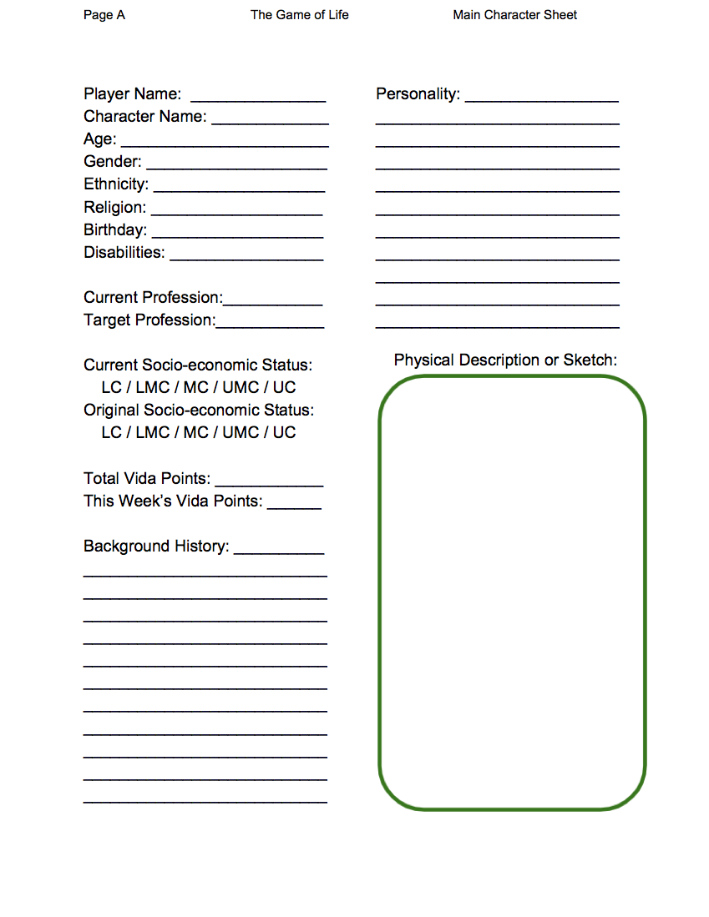
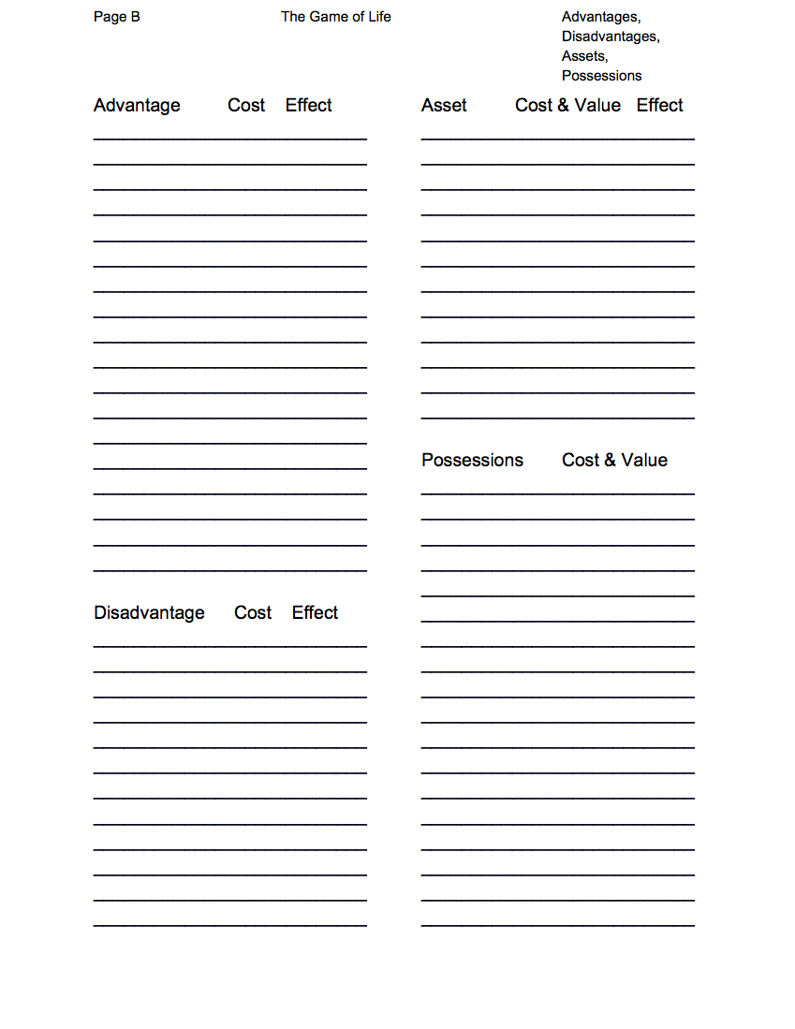

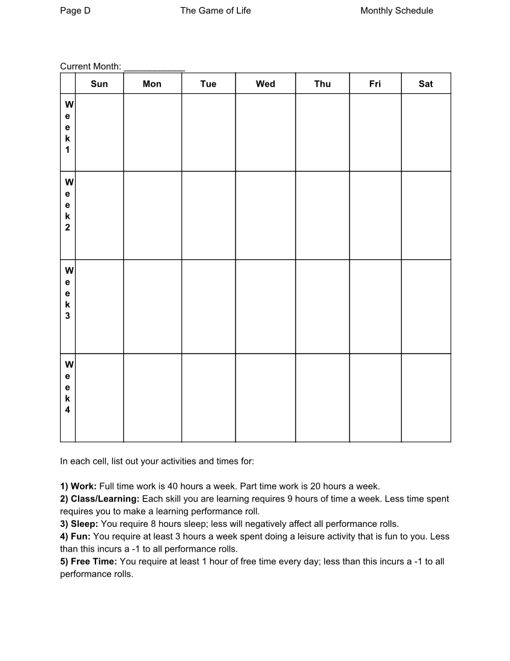
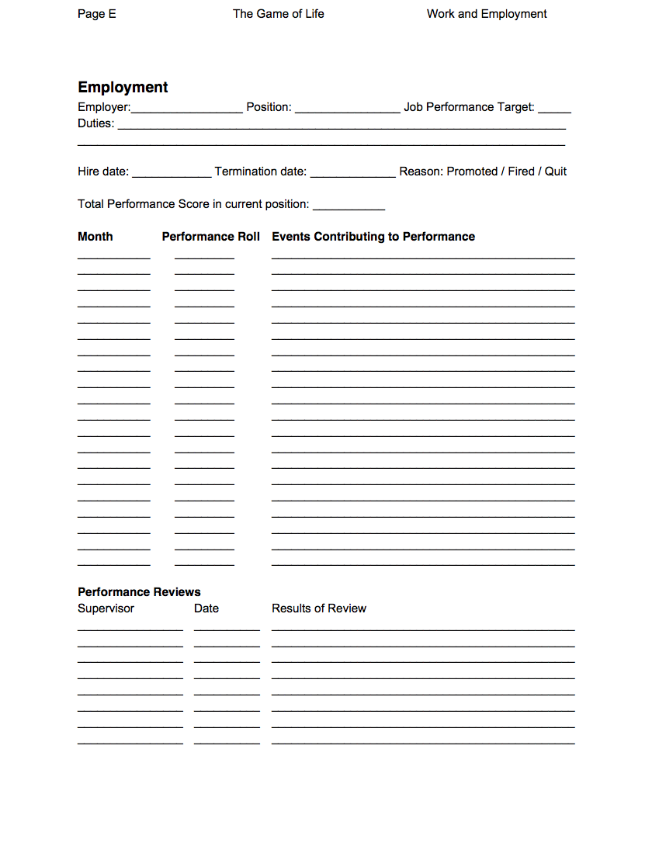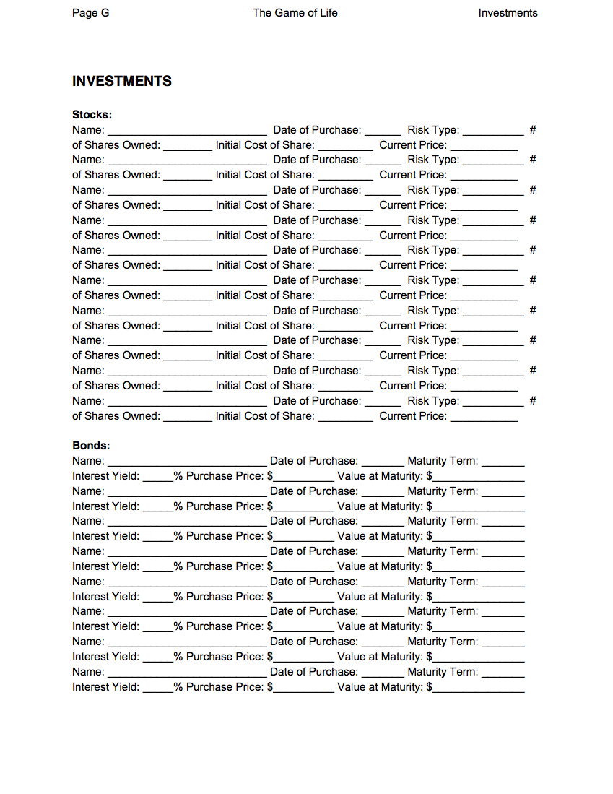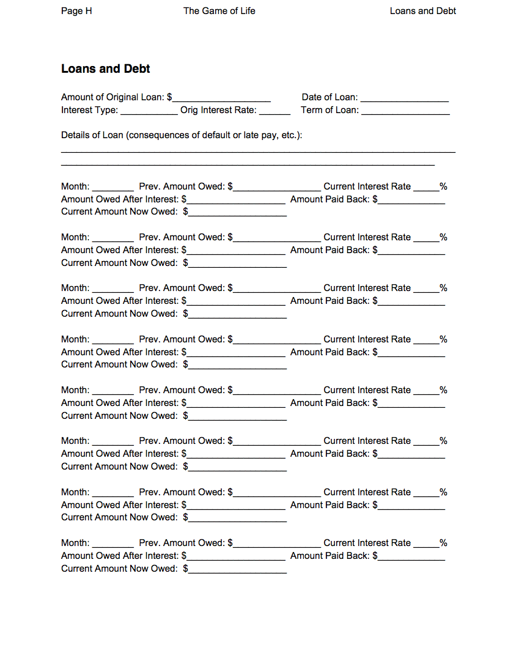

APPENDIX H: Chance Cards (English Versions)
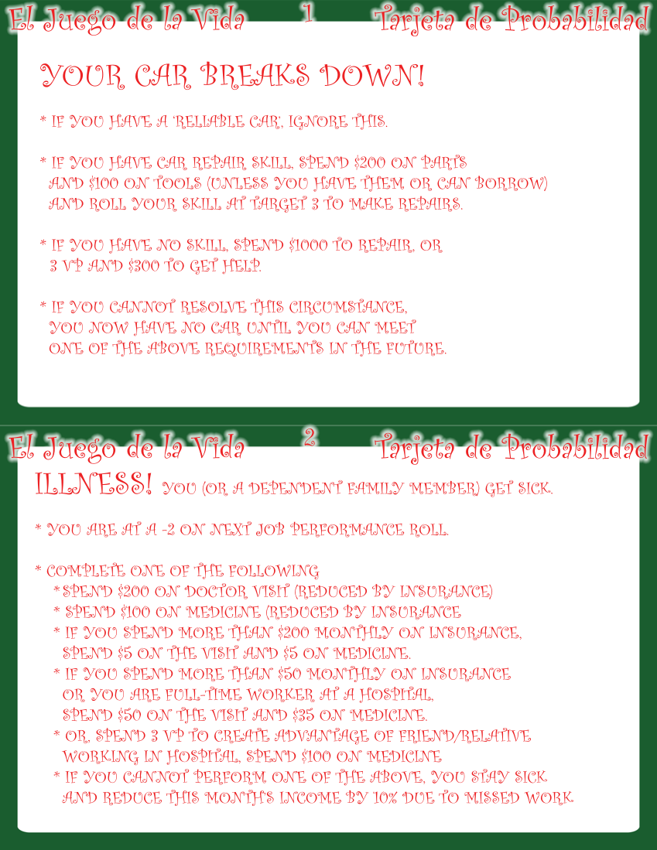
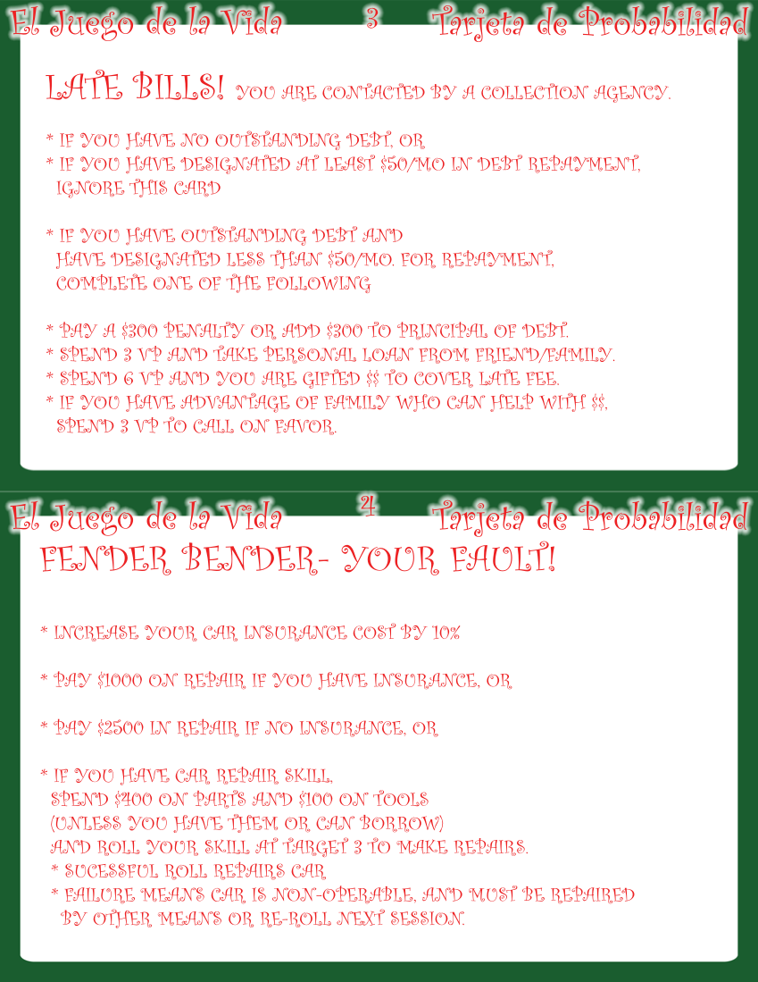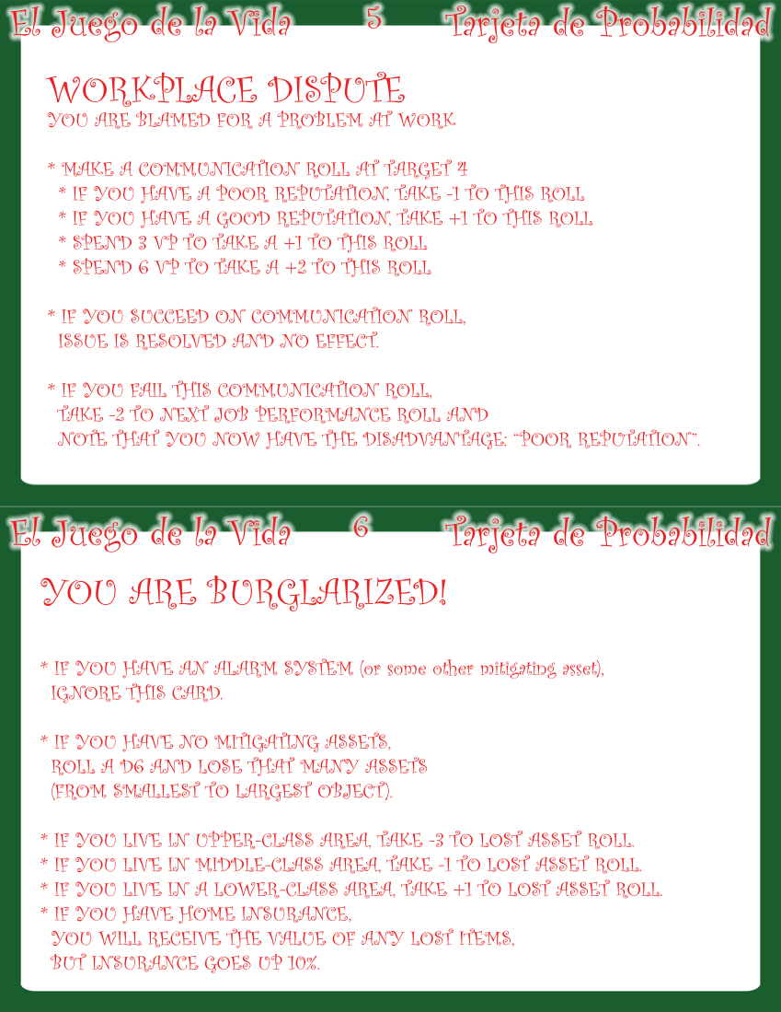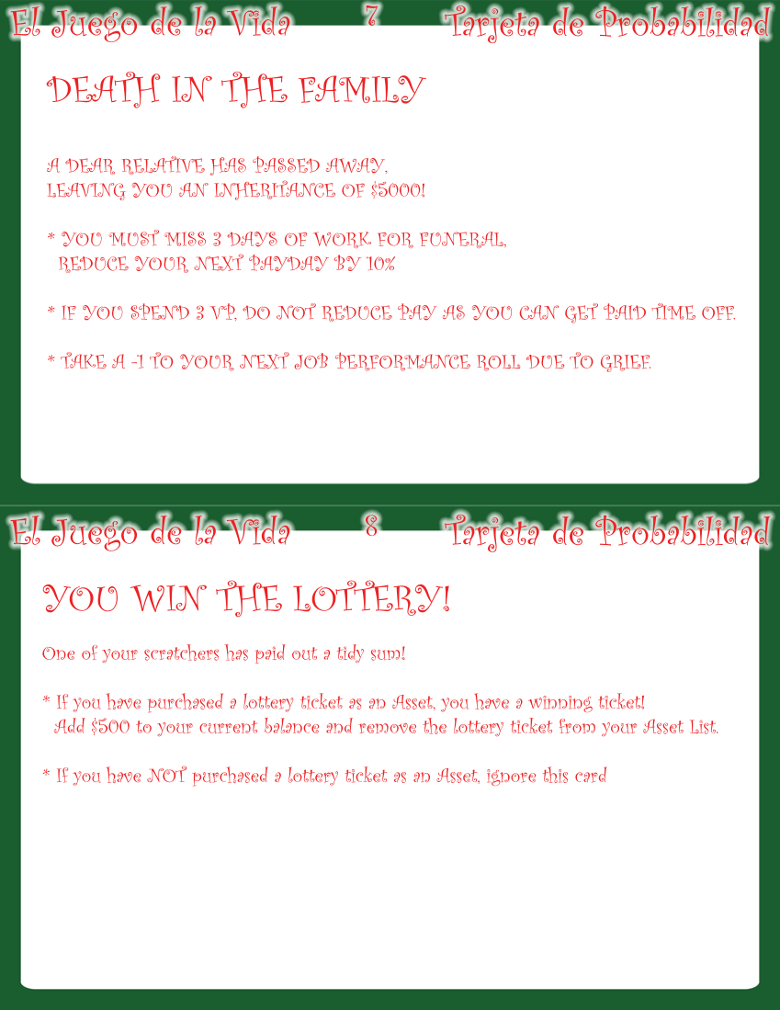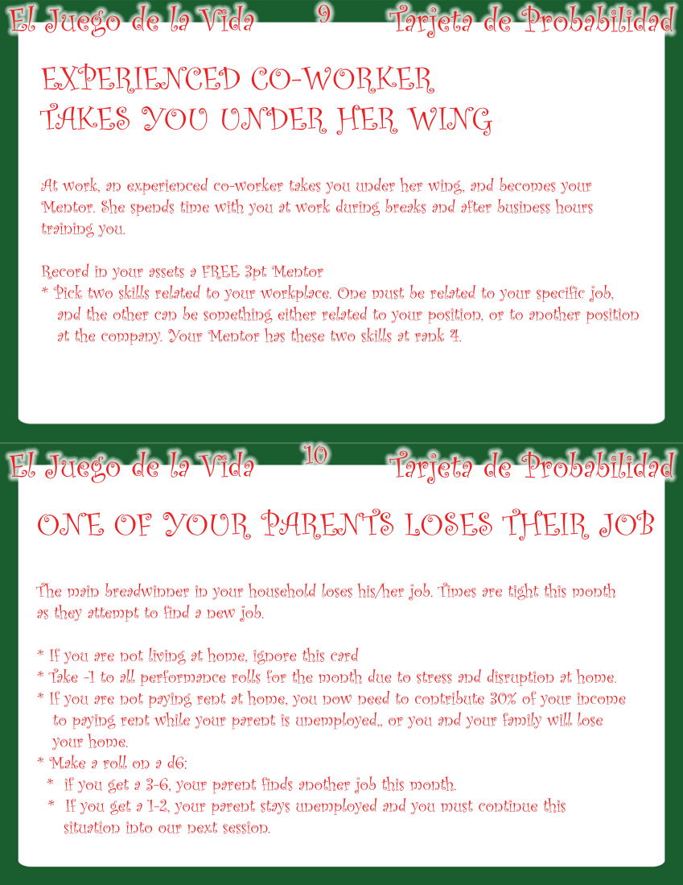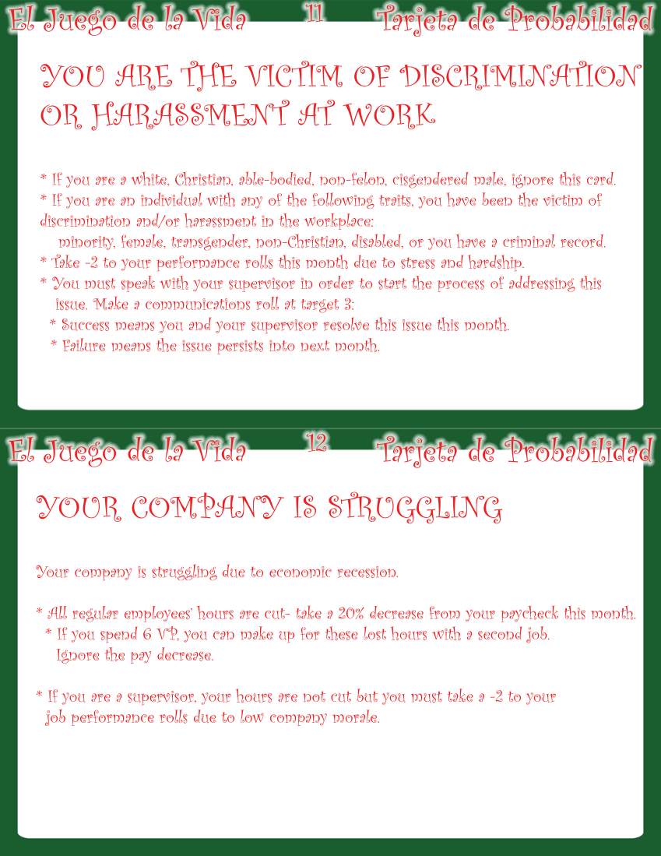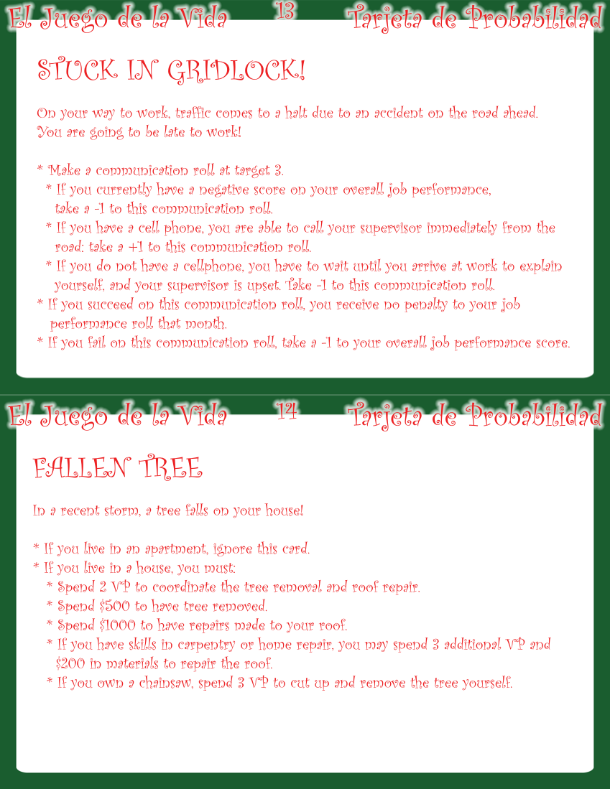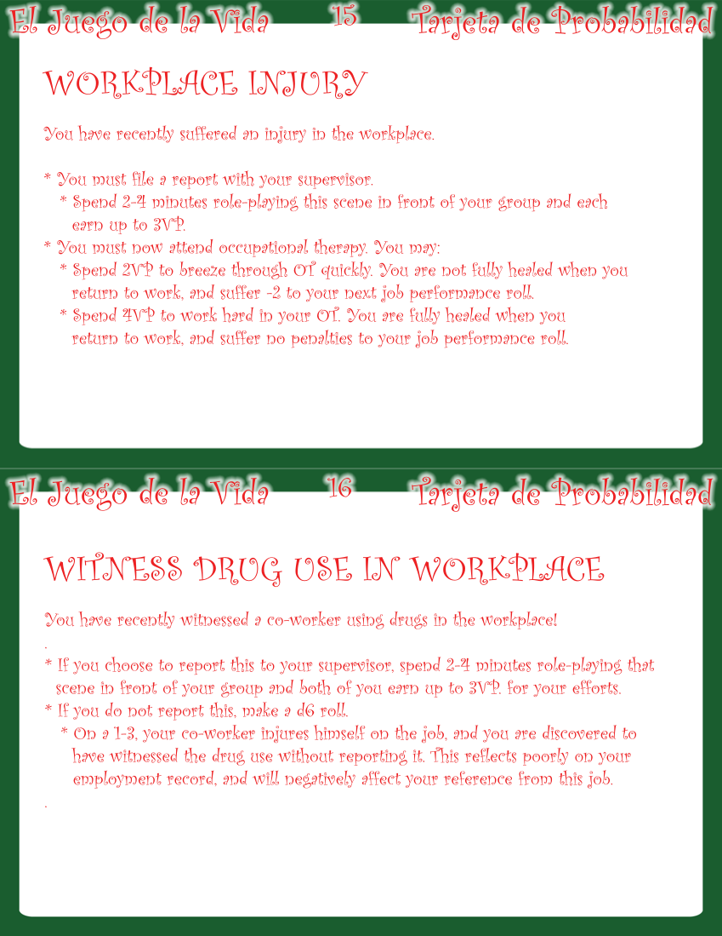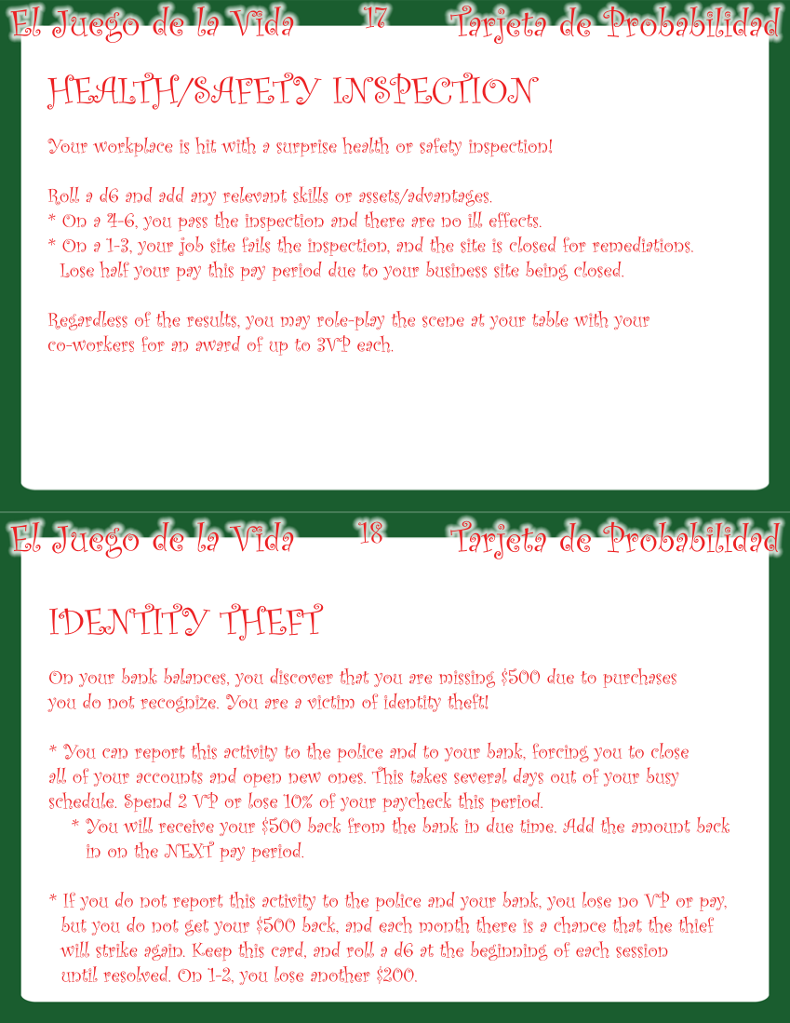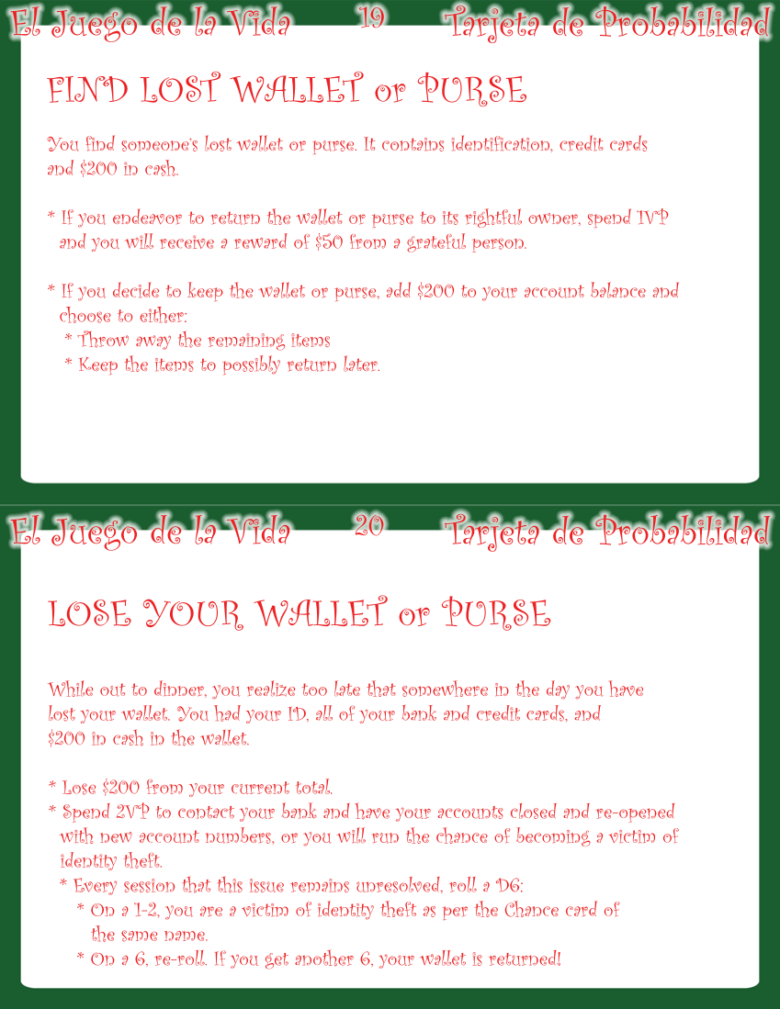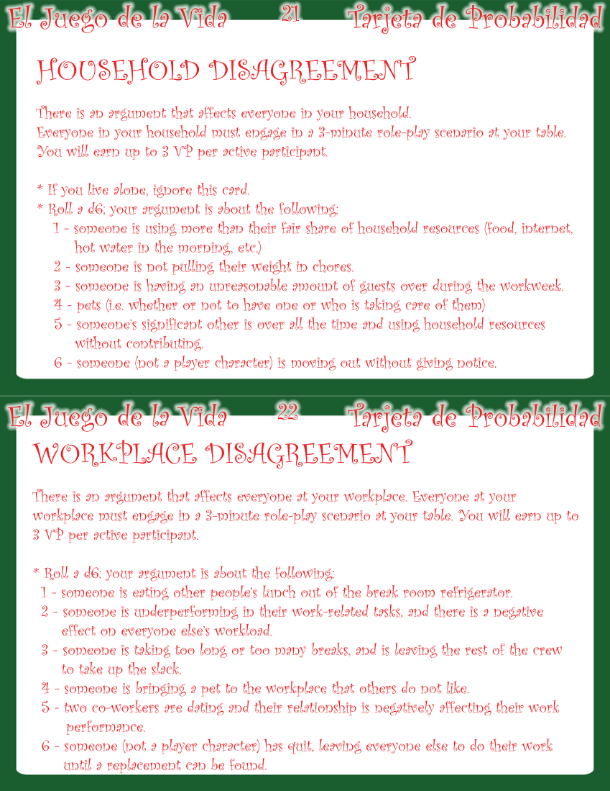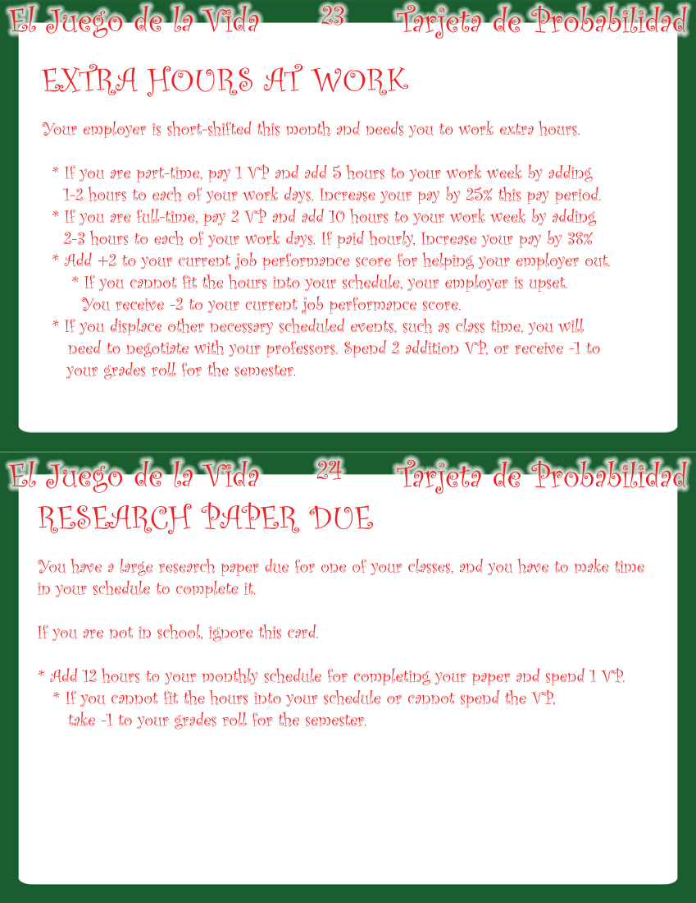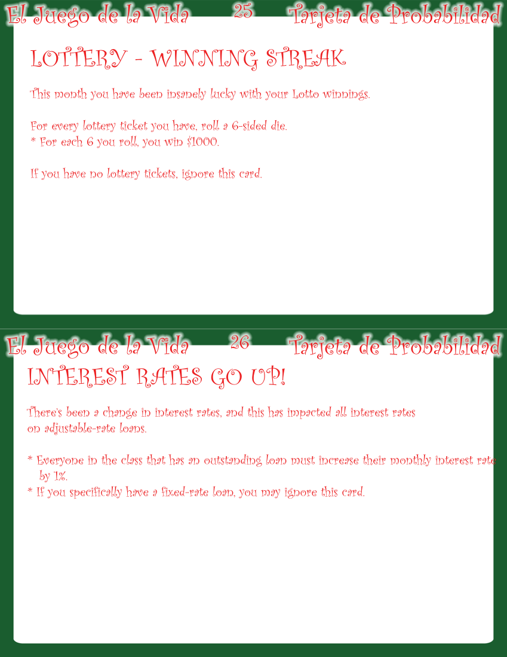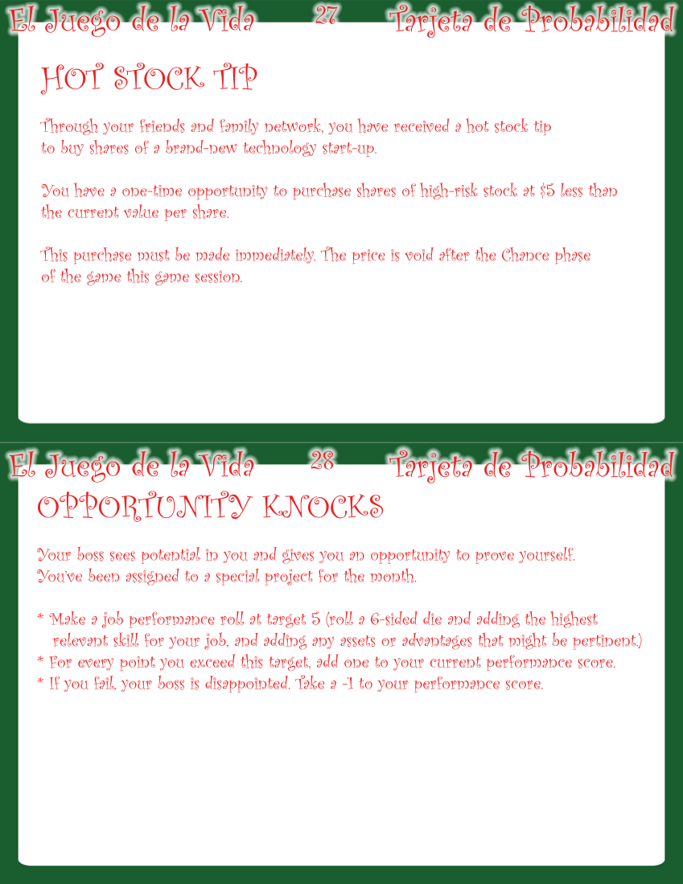

NOTES

Freire, Paulo. (2000). Pedagogy of the Oppressed. New York: Continuum
Pinar, W.F. (1975). Sanity, Madness and the School. Curriculum Theorizing: The Reconceptualists.
Pinar, W.F. (1975). Sanity, Madness and the School. Curriculum Theorizing: The Reconceptualists. p. 368.
Bennett, W.J., Fair, W., Finn, C.E., Jr., Flake, F.H., & Hirsch, E.D., Jr. (1998). A Nation Still At Risk. Policy Review. p. 176.
Bobbit, F. (1918). Scientific Method in Curriculum Making. David J. Flinders & Stephen J. Thornton (eds.), The Curriculum Studies Reader. New York: Routledge (2008)
Gee, James Paul. (2008). What Video Games Have to Teach Us About Learning and Literacy. Palgrave Macmillan
McGonigal, Jane. (2011). Reality is Broken. Penguin Press
Short, K., & Burke, C. (1991). Creating Curriculum: Teachers and Students as a Community of Learners. Portsmouth, NH; Heinemann Educational Books, Inc.
Short, K., & Burke, C. (1991). Creating Curriculum: Teachers and Students as a Community of Learners. Portsmouth, NH; Heinemann Educational Books, Inc.
Bobbit, F. (1918). Scientific Method in Curriculum Making. David J. Flinders & Stephen J. Thornton (eds.), The Curriculum Studies Reader. New York: Routledge (2008)
Bobbit, F. (1924). How to Make a Curriculum. Boston: Houghton Mifflin, Riverside Press
Horton, M. (1990). Islands of Decency. Long Haul: An Autobiography, with Judith Kohl and Herbert Kohl. Anchor Books, Doubleday. New York. pp.131-132.
Horton, M. (1990). Islands of Decency. Long Haul: An Autobiography, with Judith Kohl and Herbert Kohl. Anchor Books, Doubleday. New York. pg.133.
Horton, M. (1990). Islands of Decency. Long Haul: An Autobiography, with Judith Kohl and Herbert Kohl. Anchor Books, Doubleday. New York. pg.134.
https://en.wikipedia.org/wiki/Divergent_thinking#cite_note-1
http://www.p21.org/our-work/p21-framework
Scott Benjamin Dyson, Yu-Lin Chang∗, Hsueh-Chih Chen, Hsiang-Yu Hsiung, Chien-Chih Tseng, & Jen-Ho Chang. (2015). The Effect of Tabletop Role-Playing Games on the Creative Potential and Emotional Creativity of Taiwanese College Students. Thinking Skills and Creativity. http://dx.doi.org/10.1016/j.tsc.2015.10.004
Giroux, H.A. (2004). Critical Pedagogy and the Postmodern Divide: Towards a Pedagogy of Democratization. Teacher Education Quarterly, Winter.
http://casagrandehighschool.weebly.com/coursescourse-descriptions.html (pdf, p.26)
http://casagrandehighschool.weebly.com/academic-requirementsgraduation-requirements.html
Short, K., Burke, C. (1991). Creating curriculum: teachers and students as a community of learners. Portsmouth, NH; Heinemann Educational Books, Inc. pg. 63
http://www.p21.org/
Giroux, H. (1988). Teachers as Intellectuals: Toward a Critical Pedagogy of Learning. Westport, CT: Bergin and Garvey Press.

